Stockholm Junior Water Prize 2025

Energy-Efficient Atmospheric Water Harvester

under All Climatic Conditions

using Metal-Organic Frameworks

Seungbeom Cho

Republic of Korea

**Abstract**

As water scarcity worsens due to climate change, atmospheric water harvesting is emerging as a sustainable solution for freshwater supply in regions with limited access. This study presents an energy-efficient atmospheric water harvesting device based on metal–organic frameworks (MOFs). Unlike existing systems that operate only once daily using temperature differences between day and night or require electricity, the proposed device collects water multiple times daily without external power. Integrating MOFs with manual vacuum pump and low-temperature sources like soil accelerated water collection up to fourfold compared to non-vacuum conditions. Incorporating MOFs into a porous sponge shaped into beads or films enhanced water uptake efficiency and portability. This approach offers a promising strategy for freshwater production across diverse climate conditions.

**Table of Contents**

I. Introduction …………………………………………………………………….4

II. Objective/Aim…………………………………………………………………..5

III. Materials and Methods………………………………………………………….6

3-1. Materials………………………………………………………………………….6

3-2. Synthesis of MOFs……………………………………………………………….6

3-2-1. Synthesis of MIL-100(Fe)……………………………………………….…..6

3-2-2. Synthesis of MIL-101(Cr)…………………………………………………..6

3-2-3 Synthesis of MOF-801……………………………………………………… 6

3-3 Characterization and chemical analysis…………………………………………...7

3-4. Design of proof of concept device for water harvest with vacuum pump……….7

IV. Results and Discussion………………………………………………………….8

4-1. Characterization of MIL-100(Fe), MIL-101(Cr), MOF-801……………………..8

4-2. Analysis of water uptake of MIL-100(Fe), MIL-101(Cr), MOF-801………………...9

4-3. Analysis of water harvesting from MIL-100(Fe) and MIL-101(Cr)………………….9

4-4. Analysis of effects of exposure area of MOF in water harvesting……………………11

4-5. Development of new water harvest device…………………………………………...12

4-6. Conclusion……………………………………………………………………………14

References…………………………………………………………………………………...16

**Acknowledgements**

I would like to express my sincere gratitude to **Professor Woochul Song** from POSTECH for his invaluable guidance and support throughout my research on MOF-based water harvesting. I am also deeply thankful to **my teacher, Mr. Wonhyeong Jang**, who patiently introduced me to academic writing and consistently encouraged my experimental efforts with generosity and kindness. Lastly, I would like to give a special thanks to the **Korea Water Forum (KWF)** for the opportunity to develop my research through a series of incubation sessions and to participate in the prestigious Stockholm Junior Water Prize 2024.

1. **Introduction**

Atmospheric water harvesting, referred to as a method of collecting water from the atmosphere by condensation, offer a promising solution to freshwater scarcity[1]. According to a UNICEF report[2] released in March 2023, 190 million children in 10 African countries are suffering from water shortage problem, which causes more than 1,000 children under the age of 5 to lose their lives every day. In particular, the water shortage problem is getting worse as population growth is added to climate change[3]. To solve this water shortage problem, research on how to collect clean water from atmosphere is steadily progressing. Representative studies for water harvesting include a method of forming fog in a net[4], but there is a limitation that this can only be used where and when fog occurs. Recently, research on harvesting water using porous materials with excellent water adsorption ability has been actively conducted.

Metal-Organic Frameworks (MOFs) are a class of porous material consisting of metal clusters coordinated to organic ligands to form crystal structure. Due to their extraordinarily large surface area and pore volume, MOFs possess unique adsorption/desorption properties such as a large water-adsorption capacity and a great diversity of water-adsorption isotherms. Due to such properties, MOFs have been widely used as adsorbents to harvest water from air[5].

Omar M. Yaghi et al. reported passive water harvesting device MOF-801(Zr) using MOF-801 as the water adsorbent and exhibiting an average productivity of 0.1 L per 1 kg of MOF per day at relative humidity levels as low as 20% a day in Arizona Desert[6]. This device has drawbacks that it is not difficult to obtain a sufficient amount of water whenever necessary because water can be harvested only once a day. The same Yaghi team provided a MOF-303(Al)-based multicyclic water harvesting device with an external power source, which exhibits an average productivity of 1.3 L per 1 kg of MOF per day[7]. This device requires active heating and cooling for water production. Wang et al. provided a device coupling a passive device using MIL-101(Cr) coated on a copper foam plate, and 24 h thermoelectric power generation[8]. The device showed improved water product results 0.925 L per 1 kg of MOF per day, but such result uses too complicated system consisting of a dual-functional coating layer, low efficient solar-to-electricity system, and an air-cooling condenser. Almassad et al. reported water harvesting device using aluminum-coated trays with MOF-801, which was adapted depending on the weather/seasonal conditions, with water production up to 1.2-2.6 L per 1 kg of MOF per day[9]. This device requires huge space and external electric power.

Most of previous studies have the disadvantage of only being able to harvest water once a day because it only utilizes sunlight heat, or it requires external electrical power. In this study, unlike previous studies, a water harvesting device was developed that can harvest drinking water several times a day without external electric energy and is not bulky enough to be portable.

The main features of this study are the use of reduced pressure and increased MOF exposure area for improving water harvesting efficiency. The typical passive water harvest device merely uses day and night temperature difference for water vapor adsorption and release. The new device of this study uses reduced pressure in addition to the temperature difference. A vacuum pump is used to evacuate the air inside the water harvesting device, allowing the water vapor trapped in the MOFs to quickly release due to reduced pressure. In addition, the new device of this study uses increased MOF exposure area for obtaining enough amount of water. Specifically, the MOFs are beaded or distributed in a three-dimensional structure on a sponge so that all the MOFs are well in contact with the air. Further, the MOFs are coupled with a removable lid of the water harvesting device. During water adsorption, the lid is removed from the device to fully expose the MOFs to water vapor. The plurality of removable lids with MOF can be used in one harvest device multiple cycles of day since the time for the water harvesting is shortened by the use of hand-operated vacuum pump.

1. **Objective/Aim**

The objective of this study is to develop a water harvesting device capable of supplying water multiple times a day using a hand-operated vacuum pump. This device is designed to operate solely on sunlight which allows it to function in various environments. It aims to provide sufficient daily water yield to address water scarcity in various regions, including islands and deserts around the world.

1. Develop the water harvesting device that can supply water multiple times a day, using hand-operated vacuum pump.
2. Ensure that the water harvesting device does not need any external electric power but the sunlight so that the water harvesting device can operate anywhere (even on a lifeboat).
3. Ensure that enough amount of water can be obtained daily.
4. **Materials and Methods**

**3-1. Materials**

Zirconium tetrachloride (99.5%), fumaric acid (99%), N,N-Dimethylformamide (DMF) (99.8%), chromic nitrate nonahydrate (99%), terephthalic acid (99%), hydrofluoric acid (48%), methanol (99.8%), ferric chloride (97%), trimesic acid (95%), formic acid (98%), and acetic acid (99.7%) were purchased from Sigma-Aldrich. All chemicals and solvents were of reagent grade and used without further purification.

**3-2. Synthesis of MOFs**

**3-2-1. Synthesis of MIL-100(Fe)**

0.015g (3 mmol) of FeCl3 and 0.019 g (3 mmol) of trimesic acid (H3BTC) were dissolved in 30 mL of DMF. The reaction solution was transferred in teflon-lined autoclave and thermally treated at 40 °C for 40 h. The crystallization of reaction product is followed by its recovery through centrifugation. The product was washed many times with DMF, methanol and finally dried overnight at 20 °C[10].

**3-2-2. Synthesis of MIL-101(Cr)**

2.007 g of Cr (NO3)3·9H2O (5.0 mmol) dissolved in water and 0.823 g of terephthalic acid (5.0 mmol) dissolved in DMF were sequentially added to 100 mL beaker. 0.38 mL hydrofluoric acid was dropwise added to the mixture. The mixed solution was stirred constantly for 0.5 h. The liquid mixture was transferred to a 100 mL Teflon-lined autoclave and the reactor was sealed. The reaction autoclave was placed in a 3−550 A programmable Muffle furnace (Vulcan Co., United States) and continuously heated at 160 °C for 24 h. After the reaction completed, the autoclave was cooled to room temperature. The products were filtered and sequentially washed with hot water and hot DMF at 65 °C for 4 h to remove unreacted monomers and other impurities. Finally, the resulting product was obtained by vacuum drying oven at 130 °C for 24 h[11].

**3-2-3 Synthesis of MOF-801**

Starting materials zirconium tetrachloride (ZrCl4), fumaric acid (H2FC), acetic acid (AA), formic acid (FA), DMF, methanol were purchased from commercial suppliers and used without further purification. In a typical procedure, 0.2008 g of ZrCl4 was dissolved in 20 mL of DMF under magnetic stirring, then 46.6 µL of deionized water was added. After complete dissolving, 0.10 g of H2FC was poured to the clear solution. The mixture in a closed glass vessel was placed into a preheated oven at 40 °C for 8 hours. After cooling to room temperature, white precipitates were collected using centrifugation, washed two times with DMF and one time with methanol, and dried at 20 °C overnight[12].

**3-3 Characterization and chemical analysis**

Electron microscope images of MIL-100(Fe), MIL-101(Cr) and MOF-801 were taken by Tescan Vega 3 scanning electron microscope. Powder X-ray diffraction patterns of MIL-100(Fe), MIL-101(Cr) and MOF-801 were recorded with Bruker D8 Advance. Typically, data were collected between 3-50° with a step width of 0.0195° and a total data collection time of 30 min.

**3-4. Design of proof of concept device for water harvest with vacuum pump**

For proof of concept, water harvest device with vacuum pump was designed (Fig. 1). MOF container was fabricated using a container with a lid that MOF was put in or taken out, which is connected to a vessel. The MOF container is placed in a constant temperature chamber, which can be controlled to keep a desired temperature. One end of vessel is connected to MOF container while the other end of the vessel connected to a vacuum pump. The middle part of the vessel between MOF container and vacuum pump is immersed in a water bath at a cool temperature.

**Fig. 1. Schematic diagram of water harvest device with vacuum pump.**

1. **Results and Discussion**

**4-1. Characterization of MIL-100(Fe), MIL-101(Cr), MOF-801.**

For use in water harvest device, three types of MOFs, MOF-808, MIL-101(Cr), and MOF-801 were prepared following previously reported methods[10-12]. (Fig. 2a, 2b).

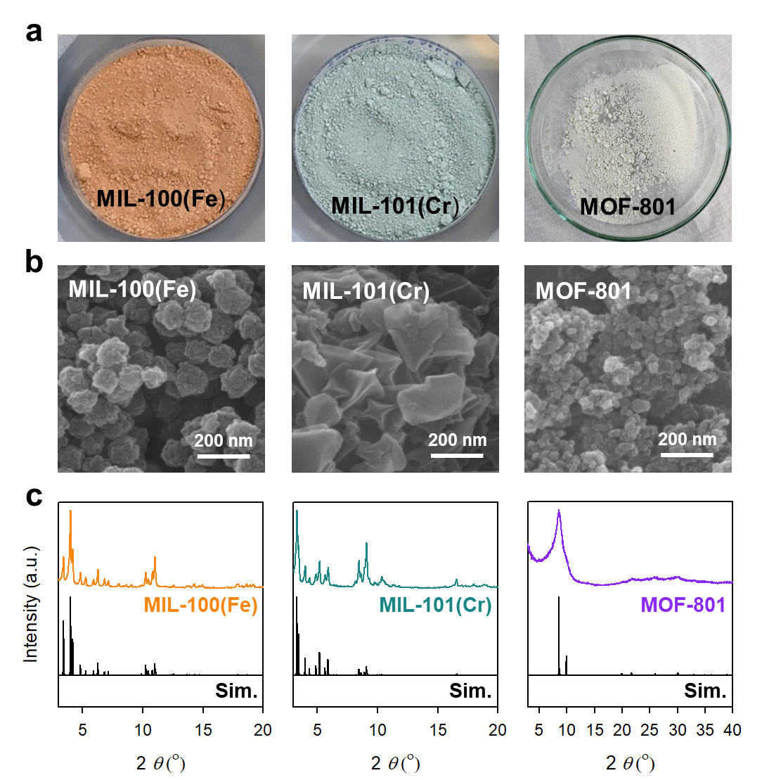

**Fig. 2. Synthesis and characterization of MIL-100(Fe), MIL-101(Cr), MOF-801.** a) Photograph of as-synthesized MIL-100(Fe), MIL-101(Cr), MOF-801. b) Scanning electron microscopy images (SEM) (magnification 100,000x) of MIL-100(Fe), MIL-101(Cr), MOF-801. c) Powder X-ray diffraction (PXRD) patterns of MIL-100(Fe), MIL-101(Cr), MOF-801.

The X-ray powder diffraction (XRPD) patterns of MIL-100(Fe), MIL-101(Cr), and MOF-801 were matched with simulated pattern, respectively (Fig. 2c). Therefore, it was confirmed that MOFs to be used in the water harvest device were well synthesized.

**4-2. Analysis of water uptake of MIL-100(Fe), MIL-101(Cr), MOF-801.**

15 g sample of each of MIL-100(Fe), MIL-101(Cr), and MOF-801 was placed in a room temperature (20℃, RH 80%) water bath for 8 hours. The weight change was measured over 8 hours to determine the amount of water uptake by the MOFs. The results of water uptake per gram for each MOF are shown in Fig. 3a. All three MOFs showed a tendency to saturate after 6 hours with minimal increase in water uptake. After 8 hours, MIL-101(Cr) showed the best water uptake performance with an increase of 71.0 wt% based on its own weight, while MIL-100(Fe) and MOF-801 showed an increase of 66.1 wt% and 12.4 wt%, respectively, as shown in Fig. 3(b). MOF-801 showed excellent water uptake in a desert environment in previous paper by Yagi et al.[6] but the sufficient amount of water uptake at room temperature were not observed in this experiment. Therefore, MOF-801 was excluded from the subsequent water harvesting experiments.

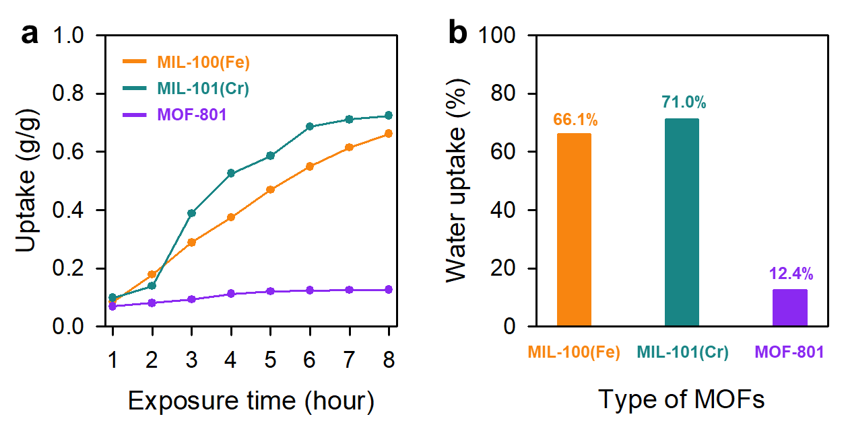

**Fig. 3. Water Uptake of MIL-100(Fe), MIL-101(Cr), MOF-801.** a) Amount (g) of water uptake per 1 g of MOF exposed to moisture environments (RH 80%) during 8 hours. b) Weight percentage of water uptake based on each MOF’s own weight after 8 hours exposure.

**4-3. Analysis of water harvesting from MIL-100(Fe) and MIL-101(Cr)**

15g of MOF was placed in a MOF container made in the manner described as in section 3-4, the lid was closed, and the pressure was depressurized by connecting the other end of the vessel to a vacuum pump. The MOF container was placed in a constant temperature chamber at 40℃ and at least half of the vessel was immersed in a 20℃ water bath. 5-meter-long vessel was initially used for increasing the contact area between the vessel and the water in the bath, which would act as a water condenser. Unlike expectations, as the length of the vessel increased, the volume of the vessel caused the water to spread inside the vessel, making it difficult to accurately measure the amount of water harvested. The formation of water droplets was observed on the vessel after 12 minutes (for MIL-100(Fe)) and 36 minutes (for MIL-101(Cr)) as shown in Fig. 4. After 3 hours, the amounts of water within the vessel were measured as 0.34 g (for MIL-100(Fe)) and 0.71 g (for MIL-101(Cr)) as shown in Table 1.

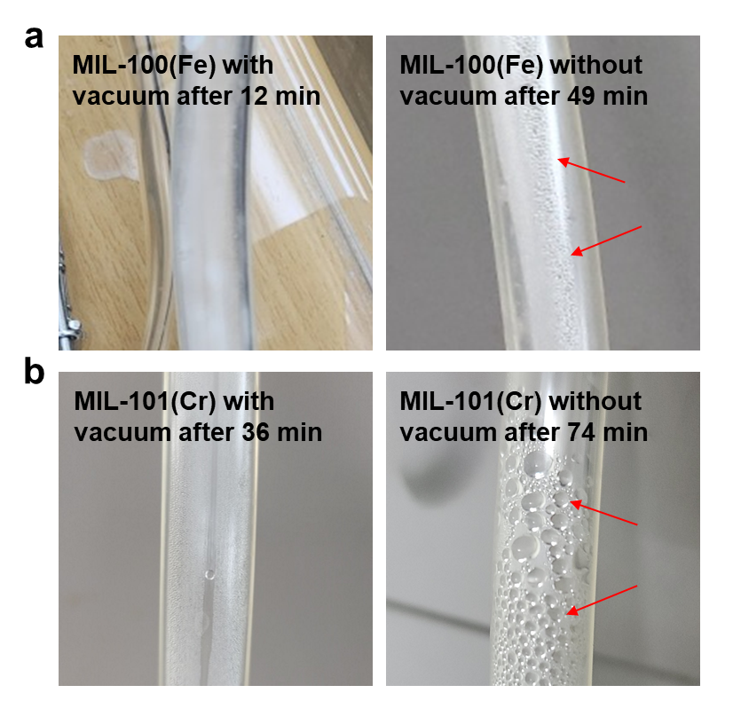

**\**

**Fig. 4. Water Harvest from MIL-100(Fe), MIL-101(Cr).** Photographs of the formation of water droplets from a) MIL-100(Fe) with vacuum after 12 min (left) and without vacuum after 49 min (right). (b) MIL-101(Cr) with vacuum after 36 min (left) and without vacuum after 74 min (right). The red arrows indicate the formation of water droplets.

**Table. 1. Water Uptake of MIL-100(Fe) and MIL-101(Cr) for 3 hours.**

|  |  |  |
| --- | --- | --- |
| Type of MOFs | Vacuum | Water uptake for 3 hours (g) |
| MIL-100(Fe) | O | 0.34 |
| X | 0.29 |
| MIL-101(Cr) | O | 0.71 |
| X | 0.54 |

To confirm the effect of vacuum, the same procedure was repeated without decompression. 15 g of MOF was placed in the MOF container, the lid was closed, the MOF container was placed in a constant temperature chamber at 40℃, and more than half of the long vessel was immersed in a 20℃ water bath. The formation of water droplets was observed on the vessel after 49 minutes (for MIL-100(Fe)) and after 74 minutes (for MIL-101(Cr)) as shown in Fig. 4. After 3 hours, the amounts of water within the vessel were measured as 0.29 g (for MIL-100(Fe)) and 0.54 g (for MIL-101(Cr)) as shown in Table 1.

**4-4. Analysis of effects of exposure area of MOF in water harvesting**

In the initial stage of this study, the experiment was conducted to evaluate the amount of water uptake with the MOF placed inside an Erlenmeyer flask. However, the water uptake amount of MOF placed inside a flask was very little even after sufficient time (more than 24 hours) had passed.

Based on the above, the exposure area of MOF to the air is identified as a significant factor of water uptake. The water uptake amount of MIL-101(Cr) was compared between the case where it was simply placed on Petri dish and the case where powder of MIL-101 was spread over the porous sponge. After placing the two samples in a water bath at room temperature (20℃, RH 80%) for 8 hours, the increased weights of each sample were measured. As a result, the water uptake of those spread over the sponge was increased by 34 percent compared to those simply on Petri dish (Fig. 5).

\**Fig. 5. Evaluation of Effect of Exposure area for Water Uptake of MIL-101(Cr).** a) MIL-101(Cr) in a Erlenmeyer flask. b) MIL-101(Cr) on petri dish. c) MIL-101(Cr) spread over porous sponge.

To further investigate the influence of physical morphology on water uptake performance, MIL-100(Fe) was synthesized in three distinct forms: powder, beads, and thin film (Fig. 6a-c). Each form was prepared with an equal mass and subjected to a controlled humid environment (20℃, RH 80%) for 8 hours. The increase in weight was measured to quantify the amount of adsorbed water. As shown in Figure 6d, the powder form exhibited the highest water uptake efficiency (55 wt%), followed by the bead form (51 wt%), while the film form showed the lowest performance (20 wt%),. These results demonstrate that the physical form of the MOF, particularly its surface area and porosity, plays a critical role in determining its adsorption capacity.

However, while the powder form showed superior water adsorption, it presents practical challenges for device integration due to its tendency to disperse or spill during handling. In contrast, the bead and thin film forms, although exhibiting slightly lower water uptake, offer advantages in terms of structural stability and ease of immobilization within a device. These trade-offs suggest that the optimal MOF form should be selected based on a balance between adsorption efficiency and processability for system-level applications.

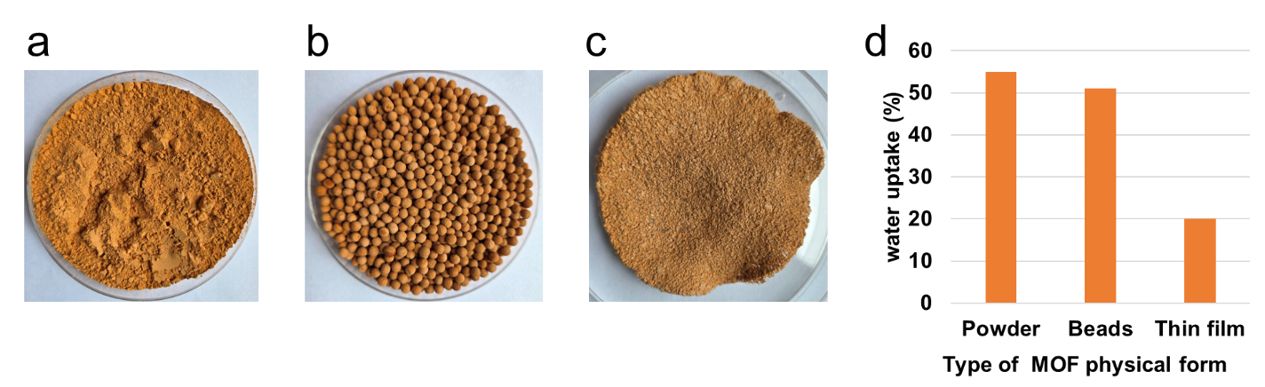

**\Fig. 6. Evaluation of the effect of physical form on the water uptake performance of MIL-100(Fe).** (a) Powder form of MIL-100(Fe); (b) Bead form of MIL-100(Fe); (c) Thin film form of MIL-100(Fe); (d) Comparison of water uptake capacities of the three forms after 8 hours of exposure (20℃, RH 80%).

**4-5. Development of new water harvest device**

From the above experiments, the concept was proved that decompression using a vacuum pump and increasing the exposure area of MOFs using another porous material is effective for water harvesting. Based on these results, a new water harvesting device was designed as follows (Fig. 7):

**Fig. 7. Development of new water harvest device.** a) Schematic diagram of new water harvest device having removable lid with MOF. b) removable lid with MOF during water adsorption. c) multiple lids for multiple cycles.

* 1. This water harvesting device has a container with a removable lid, such as screw-type and snapware-type, that can withstand and maintain reduced pressure.
  2. This device has a vacuum pump connection unit on the side of the device so that the internal pressure of the device can be reduced by vacuum pump.
  3. The bottom of this device is equipped with a water valve that allows the water harvested from this device to be drained.
  4. The MOFs are either in the form of beads[13] or dispersed by three-dimensional embedding of the MOFs in a porous medium such as a sponge to increase the air contact area of the MOFs and prevent the MOF powder from drifting away (the porous material can be a material with larger pores than the MOFs but with a lower water adsorption rate, e.g., zeolite, carbon nanotube sponge, etc.).
  5. The MOFs in the form of step D are encapsulated with a filter membrane. The filter membrane is a material that allows air and water vapor to pass through freely, but not the MOFs.
  6. The encapsulated MOF unit is coupled to the removable lid of the device. Remove it from the water harvesting device to maximize contact with airborne moisture during water adsorption, while attaching it to the water harvesting device to maintain vacuum pressure during water harvesting.
  7. The metal plate for easily heating and storing the sunlight heat is attached to the outside of the removable lid.
  8. During water harvesting, the top of the container is exposed to the sun light while the bottom of the container is immersed in cold sea or river water to maximize the temperature difference.

To verify the thermal gradient effectiveness of the developed device, a prototype was tested by exposing the removable lid (containing the MOF) to 50W of halogen light, while the lower part of the container was immersed in 20 °C of dirt. A temperature sensor was attached to the MOF-containing lid and the inner chamber to monitor heat accumulation. As shown in Fig. 8, the lid's temperature increased from 20 °C to 56 °C over a span of an hour, while the internal temperature of the lower part remained relatively constant at 20°C. This confirmed the ability of the device to create and maintain a temperature differential necessary for effective desorption under passive conditions.

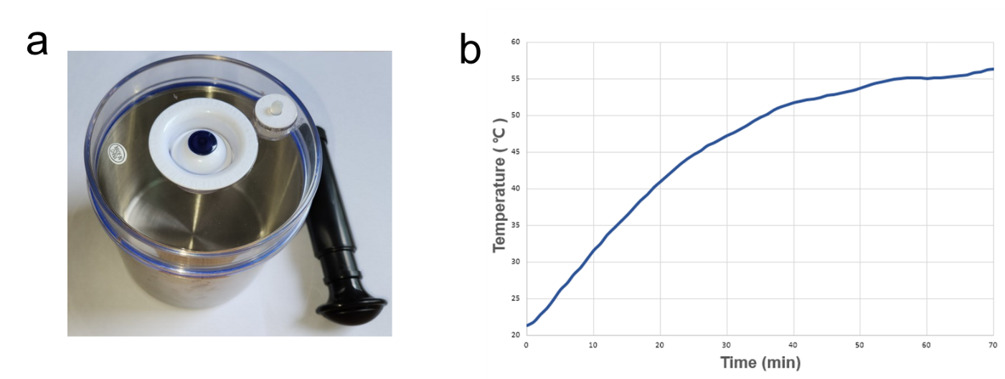

**Fig. 8. Thermal gradient generation in the prototype device.** (a) Photograph of the prototype; (b) Temperature profiles of the MOF-containing lid and internal chamber under 20 W halogen light exposure for 1 hour.

**4-6. Conclusion**

This study presents the development of an energy-efficient atmospheric water harvesting device employing MOFs, designed to collect water multiple times per day without relying on external power sources. By integrating a hand-operated vacuum pump and utilizing low-temperature sources such as seawater or soil, the system addresses key limitations of conventional technologies, which typically depend on single daily cycles or electrical input. Experimental results confirmed that vacuum-assisted desorption accelerated water release up to fourfold compared to non-vacuum conditions. In addition, embedding MOFs within a porous sponge increased water uptake by 34% through enhanced air contact. Based on these findings, a new water harvesting device was developed that combines a manual vacuum pump, a sunlight-exposed removable lid, and a lower chamber cooled by the environment. The combined use of vacuum pressure and optimized MOF exposure resulted in a practical and portable solution adaptable to diverse climatic and humidity conditions.

Nonetheless, the study has several limitations. Quantitative data on actual water yield were limited, as the MOFs used MIL-100(Fe) and MIL-101(Cr) did not demonstrate optimal adsorption under the test conditions. MOF-801 has shown high water uptake efficiency in arid environments and deserts, while MIL-100(Fe) performs stably across a broad humidity range. In contrast, MIL-101(Cr) demonstrates superior water adsorption in high-humidity conditions, suggesting its suitability for tropical or inland regions. Optimizing the structural design and maximizing the temperature differential could further enhance performance. Future improvements may include refining the thermal management system, introducing modular designs with multiple MOF-lid units for continuous cycling, and expanding applicability to water-scarce environments such as island regions, emergency lifeboats, and isolated inland communities. Furthermore, integrating components like air blowers or electric vacuum pumps may increase operational reliability and user convenience.

In summary, this work validates the feasibility of a non-powered, multi-cycle water harvesting system based on MOFs and vacuum-assisted desorption. Continued advancements in material development and device engineering will be essential to fully realize the potential of this approach as a decentralized, sustainable freshwater solution.

**References**

[1] Wahlgren, R. V., Atmospheric water vapour processor designs for potable water production: a review. Water Research, 2001, 35(1), 1-22.

[2] Unicef Press Release, A triple threat of water-related crises is endangering the lives of 190 million children – UNICEF, March 2023 (https://www.unicef.org/press-releases/triple-threat-water-related-crises-endangering-lives-190-million-children-unicef)

[3] Mekonnen, M. M., & Hoekstra, A. Y. Four billion people facing severe water scarcity. Science Advances, 2016, 2(2), e1500323.

[4] Korkmaz, S., & Kariper, İ. A. Fog harvesting against water shortage. Environmental Chemistry Letters, 2020, 18(2), 361-375.

[5] Hanikel, N., Prévot, M. S., & Yaghi, O. M. MOF water harvesters. Nature Nanotechnology, 2020, 15(5), 348-355.

[6] Fathieh, F., Kalmutzki, M. J., Kapustin, E. A., Waller, P. J., Yang, J., & Yaghi, O. M. Practical water production from desert air. Science Advances, 2018, 4(6), e3198.

[7] Hanikel, N. et al., Rapid cycling and exceptional yield in a metal-organic framework water harvester. ACS Central Science, 2019, 5(10), 1699-1706.

[8] Li, T. et al., Simultaneous atmospheric water production and 24-hour power generation enabled by moisture-induced energy harvesting. Nature Communications, 2022, 13(1), 6771.

[9] Almassad, H. A., Abaza, R. I., Siwwan, L., Al-Maythalony, B., & Cordova, K. E. Environmentally adaptive MOF-based device enables continuous self-optimizing atmospheric water harvesting. Nature Communications, 2022, 13(1), 4873.

[10] Nehra, M., Dilbaghi, N., Singhal, N. K., Hassan, A. A., Kim, K. H., & Kumar, S. Metal organic frameworks MIL-100 (Fe) as an efficient adsorptive material for phosphate management. Environmental Research, 2019, 169, 229-236.

[11] Zhao, H., Li, Q., Wang, Z., Wu, T., & Zhang, M. Synthesis of MIL-101 (Cr) and its water adsorption performance. Microporous and Mesoporous Materials, 2020, 297, 110044.

[12] Butova, V. V., Pankin, I. A., Burachevskaya, O. A., Vetlitsyna-Novikova, K. S., & Soldatov, A. V. New fast synthesis of MOF-801 for water and hydrogen storage: Modulator effect and recycling options. Inorganica Chimica Acta, 2021, 514, 120025.

[13] Yang, S. et al., Preparation of highly porous metal–organic framework beads for metal extraction from liquid streams. Journal of the American Chemical Society, 2020, 142(31), 13415-13425.