# ENTRY TO THE STOCKHOLM JUNIOR WATER PRIZE NETHERLANDS 2024

Biological Oxygen-Dosed Activated Carbon (BODAC) filters: A bioprocess for in water sustaining herbicide removal

Yoline Maria Claire Ruiter

The Netherlands

Advisors: Amanda Larasati, Ir. E.J. Zwiers

School: Dr. Nassau College Quintus, The Netherlands

Research Institute: Wetsus, European Centre of Excellence for Sustainable Water Technology, the Netherlands

# Abstract

With the climate changing, water becomes more polluted with toxins due to a great amount of sweet water vaporizing, in addition to current exceeded herbicide use. The toxication of our waters is very harmful to non-targeted plants, mammals, humans, and aquatic life [1]. Study has shown that additional effective water treatment methods are of great importance. [61] That is what this research provides. It shows a new biological water purification method to a degree never seen before. The key ingredient is BODAC, an acronym for Biological Oxygen-Dosed Activated Carbon. These bio-based water treatment filters have been proven to remove over 70% of often-used medicine from water. This was accomplished with the use of the microbiological growth in the BODAC filter. [2] This study will provide scientific research on the removal of micropollutants and a look into the only two previous studies done on BODAC. This is to determine if the promising possibilities of BODAC are true.

# Highlights

# Acknowledgments

This work has been supported by the cooperation framework of Wetsus, European Centre of Excellence for Sustainable Water Technology (www. Wetsus.eu). Wetsus is co-founded by the Dutch Ministry of Economic Affairs and Ministry of Infrastructure and Environment, The European Union Regional Development Fund, the Province of Fryslȃn and the Northern Netherlands Provinces. I would like to deeply thank the following people for assisting me with this research, without them this would not have been possible: Amanda Larasati, Trienke de Vries, Rouel Gnodde, Erik Zwiggelaar, Anke Durand, E.E. Zwiers. My thanks for inspiring me also go to the UWP factory in Emmen, where the full-scale of BODAC filters are located (Nieuwater, https://nwtr/). And last but not least my family and friends for their love and mental support.

# Keywords:

Biological Activated Carbon; Micropollutant removal; Biofilm; Pesticide/ Herbicide Removal;

## Acronyms:

|  |  |
| --- | --- |
| Acronym | Explanation |
| 2,4-D | (2,4-Dichlorophenoxy) acetic acid |
| MCPP | Mecoprop: 2-(4-Chloro-2-methylphenoxy) propanoic acid) |
| ATZ | Atrazine: (6-chloro-4-N-ethyl-2-N-propan-2-yl-1,3,5-triazine-2,4-diamine) |
| BODAC | Biological Oxygen-Dosed Activated Carbon |
| UPW | Ultra-Pure Water Factory Emmen |
| WWTP | Waste Water Treatment Plants |
| DS | Drum Sieve |
| UF | Ultra-Filtration |
| RO | Reverse Osmosis |
| sEPS | soluble Extracellular Polymeric Substance |
| EDI | Electro DeIonization |
| BAC | Biological Activated Carbon |
| OMP | Organic Micro Pollutants |
| VGAC | Virgin Granulated Activated Carbon |

# Table of Contents

1 Introduction 4

1.1 Hypothesis 4

1.2 The characteristics of the pesticides in question 4

1.3 Metabolization 5

1.4 Health Hazards 5

1.5 Herbicide application 5

1.6 Extend of herbicide use 5

1.7 BODAC properties and performance 6

1.8 Process performance of BODAC-filters 8

2 Method and materials 12

2.1 Materials 12

2.2 Method of Experimenting 12

3 Results and Result Analysis 15

3.1 pH measurements 15

3.2 Concentration 2,4-D over time 15

3.3 Concentration Atrazine over time 16

3.4 Concentration MCPP over time 17

4 Conclusion and discussion 18

5 Credit authorship contribution statement 20

6 Declaration of Competing Interest 20

7 Appendix 21

# Introduction

## Hypothesis

BODAC is expected to be capable of decomposing the herbicides 2,4-D, MCPP, and Atrazine to a reasonable amount. This is presumed since BODAC has shown to remove over 70% of the researched OMPs (Organic Micro Pollutant) in the previous study done on BODAC by Olga Bernadet, H. Pieter J. van Veelen, Gert Jan Willem Euverink, Maria Cristina Gagliano and Amanda Larasati et al. [2]

## The characteristics of the pesticides in question

Figure 1 Chemical stucture 2,4-D

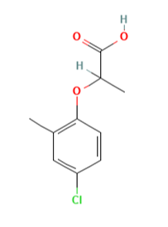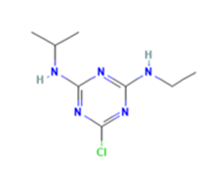The herbicides 2,4-D (2,4-Dichlorophenoxyacetic acid), Mecoprop/MCPP (2-(4-Chloro-2-methylphenoxy) propanoic acid), and Atrazine/ATZ (6-chloro-4-N-ethyl-2-N-propan-2-yl-1,3,5-trazine-2,4-diamine) were elected for this paper. As a result of their persistence in water, the characteristics of BODAC could be investigated. In Figures 1, 2 and 3, the herbicides' chemical structures are shown. A table of multiple characteristics can be found in the appendix {7.4}, along with the sources used in this subsection. 2,4-D and MCPP are chlorophenoxy and phenoxyalkanoic acid herbicides. This means they are analogs of auxins; plant-growth hormones. They will cause increased, and eventually lethal, growth in target plants. The fact that 2,4-D and MCPP work the same way can be partially stated from the fact that the chemical structures are very resemblant, as can be observed by looking at Figure 1 and Figure 2. Atrazine, on the other hand, acts as a photosynthetic electron transport inhibitor at the photosystem II receptor site; it affects the photosynthesis in target plants causing them to dry out and die. [3], [4], [5], [6], [7] The three herbicides are proven to be toxic to humans and aquatic life. For further specification, please take notice of table {7.2} ’Hazard Statements', in the appendix and paragraph 1.4. Furthermore, the substances MCPP, Atrazine and metabolites of MCPP impact microbial communities negatively. [8] Moreover, Atrazine causes alteration in the bacterial community structure in soil, which causes bacterial degradation. [9]

Figure 2 Chemical stucture MCPP

Figure 3 Chemical stucture ATZ

## Metabolization

The herbicide's metabolites are often characterized by their high toxicity, frequent occurrence, and persistence in the environment. By coexisting in an environmental medium, they form various mixtures, the products of the possible reactions between these substances may be additive, or unpredictable; analogous to synergistic and antagonistic. The formation medium is often soil and therefore they are not further mentioned in this paper. For exact data, please see the appendix. {7.5, 7.6 and 7.7} ‘Plain metabolites of ….' [4] [10][11]

## Health Hazards

Overall, the three herbicides are very toxic to mammals, non-targeted plants, humans and aquatic life. Reducing growth rates, inducing reproductive problems, being possibly carcinogenic, and causing developmental, neurological and genotoxic effects and death in plants and animals. A more detailed explanation along with a table and sources can be found in the attachments {7.2 and 7.3}.

## Herbicide application

2,4-D is the second most widely used herbicide worldwide due to its low cost and general applicability. [12] That is why, in the American agricultural sector, 2,4-D has a spot in the top 10 most used conventional active ingredients of pesticides. Furthermore, 2,4-D is the most frequent used active herbicide ingredient in the non-agricultural sectors. [13] [14] 2,4-D is allowed to be used in the EU [15]. MCPP is used to control (broad-leaved) weeds and has a worldwide application.[16] MCPP has been illegal to use in the EU since 31/01/17. [15] Atrazine is mostly used on crops to prevent the growth of broadleaf weeds. [17] Additionally, Atrazine is ranked the second most widely used herbicide in the United States and one of the most effective and cheapest herbicides in the world and is therefore used to a great extent. [18][19] Globally, Atrazine is mostly applied in the US and Brazil as a pre-emergent or early post-emergent herbicide. The European Commission forbade the use of Atrazine in the EU in 2003. [15], [18]. The United States on the other hand, reapproved the use of Atrazine in the fall of 2020. [17]

## Extend of herbicide use

It is generally considered challenging to determine the amount of use of a hardly registered, and sometimes illegal substance. However, by looking at the concentrations in water a slight insight is given. An example is the Netherlands, where the water pollutants are well monitored, for example in source [20]. From 1999 to 2010, 2,4-D was the most frequently detected herbicide in suburban surface waters in the US, with the highest concentration being 0,46 μg/L. In the non-agricultural sectors of the US, the amount of 2,4-D is respectively 8–11 and 16–22 million pounds. In the USA, rates of application were less than 1.7 kg acid/Ha, and approximately less than 2.2 kg/Ha was applied annually. [13] MCPP is not often found in food and drinking water. When MCPP is detected, the concentration is usually not more than a few microg/L [21]. However, MCPP is regularly found in surface water samples at 0.01–1 μg/L levels in most countries. [16]. Atrazine is due to its often use, the most common chemical contaminant in US water supplies. 90% of the water tested by the USDA contained Atrazine and its metabolites [18].

## BODAC properties and performance

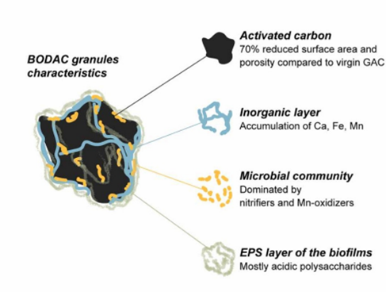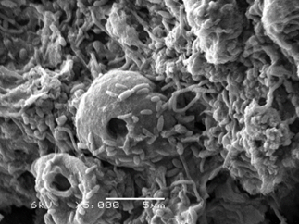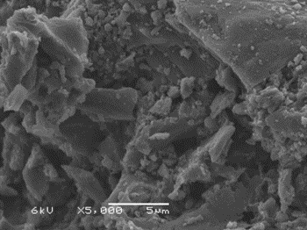Biological Oxygen-Dosed Activated Carbon (or BODAC) is formed when full-scaled BAC filters, dosed with a high oxygen concentration, are used. A BAC (Biological Activated Carbon) filter is used to purify water by using the absorption abilities of activated carbon granules while desorption and biodegradation occur simultaneously. This results in the longevity of the carbon bed. As a result of the combination of adsorption, and the activity of the biofilm growing on the carbon surface, the removal of nutrients, organics, and organic micropollutants with the use of BAC granules is accomplished. BAC's purifying abilities get increased by adding dissolved oxygen, due to the stimulation of bio-regeneration in BAC filters, forming BODAC. [2] BAC and BODAC are stated in Figures 5 and 4. In Figure 4, the biofilm of BODAC is notably visible, this biofilm contributes to the carbon bio-regeneration by metabolizing the adsorbed compounds. [2]

Figure 4 BODAC, carbon with biofilm

Figure 5 BAC, clean carbon without biofilm

In Figure 6 the characteristics of BODAC are stated. Such as the microbial community, the inorganic layer, and the activated carbon. The used biofilm sample was retrieved by using the backwashed bacteria and it consists of particles of the inorganic layer, the microbial community, and the EPS layer. The latter was formed by the microorganisms attached to the BODAC granules' surface. Adsorption, desorption, and conversion occur, but the latter only occurs when the whole is shaken with immense force and does not occur on itself.[2]

Figure 6 BODAC granules characteristics

The UPW (UltraPure Water factory in Emmen, The Netherlands) uses several consecutive water treatment steps when purifying with BODAC, as can be seen in Figure 7. Starting with wastewater treatment plants (WWTPs), followed by drum sieves (DS) and ultrafiltration (UF); a membrane filtration technique, in which external hydrostatic pressure pushes a liquid through a semipermeable membrane that can remove a target, usually particles, microorganisms, and organic matter from the bulk solution. This is to prevent biofouling in the RO units. Then BAC filters would be used to reduce the concentration of potential foulants. However, since BAC filters are not able to remove organics such as soluble extracellular polymeric substances (sEPS) and humic-like substances, BODAC filters are used. They are BAC reactors with a high dosed oxygen concentration which are regularly dosed to maintain the oxidic concentrations. This is to prevent biomass decay and stimulate microbial kinetics, which decomposes recalcitrant organics. [2] [22]

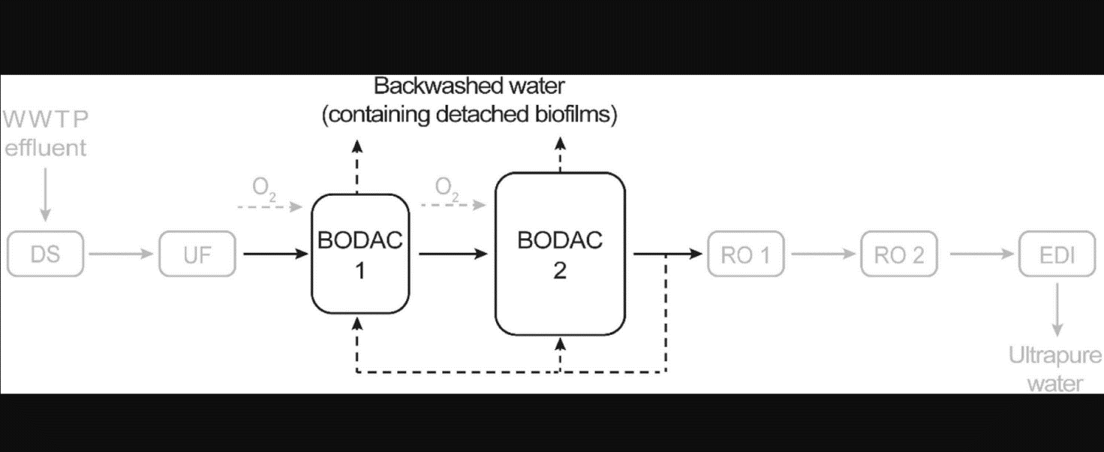

Figure 7 Schematic overview of the UPW production with BODAC, at the UPW factory in Emmen, the Netherlands

In this setup, BODAC purifies the water twice. The backwashed water, containing detached biofilms, is drained to remove the accumulation of solids and inactive biomass on the BODAC granules' surface. The purpose of backwashing is to prevent bio-fouling, which is usually inevitable, by dethatching the biofilm from the granules. This is conducted by air scouring; this creates agitation and a subsequent water flush from the BODAC 2 effluent. Oxygen is added to stimulate the bio-regeneration which will improve the adsorption abilities of the BODAC granules. After that, Reverse Osmosis membranes (RO 1 and RO 2) purify the water even further. Since BODAC could remove the foulants before the RO filters did, the RO filters were able to operate for 11 years without major fouling issues occurring. Not only did BODAC filters remove organic micropollutants for 99% during those 11 years, they did not need (ex-situ) chemical or terminal regeneration or carbon replacements in that same time period. This greatly exceeds the extent of the service life of typical carbon, which is 6 months to 5 years depending on the organic loading rate. Due to this result, BODAC filters have proven to have the potential to further treat secondary wastewater and effluent and be a sustainable method of water purification. The setup ends with Electrodeionization (EDI), continuing to produce Ultrapure water. This ultrapure water currently just has industrial purposes (e.g.) steam injection in an oil extraction process. [2], [22]

## Process performance of BODAC-filters

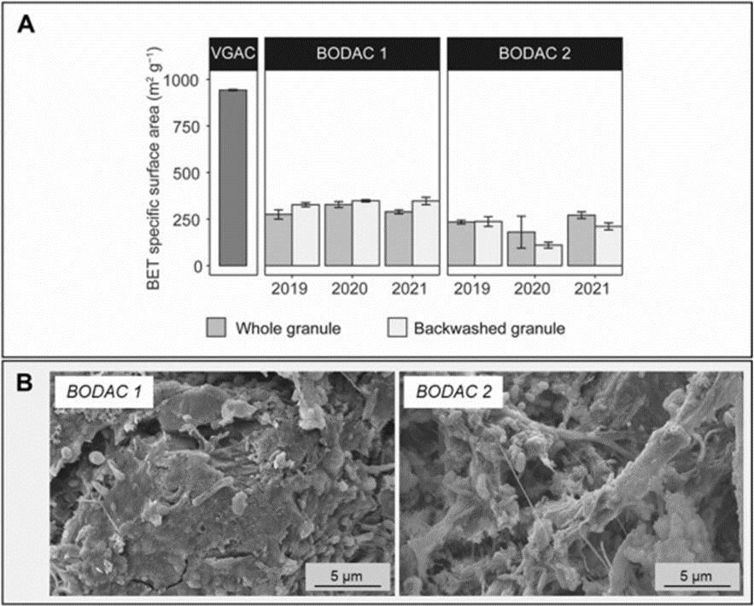A research team, consisting of Olga Bernadet, H. Pieter J. van Veelen, Gert Jan Willem Euverink, Maria Cristina Gagliano, and Amanda Larasati, the latter has been involved in this particular research as well, investigated the performances of BODAC filters. They focused on the physical and chemical characteristics of the granules, the biofilm characterization, and the capability of BODAC to remove organics, nutrients, and 13 different OMPs (Organic Micro Pollutant) from wastewater secondary effluent. They aimed to holistically evaluate this full-scale scenario. This study was the first to present a multidisciplinary and comprehensive insight into the BODAC filters, laying the foundation for a deeper understanding of BODACs' possible application as an innovative water treatment approach and a stable long-term operation. [2] In their study, two BODAC samples were used. BODAC 1, which comprises an influent of ultra-filtration permeate whereas BODAC 2 comprises the effluent of BODAC 1. The empty bed contact time of BODAC 1 and BODAC 2 are respectively 16 and 32 minutes. The filtration rate was 10 and 5 m/h. The samples were aerobically operated by regular dosing of pure oxygen; a higher oxygen concentration was applied after a higher ammonia concentration was detected in the influent. [2] Over 11 years the granule's surface was reduced by 70% compared to Virgin Granular Activated Carbon (VGAC). As can be seen in Figure 8. This indicates that there was less surface area available in aged granules over time, this corresponded to a complex surface morphology with biofilms, cells, and inorganic deposits. Which, however, did not change after backwashing. In this referenced study backwashing had a minor positive influence on Brunauer-Emmet-Teller-specific surface area (BETSSA) on BODAC 1, which can too be stated from Figure 8. Nevertheless, backwashing was found to be unable to restore BETSSA to a level comparable to VGAC, as can be seen in Figure 8 [2] Backwashing 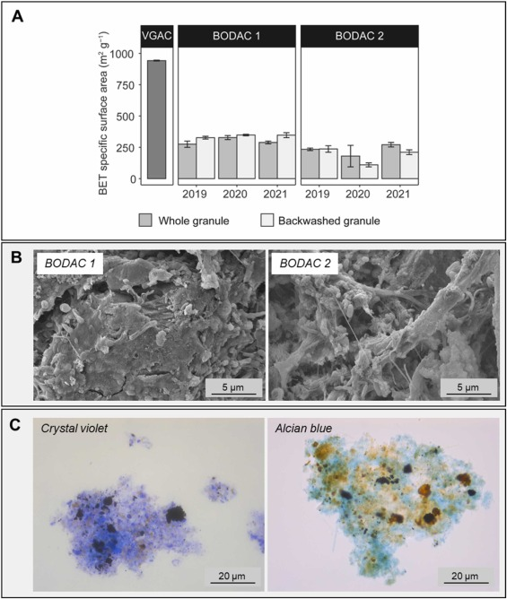did lead to a significantly lower removal of organic compounds in BODAC 1, however, the total removal after being treated with BODAC 1 and 2 remained the same. Whole granule samples were obtained before and after backwashing from the top of the BODAC filters. The surface characteristics of BODAC 1 and BODAC 2 were investigated using SEM (Scanning electron microscopy) analysis, as can be observed by looking at Figure 9. Thick biofilms and different cells were visible on BODAC 1 and 2, even after backwashing. For a graphical comparison with VGAC, Figure 4 can be looked at. EDX (Energy Dispersive X-ray) analysis showed that Ca and Fe accumulated a little on the surface of the whole granule samples and backwashed granules samples. Mn was found to accumulate the most. This can be stated by looking at 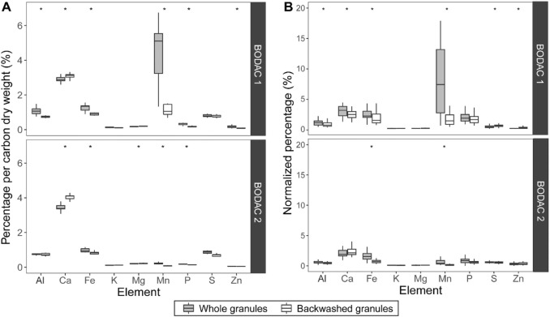Figure 10. [2]

Figure 8, difference in surface area over time

Figure 9 BODAC 1 and BODAC 2 surface characteristics using SEM analysis

Figure 10 Accumulation of elements in % on BODAC 1 and 2 during 2 years of sampling. (A) dry weight percentage, (B) EDX analysis of the granules surface [58]

The organic content of the BODAC filter influent consisted of soluble molecules, mainly proteins. During the two years of research 10 – 15% of the organics, again mainly proteins were removed by BODAC 1 and 2. BAC filters were reported to perform better at removing these proteins compared to Granulated Activated Carbon (GAC), this is because biodegradation occurred in BODAC. BODAC filters were also tested for the possibility of removing 13 OMPs of interest. As it turned out the filters consistently removed OMPs such as hydrochlorothiazide, metoprolol, atenolol, sotalol, lidocaine, and trimethoprim by at least 70 % in BODAC 1 and 2 in more of the six points measured. BODAC 1 removed more than half of the total removal percentage, turning BODAC 2 into a polishing filter that still contributes to the overall removal of OMPs. The reduction of the concentrations of the OMPs were tested in different temperatures and at different oxygen doses, causing different efficiencies to be observed. A higher dose of oxygen turned out to increase the efficiency. [2] The presence of inorganic deposits and microorganisms caused the surface of the carbon to be more heterogeneous. That is why the removal of OMPs on the BODAC granules are difficult to possibly predict, especially with the hydrophobicity and charge of the OMPs. [2]

Treatment with BODAC 1 and 2 did not affect the total amount of nitrogen in the influent. However, all of NH4+ and NO2- were found to be completely converted to NO3 -. This showed that in two years, complete nitrification occurred. Therefore, it could be concluded that oxidizable nitrogen species were present in the biofilm of BODAC. Further research showed that the oxygen dosing was beneficial for the mentioned nitrification process. What was notable as well, is the fact that further nitrification took place in BODAC 2. Moreover, Mn was consistently and completely (>99%), regardless of the concentration of season, removed from the influent after treatment with BODAC filters. Furthermore, the inorganics Ca, Fe and Mn along with P and Al accumulated on the surface and in the pores of the granules, as can be concluded from Figure 10 [2], [22] Pore clogging did not occur in BODAC, and BODAC was able to ensure consistent performance. This may be because of the severe reduction of the Mn presence since that causes irreversible fouling in membranes and pore-clogging. [2] This referred study carried out microbial community analysis to determine possible microbial protagonists in the granules biofilm catalyzing the nitrification and Mn (II) oxidation processes. However, part of the microbial community remained unclassified. In BODAC 1 the dominant nitrification catalyzing genus was *Nitrospira*, a nitrite-oxidizing bacteria that are the main drivers of NO2- oxidation. In BODAC 2, concerning the protagonist groups, the microbes turned out to be members of the *Nitrosomonadaceae* family. They converted NH4+ to NO2- after that, the family of *Nitrospira* converted the NO2- again to NO3-. In BODAC 1 the *Nitrosomonas* were present to conduct the ammonia-oxidizing function but, in fewer numbers (2,8 % relative abundance in BODAC 1). [2] Numerous microbial communities on BODAC 1 and 2 turned out to be related to Mn oxidizers. This being *Pedomircobium* and *Hyphomicrobium*; bacteria that speed up the rate of Mn-oxidation to five times compared to non-biological Mn-oxidation. Other microbial groups detected and probably connected to Mn-oxidation are; S*tenotrophobacter, Terrimonas, Burkholderiaceae* and *Gammaproteobacteria PLTA13*, and bacteria that need Mn for growing purposes such as *Bradyrhizobium.* Among the groups directly involved in the degradation of the OMPs there were members of the *Rhizobiales* (e.g.) *Bradyrhizobium* and *Hyphomicrobium* families. These can degrade aromatic compounds and contribute to bioremediation of contaminated soil. [2]

In the first 200 days of research, the adsorption appeared to be the main removal mechanism. After that, biodegradation was suggested to be the dominant removal mechanism. This is in line with the three phases of organic removal when using BAC filters; (phase 1) adsorption, (phase 2) transition from adsorption to biodegradation and (phase 3) stationary phase. In the last phase, biodegradation prevails with a removal range of 10-40% of all organics. Due to this mechanism, BODAC filters could actively remove OMPs for 11 years. Due to the removal of biofouling precursors after reaching the stationary phase, no fouling issues were reported. [2] BODAC filters, compared to mere BAC filters, have a service life of 2 to 3 times longer, while still complying with the same standards.

The second study on BODAC, which aimed to identify the primary fouling precursors and their removal, showed that the amount of nitrogen species in the BODAC 1 and BODAC 2 effluent were alike. Indicating that the kind of use of the BODAC filter does not influence the number of microbial species in the effluent. In this study, small sugars, small organic acids, alcohols, aldehydes, ketones, amino sugars, and amino acids were mentioned to contribute to microbial growth. Possibly causing biofouling. [22] The purpose of the referred study has been to introduce a pre-treatment, along with low-pressure Ultra Filtration, which would be capable of improving the removal of organic matter and foulants. Which would then reduce the usage of reverse osmosis filters in the line of producing ultra-pure water. Since over 99% Mn oxidation and complete nitrification were consistently achieved due to the present microbial families. This study also found that, due to the removal of Mn, fouling no longer occured, and the production of Ultra-Pure water was able to take place. The enzymatic activity of the nitrifying bacteria could mean that said bacteria significantly contribute to the co-metabolism of the OMPs. The removal of OMPs with the use of BODAC is a huge added value to the production of Ultra-Pure water. While too overcoming the regular issues with the accumulation limit of OMPs after rejection by the RO units in the permeate.

The novelty of the present research is the combination of in-water-sustaining herbicides and the filtration process of BODAC. These two were combined to gain insight into this novel manner of water detoxification and to inquire if there is a way to remove the herbicides from polluted water. BODAC filters have a lot of potential for future use since they are an eco-friendly and sustainable way of water purification.

# Method and materials

The laboratory test was conducted to distinguish the herbicide removal from the solution over time, between the biodegrading abilities of the biofilm and the adsorption and biodegration performed by the BODAC granules. This, to shed light on whether BODAC is able to remove pesticides from water, and to gain further insights into the abilities of BODAC. In this laboratory experiment, 2,4-D, MCPP and Atrazine were put together with the BODAC biofilm and BODAC granules. By conducting this experiment, the removal of the herbicides was followed over time.

## Materials

* 1 bottle (1L)
* 4 flasks (with cap) 50 mL
* 10 mg 2,4D
* 10 mg Atrazine
* 10 mg Mecoprop
* Balance
* unrecyclable spoons
* 0,2 g BODAC
* 2,0 g (wet weight) biofilm
* Centrifuge (an Eppendorf 5424 was used)
* 1 Liter pure H2O
* 6 bottles with cap 100 mL
* Balance
* Pipet, unrecyclable 50 mL
* micropipette
* 6x 2 ml Eppendorf flasks
* Liquid chromatography/ mass spectrometry machine (LC/MS)
* standard pH solutions
* 6x 1 ml bottles (with cap)
* pH measure machine

## Method of experimenting

To prepare the micropollutant and carbon samples, a stock solution is 10 mg/L of mixture 2,4-D, MPCC and Atrazine was made. The objected solution is 20µg/L. First, label the 1L bottle: 24D ATZ MCPP 20µg/L and the 4 50 mL flasks (with cap): Carbon 1, Carbon 2, Biofilm 1, Biofilm 2. To produce the '24D ATZ MCPP 20µg/L'; add 10 mg of each herbicide in the 1 L bottle, thus 30 mg in total is contained and add 1liter pure H2O. Label it as 'concentrated herbicide'. Since 20µg is quite impossible to measure, this concentration will be diluted. Before preparing the actual solution (20µg/L), one should know that a concentration of 20µg/L is the same as the concentration of 10µg/0,5L. To achieve a solution with a concentration of 20 µg/L, add 1 mL of the solution 10mg/L in 500 ml H2O. This amount was calculated using the equation C1V1 = C2V2. To prepare the BODAC, add more than 0,2 gram each of BODAC in the flasks labeled 'Carbon 1' and 'Carbon 2' (with cap, 50 mL) with pure water until the bottle is filled to 50 mL. To prepare the biofilm samples, add (wet weight 2,0 g) biofilm (segregated from carbon) in both flasks labeled 'Biofilm 1' and 'Biofilm 2' (with cap, 50 mL) with pure water until the bottle is filled to 50 mL. Centrifuge the flasks. To make the solutions, label 6 bottles with the next labels: Control (micro pollutant replicate) 1, Control (micro pollutant replicate) 2, Carbon (replicate) 1, Carbon (replicate) 2, Biofilm (replicate) 1, Biofilm (replicate) 2. After centrifuging the flasks, get rid of the water in the Carbon sample. Poor it into the sink. Make sure not to pour the BODAC into the sink as well. After that, weigh 0,20 grams of Carbon sample on a balance and put it into each of the bottles labeled Carbon 1 and Carbon 2, use an unrecyclable spoon. Get rid of the water in both of the Biofilm samples. Poor it into the sink. Make sure not to pour the Biofilm into the sink as well. Put all of the 2,0 g (wet weight) biofilm from Biofilm sample 1 into the Biofilm 1 labeled bottle. Replicate these actions for Biofilm sample 2. Then, add, with a pipet (50 ml), 50 ml 24D ATZ MCPP 20µg/L to each Control 1 and Control 2. To make the actual solutions with the micropollutant. Add 50 ml of 24D ATZ MCPP 20µg/L with a pipet (50 mL) in each of the Carbon 1, Carbon 2, Biofilm 1 and Biofilm 2 bottles. In this process, clean the used spoons and used biofilm flasks (of the concerning substance) and put this into the concerning bottle. After that, put the 6 bottles in the shaker for 30 min at 20 ⁰C and 120 RPM in a dark condition. In the meantime, label the 2 ml flasks with the next labels: Control 1, Control 2, Carbon 1, Carbon 2, Biofilm 1, and Biofilm 2. After that, take the samples periodically at precisely, 30 min, 2h, 24h, 1 week and 2 weeks. When taking the samples, take the following actions. First, test the specific pipet (installed at 1 mL) with water. Put 1 mL on a dish on a balance and check if the value is correct. Then, put 2 times 1 mL into the corresponding Eppendorf tube, and use a new pipet with each bottle. Proceed to centrifuge the 6 Eppendorf tubes at 10 000 RPM for 5 min. Label in the meantime (1 mL) bottles with the next labels: (30m/2h/24h/1w/2w) (1-8). There are 6 samples at every point measured, when measuring for the first time, make sure there are two more blanks. After centrifuging, pipet 1 mL of each bottle in a 1 mL bottle. For measuring, put the samples in the LC/MS machine. To check the 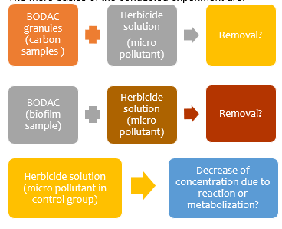resemblance between the 100 mL bottles, measure the pH. Operate by first checking the equipment with three standard solutions. Make sure to clean the machine after every sample.

The mere basics of the conducted experiment are shown in Figure 11. The removal of herbicide can be indicated by the amount of herbicide in the Biofilm and/or Carbon sample in contrary to the Control sample. A relatively lower, when compared to the control group, amount of herbicide in the Carbon and/or Biofilm sample indicates a high removal of the herbicide.

Figure 11 Basics of conducted experiment

# Results and Result Analysis

The purpose of this study was to follow the removal of herbicides over time. This is what is shown in the next graphs. The conducted laboratory test was meant to distinguish the difference between biodegradation and adsorption by the BODAC granules.

## pH measurements

To get an indication of the resemblance of the different samples, the pH was measured. Table 1 shows the measured pH values. Since the pH values of the control samples 1 and 2, in Table 1, are the same, it can be concluded that the substances are resemblant. What can be noticed here is the significant difference between the Biofilm and the Carbon (BODAC) samples, this is due to the even higher (7-8) PH value of active carbon.

Table 1, pH values samples

## Concentration 2,4-D over time

The decreased values of 2,4-D in the solution at the certain points in time are given in Figure 12. The BODAC 2 sample at 24h was lost due to LC-MS machine failure, this applies to the other OMPs as well. At 24h, the resulting Carbon sample does a slightly better job at removing 2,4-D from the solution than biofilm samples do. However, after 168 hours the Biofilm sample performs significantly better, removing 53,2% of 2,4-D in contrary to the 33,4% that the Carbon film can remove. The control groups are stable, meaning the herbicides were not hydrolyzed and no metabolization occurred. At 336 h the Biofilm samples are able to extract 87,6% 2,4-D, in contrast to the 63,4 % the Carbon sample can remove. In the end, the Biofilm turns out to be quite proficient at the removal of 2,4-D. The gap between the duplicates indicates the average value and error due to the difference in weight, pipetting error, and low concentration. The shown error bars are a vertical 5,0% deviation in every figure.

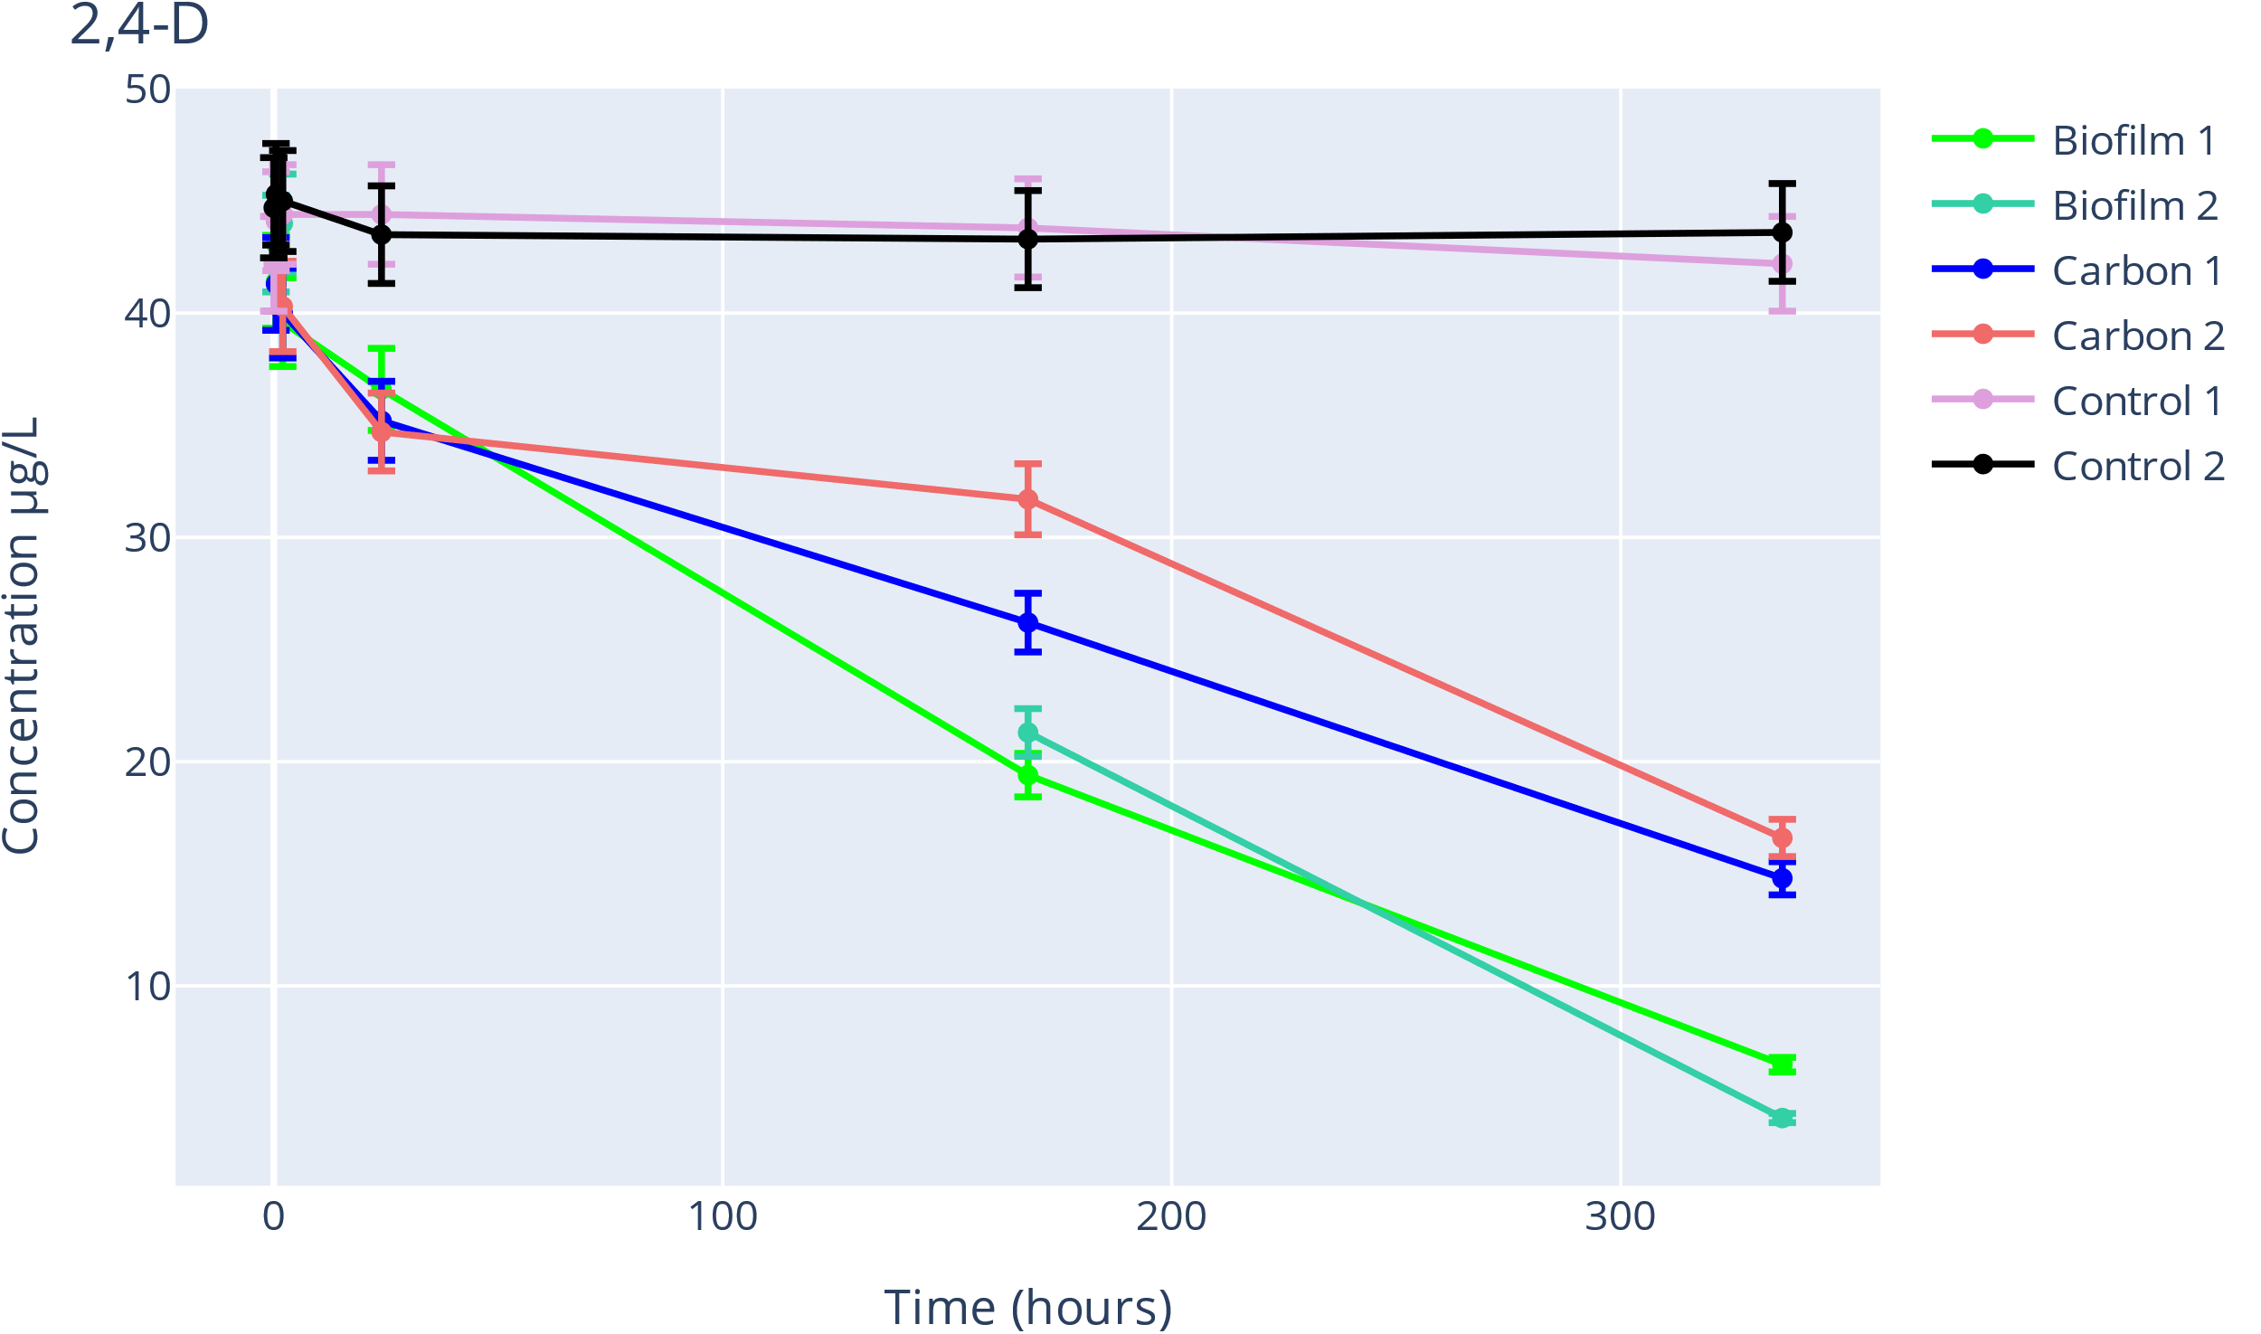

Figure 12 Concentration 2,4-D over time

## Concentration Atrazine over time

The concentrations of Atrazine over time are shown in Figure 13, the concentrations of the control groups stay stable, meaning that again no hydrolyzation and no metabolization occurred. The Carbon samples extract noticeably more Atrazine than the Biofilm samples do. Meaning that the large amount of extraction is mostly due to the activated carbon and not the biofilm on the carbon granules. After 24 hours 56,2% of Atrazine was extracted from the Carbon granule analyte. This is more than half of what is extracted at 336 hours: being 81,7%. The Biofilm performance at 168 h was 3,7 %. The passiveness of the biofilm samples may be due to Atrazine's ability to destroy microbial communities, but that contradicts the adsorption of 2,4-D. Therefore, the biofilm of BODAC does not get killed off by Atrazine, the biofilm just cannot absorb atrazine. This possible effect of Atrazine on microbial communities has been mentioned in the subsection.

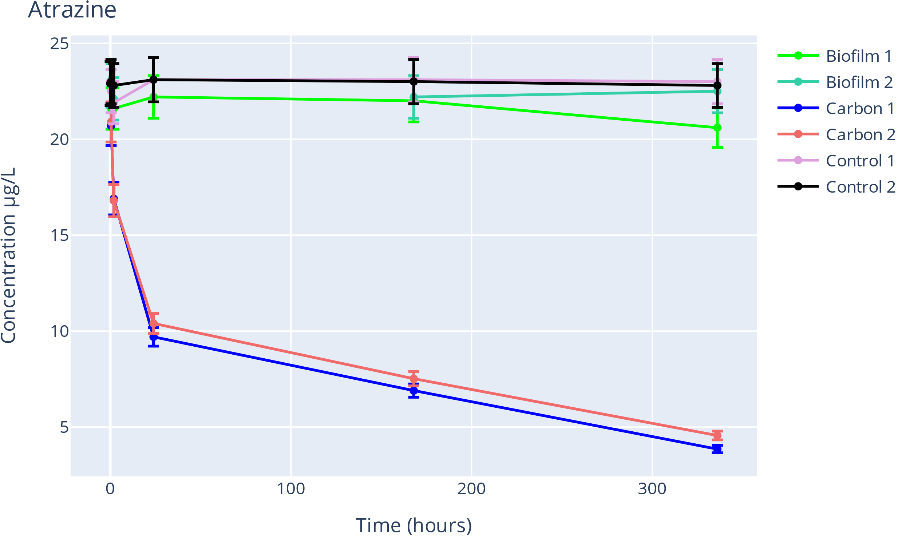

Figure 13 concentration Atrazine over time

## Concentration MCPP over time

In Figure 14, similar to Atrazine the extraction of MCPP in the carbon samples happens relatively fast in the beginning and then slows down. On the contrary to the removal of Atrazine, Mecoprop does get removed in the biofilm analyte. Actually, in the end, the biofilm removed more MCPP than the Carbon samples did. At 24 hours, the Carbon analyte has a 39,8% removal efficiency while the Biofilm has a 4,6 % removal efficiency. However, at 336 h the Carbon analyte has a removal efficiency of 65,0% and the Biofilm analyte has now a 70,0 % removal efficiency. This may be because of the larger reaction surface of the Biofilm compared to BODAC. This faster reduction of the MCPP concentration may be due to the fact that, at first the activated carbon sets in and then the biofilm 'activates'. Resulting into the primary removal being done by the activated carbon in the first 24 hours. The concentration of the control group stays the same, meaning that there is again no metabolization. The Carbon and the Biofilm samples perform almost equally at 336 h (65 to 70), meaning that the biofilm is actively removing Mecoprop. In the subsection, the impact on the microbial communities due to MCPP was mentioned. Since removal in the biofilm samples still occurs, this effect is zero to minimal. Overall, optimal removal of the three concerning herbicides takes time. The results show that the removal is a continuous process, but that optimal removal lies often within a shorter time period than 336, considering the accelerated adsorption within the first 24 hours in all three cases. This is in line with the phases mentioned earlier. This being (phase 1) adsorption as a result of the activated carbon, (phase 2) transition from adsorption to biodegradation and (phase 3), the stationary phase in which 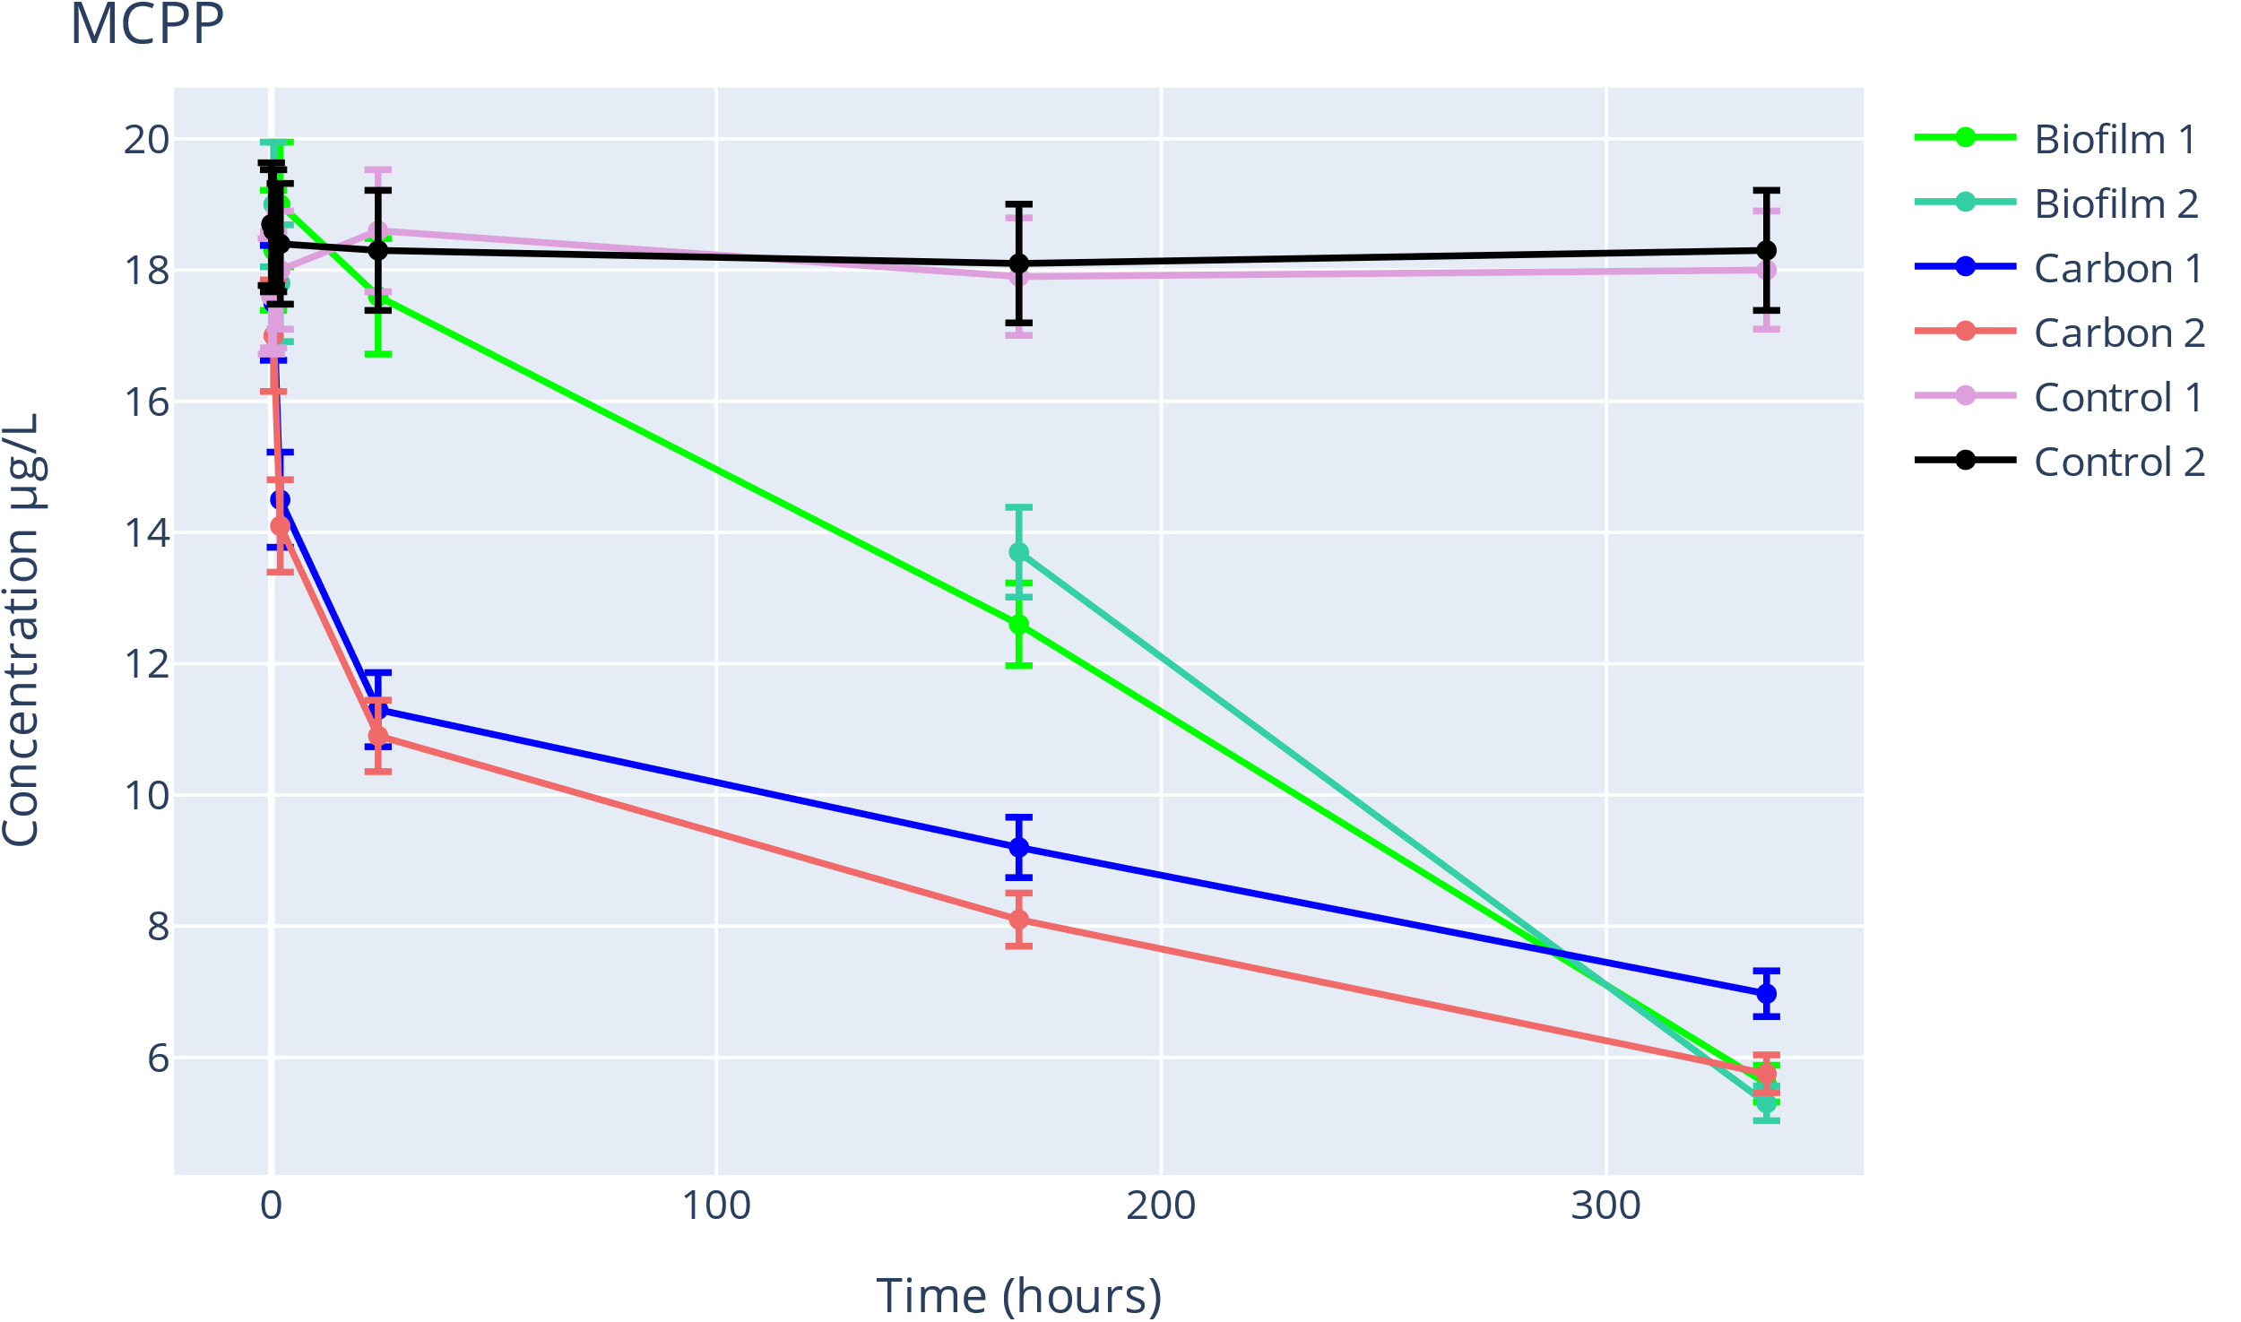biodegradation prevails.

Figure 14 Concentration Mecoprop over time

# Conclusion and discussion

In conclusion, the biofilm of BODAC may be ineffective when dealing with substances comparable to Atrazine. This does not mean BODAC is entirely ineffective in those cases since active carbon can remove these substances quite well on its own. The attack on the microbial community due to Atrazine and MCPP application is not seen in this research, since the biofilm was still effective in another case in the same solution. However, a higher level of effectiveness in biodegrading might have been obtained when Atrazine was present in the herbicide solution. This paper shows that BODAC turns out to be an optimal process since the active carbon removes relatively much in the first 24 h, after that the biofilm kicks in and assists with the removal of the OMPs; in line with the earlier referred study. In virtue of this effective removal of these three herbicides, BODAC has numerous future possibilities. For examples being: effective wastewater treatment and clean drinking water production. This study further proves that BODAC succeeds in removing OMPs from water, therefore, the possibilities of BODAC must be further looked into.

Elements that could have been done differently are: using virgin BAC granules to compare the removal efficiency. This way the active carbon part of BODAC could be looked into, however, that has been partially done in the study on BODAC which was referred to earlier. There may be negative effects of the biofilm on the activated carbon such as pore clogging. However, this is not very probable since the referred study on BODAC did not show any pore-clogging or fouling issues. Since the number of bacteria in the BODAC substance is unknown, it is complex to measure, it is very probable that the biofilm concentration in the Carbon analyte is lower than the concentration of the biofilm sample. That may be the reason the biofilm sample performed better at removing MCPP and 2,4-D. By looking at the pH values it can however be determined that the biofilm on the carbon has about the same pH value as the biofilm sample because the average pH of biofilm, carbon granules, and biofilm translate to the pH value of the carbon samples. This may need additional evaluation. Another point of discussion might be that the biofilm is heterogeneous and that is why the composition of the biofilm may be different with different samples.

Desorption of BODAC granules is possible but only if the substance is shaken with immense force, this may occur, since that did not happen. The chance of this influencing this research is quite small. There still is a knowledge gap regarding the transition from one main-removal-substance to another, this is mainly due to the low quantity of research on this subject. This study may have cleared some things up such as the time period and the point of transition. However, since the removal of just three OMPs were looked into this does not mean this happens with every substance and can therefore not be determined. In this study, the reaction between herbicides was not investigated. However, since the concentration of herbicides in the control group did not change, it can be determined that no reaction occurred. The same is true for metabolization. The lack of reaction between the research will not happen every time and should therefore be investigated. Oxygen was not added during this experiment indicating that the biofilm possibly may have been deteriorating throughout the experiment. This may too mean that when more oxygen was added during the conduction of the experiment the biofilm may have even removed more of the OMPs, complementary to the results of the previously referred study. One sample got lost while conducting the experiment, the Biofilm 2 analyte at 24h, due to machine malfunction. This may cause inaccuracy in the results. However, since the Biofilm 1 sample at 24 hours did not get lost, this effect is relatively small. A higher number of samples would however have caused a higher accuracy. Since there were already two samples a different result is not to be expected, additional samples would only increase the reliability. In this paper, a high concentration of pesticides was used to easily distinguish the biodegradation and adsorption by the BODAC granules. In reality, the Carbon and Biofilm could remove these OMPs at a lower concentration in a shorter time. However, due to practicality, a higher concentration of the pesticides was taken.

The removal repeatedly occurred in the same climate; therefore, this is not a factor of unreliability. Since the experiment was conducted by humans in a lab, a few minutes away from the shaker, inaccuracy may have occurred. However, since this is such a minute amount this will not have any effect on the results. The shaker was closed to light and a constant pressure and temperature were applied. The samples were put in the freezer for a short amount of time between the shaker and the measuring machine this is because further reactions were put on hold. Nevertheless, since this was not 0 Kelvin, reactions still may have occurred. Yet not to an amount that the results have been affected much. This is the same reason for the significantly of the points in time, for example, 24 instead of 24,0.

The used machines have a deviation, this is such a small amount that this can be mostly ignored. Since there are no Mn or N groups present in 2,4-D and MCPP it can be concluded that the bacteria in the biofilm are not merely able to degrade these substances. What is odd, is that Atrazine, the herbicide with the N groups, does not get affected by the biofilm. This is related to the biodegrability of Atrazine. A great amount of further research possibilities come from this study. To get that all in line: What are the further differences between BODAC and pure active carbon (BAC)? What are the details of the 'defect' or 'failed work' of the biofilm on Atrazine? Furthermore, does BODAC work on the even more hazardous metabolites of these herbicides?

The usage of BODAC could be realized in water storages that are contaminated with herbicides. To do this one could use the setup described in figure 7 or research an optimal setup for a different influent. Since the removal of the OMP’s improves over time, an increased contact time would improve the pureness of the water effluent. A lager amount of BODAC and a high dosed oxygen concentration increases the efficiency and therefore shortens the time before the same level of purification is reached when purifying the same volume of influent.

Due to the promising characteristics of BODAC, such as its sustainability and the wide scalar of OMP’s that can be removed to a reasonable amount, the BODAC filters can be considered future proof and may help us solve a major water challenge.

# Credit authorship contribution statement

Amanda Larasati: Methodology, Conducting, Supervision. Zwiers: Supervision. Yoline Maria Claire Ruiter: Methodology, Conceptualization, Validation, Formal analysis, Investigation, Conducting, Writing – original draft, Writing – review & editing

# Declaration of Competing Interest

The author (s) declare that they have no known competing financial interest or personal relationships that could have appeared to influence the work reported in this paper



# Appendix

## Sources

The sources are shown [x] likewise in this paper

1. Pérez-Portuondo, I., Serrat-Díaz, M., Pérez-Silva, R.M. and Ábalos-Rodríguez, A. (2021) Phytotoxic Effects of 4-Chlorophenol and 2,4-Dichlorophenol in the Germination of Seeds of Phaseolus vulgaris and Zea mayz. American Journal of Plant Sciences, 12, 614-623. <https://doi.org/10.4236/ajps.2021.124041>
2. Bernadet, O., Larasati, A., Van Veelen, H. P. J., Euverink, G., & Gagliano, M. C. (2023). Biological oxygen-dosed activated carbon (BODAC) filters – a bioprocess for ultrapure water production removing organics, nutrients and micropollutants. Journal of Hazardous Materials, 131882. <https://doi.org/10.1016/j.jhazmat.2023.131882>
3. Chemical fact sheets: Atrazine. (z.d.). https://www.who.int/publications/m/item/chemical-fact-sheets--atrazine
4. Ju, Z., Liu, S., Xu, Y., & Li, K. (2019). Combined toxicity of 2,4-Dichlorophenoxyacetic acid and its metabolites 2,4-Dichlorophenol (2,4-DCP) on two nontarget organisms. ACS omega, 4(1), 1669–1677. <https://doi.org/10.1021/acsomega.8b02282>
5. Guo, W., Wang, W., Zhang, W., Li, W., Wang, Y., Zhang, S., Chang, J., Ye, Q., & Gan, J. (2021). Mechanisms of the enantioselective effects of phenoxyalkanoic acid herbicides DCPP and MCPP. Science of The Total Environment, 788, 147735 <https://doi.org/10.1016/j.jhazmat.2023.131882>
6. Herbicides | US EPA. (2023, 2 maart). US EPA. <https://www.epa.gov/caddis-vol2/herbicides>
7. Chemical fact sheets: Mecoprop. (z.d.). https://www.who.int/publications/m/item/chemical-fact-sheets--mecoprop
8. Casas, M. E., Nielsen, T. K., Kot, W., Hansen, L. H., Johansen, A., & Bester, K. (2017). Degradation of mecoprop in polluted landfill leachate and waste water in a moving bed biofilm reactor. Water Research, 121, 213–220. <https://doi.org/10.1016/j.watres.2017.05.031>
9. W. Meng, D. Wang, S. Li, Y. Wang, C. Jiang, H. Tian and M. Ji. (2022) Residual Characteristics of Atrazine and Its Metabolites in the Liaoning Province of China. Chromatography-Mass Spectrometry Technology Research. <https://www.mdpi.com/2297-8739/9/12/397/html>
10. University of Hertfordshire. (z.d.-b). 6-deisopropyl atrazine (Ref: G-28279). <https://sitem.herts.ac.uk/aeru/ppdb/en/Reports/961.htm#none>
11. Henn, C., Monteiro, D. A., Boscolo, M., Da Silva, R., & Gomes, E. (2020). Biodegradation of atrazine and ligninolytic enzyme production by basidiomycete strains. BMC Microbiology, 20(1). <https://doi.org/10.1186/s12866-020-01950-0>
12. Ueda, R. M. R., De Souza, V. M., Magalhães, L. R., Chagas, P. H. N., Veras, A. S. C., Teixeira, G. R., & Nai, G. A. (2021). Neurotoxicity associated with chronic exposure to dichlorophenoxyacetic acid (2,4-D) – a simulation of environmental exposure in adult rats. Journal of Environmental Science and Health Part B-pesticides Food Contaminants and Agricultural Wastes, 56(8), 695–705. https://doi.org/10.1080/03601234.2021.1939622
13. 2,4-DICHLOROPHENOXYACETIC ACID. (2018). In WHO IARC (Nr. mono113-03). monographs.iarc.who.int. Geraadpleegd op 12 december 2023, van <https://monographs.iarc.who.int/wp-content/uploads/2018/07/mono113-03.pdf>
14. IARC (z.d.) 2,4-dichlorophenoxyacetic acid https://monographs.iarc.who.int/wp-content/uploads/2018/07/mono113-03.pdf
15. Search Active substances, safeners and synergists. (z.d.). European Commision. Geraadpleegd op 12 december 2023, van <https://ec.europa.eu/food/plant/pesticides/eu-pesticides-database/start/screen/active-substances>
16. Yeary, R. A. (2006). Miscellaneous Herbicides, Fungicides, and Nematocides. In CHAPTER 6 - Gas chromatographic enantioseparation of chiral pollutants—techniques and results. <https://doi.org/10.1016/b0-72-160639-3/50050-2>
17. Stradtman, S., & Freeman, J. L. (2021). Mechanisms of neurotoxicity associated with exposure to the herbicide Atrazine. Toxics, 9(9), 207. <https://doi.org/10.3390/toxics9090207>
18. Atrazine: the most common toxic contaminant in our water - Dr. Axe. (2019, 5 september). Dr. Axe. https://draxe.com/health/atrazine/
19. Graymore, M., Stagnitti, F., & Allinson, G. (2001). Impacts of atrazine in aquatic ecosystems. Environment International, 26(7–8), 483–495. https://doi.org/10.1016/s0160-4120(01)00031-9
20. Atlas Bestrijdingsmiddelen in oppervlaktewater. (z.d.). <https://www.bestrijdingsmiddelenatlas.nl/atlas/10/1>
21. GDWQ, fourth edition incorporating the first and second addendum.(March 2022). Chemical fact sheets: Mecoprop. WHO. https://cdn.who.int/media/docs/default-source/wash-documents/water-safety-and-quality/chemical-fact-sheets-2022/mecoprop-fact-sheet-2022.pdf?sfvrsn=24a8279d_2&download=true
22. Pinela, S. R., Larasati, A., Meulepas, R. J., Gagliano, M. C., Kleerebezem, R., Brüning, H., & Rijnaarts, H. (2024). Ultrafiltration (UF) and biological oxygen-dosed activated carbon (BODAC) filtration to prevent fouling of reversed osmosis (RO) membranes: a Mass Balance analysis. Journal of Water Process Engineering, 57, 104648. <https://doi.org/10.1016/j.jwpe.2023.104648>
23. Lewis, K.A., Tzilivakis, J., Warner, D. and Green, A. (2016) An international database for pesticide risk assessments and management. Human and Ecological Risk Assessment: An International Journal, 22(4), 1050-1064. DOI: 10.1080/10807039.2015.1133242
24. Agents classified by the IARC Monographs, Volumes 1–134 – IARC Monographs on the Identification of Carcinogenic Hazards to Humans. (z.d.). https://monographs.iarc.who.int/agents-classified-by-the-iarc/
25. Lewis, K.A., Tzilivakis, J., Warner, D. and Green, A. (2016) An international database for pesticide risk assessments and management. Human and Ecological Risk Assessment: An International Journal, 22(4), 1050-1064. DOI: 10.1080/10807039.2015.1133242
26. De Azevedo Mello, F., Silva, B. B. M., Barreiro, E. B. V., Franco, I. B., Nogueira, I. M., Chagas, P. H. N., Parizi, J. L. S., Pereira, D. R., Rossi, R., & Nai, G. A. (2020). Evaluation of genotoxicity after acute and chronic exposure to 2,4-dichlorophenoxyacetic acid herbicide (2,4-D) in rodents using machine learning algorithms. Journal of Toxicological Sciences, 45(12), 737–750. <https://doi.org/10.2131/jts.45.737>
27. Besplug, J., Filkowski, J., Burke, P., Kovalchuk, I., & Kovalchuk, O. (2004). Atrazine induces homologous recombination but not point mutation in the transgenic Plant-Based biomonitoring assay. Archives of Environmental Contamination and Toxicology, 46(3). <https://doi.org/10.1007/s00244-003-3075-9>
28. Benli, A. Ç. K., Sarikaya, R., Sepici-Dincel, A., Selvi, M., Sahin, D., & Erkoç, F. (2007). Investigation of acute toxicity of (2,4-dichlorophenoxy)acetic acid (2,4-D) herbicide on crayfish (Astacus leptodactylus esch. 1823). Pesticide Biochemistry and Physiology, 88(3), 296–299. https://doi.org/10.1016/j.pestbp.2007.01.004
29. Erickson, B. E. (3BC, september 21). US EPA reapproves atrazine. c&en. Geraadpleegd op 22 juli 2023, van <https://cen.acs.org/environment/pesticides/US-EPA-reapproves-atrazine/98/web/2020/09>
30. PubChem. (z.d.). 2,4-Dichlorophenoxyacetic acid. PubChem. https://pubchem.ncbi.nlm.nih.gov/compound/1486
31. PubChem. (z.d.-b). Hazardous Substances Data Bank (HSDB) : 202. PubChem. <https://pubchem.ncbi.nlm.nih.gov/source/hsdb/202>
32. NITE - Chemical Management Field - GHS Information. (z.d.). <https://www.nite.go.jp/chem/english/ghs/16-mhlw-0110e.html>
33. NITE - Chemical Management Field - GHS Information. (z.d.-b). <https://www.nite.go.jp/chem/english/ghs/06-imcg-0133e.html>
34. Gov, N. O. O. R. A. R. U. (z.d.). 2,4-DICHLOROPHENOXYACETIC ACID | CAMEO Chemicals | NOAA. https://cameochemicals.noaa.gov/chemical/8523
35. Islam, F., Wang, J., Farooq, M., Khan, M. S., Xu, L., Zhu, J., Zhao, M., Muños, S., Li, Q. X., & Zhou, W. (2018). Potential impact of the herbicide 2,4-dichlorophenoxyacetic acid on human and ecosystems. Environment International, 111, 332–351. <https://doi.org/10.1016/j.envint.2017.10.020>
36. 2,4-D | US EPA. (2023, 21 februari). US EPA. <https://www.epa.gov/ingredients-used-pesticide-products/24-d>
37. EUR-Lex - 02008R1272-20221217 - EN - EUR-Lex. (z.d.). https://eur-lex.europa.eu/legal-content/EN/TXT/?uri=CELEX%3A02008R1272-20221217
38. Details. (z.d.). <https://hcis.safeworkaustralia.gov.au/HazardousChemical/Details?chemicalID=878>
39. Details. (z.d.-b). https://hcis.safeworkaustralia.gov.au/HazardousChemical/Details?chemicalID=2807
40. PubChem. (z.d.-c). Hazardous Substances Data Bank (HSDB) : 1738. PubChem. <https://pubchem.ncbi.nlm.nih.gov/source/hsdb/1738>
41. PubChem. (z.d.-d). NITE-CMC - PubChem Data Source. PubChem. <https://pubchem.ncbi.nlm.nih.gov/source/NITE-CMC>
42. Gómez-Ramírez, P., & García-Fernández, A. J. (2014). Mecoprop. In Elsevier eBooks (pp. 176–179). <https://doi.org/10.1016/b978-0-12-386454-3.01187-8>
43. PubChem. (z.d.-b). EU Pesticides Database - PubChem Data Source. PubChem. https://pubchem.ncbi.nlm.nih.gov/source/EU%20Pesticides%20Database
44. Environment Agency Science Group: Air, Land & Water (March 2004) Attenuation of mecoprop in the subsurface. Science Group report NC/03/12. <https://assets.publishing.service.gov.uk/government/uploads/system/uploads/attachment_data/file/290417/scho0304bhst-e-e.pdf>
45. PubChem. (z.d.-c). Hazardous Substances Data Bank (HSDB) : 413. PubChem. https://pubchem.ncbi.nlm.nih.gov/source/hsdb/413
46. Lazorko-Connon, S. L., & Achari, G. A. (2009). Atrazine: its occurrence and treatment in water. Environmental Reviews, 17(NA), 199–214. https://doi.org/10.1139/a09-009
47. Gov, N. O. O. R. A. R. U. (z.d.-b). ATRAZINE | CAMEO Chemicals | NOAA. <https://cameochemicals.noaa.gov/chemical/8300>
48. NITE - Chemical Management Field - GHS Information. (z.d.-c). <https://www.nite.go.jp/chem/english/ghs/06-imcg-0111e.html>
49. NITE - Chemical Management Field - GHS Information. (z.d.-d). <https://www.nite.go.jp/chem/english/ghs/10-mhlw-2007e.html>
50. PubChem. (z.d.-d). Hazardous Substances Data Bank (HSDB) : 413. PubChem. <https://pubchem.ncbi.nlm.nih.gov/source/hsdb/413>
51. Atrazine Fact Sheet. (z.d.). http://npic.orst.edu/factsheets/atrazine.html
52. University of Hertfordshire. (z.d.-c). Genotoxicity codes. <https://sitem.herts.ac.uk/aeru/ppdb/en/pop_genotoxic.htm>
53. Masood, M. I., Hauke, N. T., Nasim, M. J., Sarfraz, M., Naseem, M., & Schäfer, K. H. (2021). Neural stem cell-based in vitro bioassay for the assessment of neurotoxic potential of water samples. Journal of Environmental Sciences-china, 101, 72–86. <https://doi.org/10.1016/j.jes.2020.07.028>
54. International Agency for Research on Cancer. (1991). Atrazine. Occupational Exposures in Insecticide Application, and Some Pesticides - NCBI Bookshelf. <https://www.ncbi.nlm.nih.gov/books/NBK499610/>
55. Ministerie van Algemene Zaken. (2023, 17 augustus). Welke gewasbeschermingsmiddelen mag ik gebruiken? Rijksoverheid.nl. <https://www.rijksoverheid.nl/onderwerpen/bestrijdingsmiddelen/vraag-en-antwoord/welke-gewasbeschermingsmiddelen-mag-ik-gebruiken>
56. CTGB toelatingen. (z.d.). Toelatingen. https://toelatingen.ctgb.nl/nl/authorisations/1498
57. Salahshoor, Z., Ho, K., Hsu, S., Lin, C., & De Cortalezzi, M. M. F. (2022). Detection of atrazine and its metabolites by photonic molecularly imprinted polymers in aqueous solutions. Chemical Engineering Journal Advances, 12, 100368. <https://doi.org/10.1016/j.ceja.2022.100368>
58. University of Hertfordshire. (z.d.). MECoPrOP (Ref: RD 4593). <https://sitem.herts.ac.uk/aeru/ppdb/en/Reports/430.htm>
59. University of Hertfordshire. (z.d.-a). 2,4-D (Ref: L 208). <https://sitem.herts.ac.uk/aeru/ppdb/en/Reports/4.htm>
60. University of Hertfordshire. (z.d.). Atrazine (Ref: G 30027). <https://sitem.herts.ac.uk/aeru/ppdb/en/Reports/43.htm>
61. Saleh, I. A., Zouari, N., & Al-Ghouti, M. A. (2020). Removal of pesticides from water and wastewater: Chemical, physical and biological treatment approaches. Environmental Technology & Innovation, 19, 101026. https://doi.org/10.1016/j.eti.2020.101026

|  |  |  |  |
| --- | --- | --- | --- |
| Issue | 2,4-D | MCPP | Atrazine |
| Carcinogen | (IARC listed – 2B)  Possibly | (IARC listed – 2B)  Possible | (IARC listed – 3) Possible |
| Reproduction effects | V | X | Possible, NI |
| Respiratory tract irritant | V | V | V |
| Eye irritant | V | V | V |
| Skin irritant | Possible, NI | V | V |
| Skin sensitiser | Possible, NI | NI | Possible, NI |
| Endocrine disruptor | V | NI | V |
| Neurotoxicant (Neuron damage) | V | Possible, NI | Possible, NI |
| Genotoxic (DNA damage) | A3, B0, C0, D0, E3 | A3, B0, C0, D0, E1 | A3, B0, C0, D0, E3 |
| General health issues | >>1 | NI | >>2 |
| *GHS Hazard Statements* | H302, H312, H313, H316, H317, H318, H319, H320: H332, H334: H335, H336, H351, H36, H370,  H372, H373, H400, H402, H412 | H302, H317, H320, H333  H361, H371  H373, H400, H410 | H302, H317,  H320, H333,  H361, H371,  H373, H400, H410 |

## Hazards Statements

## The long-term human health concerns

MCPP and 2,4-D are chlorophenoxy herbicides, and have therefore been classified to the IARC group 2B (possibly carcinogenic). However, since this has not yet been scientifically able to prove, the water-quality guidelines are based on the other toxic effects. [23] [21] Atrazine has been IARC identified as 3; ‘Not classifiable as to its carcinogenicity to humans’. [24] Nonetheless, ATZ is still possible to be carcinogenic. Furthermore, Atrazine is sus-pected to cause reproduction effects. However, the current information is incomplete. 2,4-D does cause reproduction effects. All three herbicides are respiratory tract irritants, and therefore cause trouble breathing. They are in addition all eye irritants. MCPP and Atrazine are additionally skin irritants. The status of 2,4-D on harming skin is not yet identified. There is no information on the three herbicides being skin sensitizers and therefore no information on causing an allergic reaction if skin is ex-posed to the concerning pesticides. 2,4-D and Atrazine are both endocrine disruptors and cause interference with the hormonal system. 2,4-D is causes endocrine issues; there happen to be synergistic androgenic effects when 2,4-D is combined with testosterone. The endocrine issues caused by Atrazine are andro-gen inhibition, and a weak estrogenic effect [60] [25]. In addition, 2,4-D is a neurotoxicant. Research on rats has proven that 2,4-D, regardless on the route exposure, causes a deficit in neurobehavioral tests and a decreased thickness of the cerebral cortex, causing increased expression of the pro-apoptotic protein BAX. [12] Atrazine is associated with mechanisms of neurotoxicity. A study done to determinate the so called ‘Mechanisms of neurotoxicity associated with exposure to the herbicide Atrazine’ has shown that there is evidence of crosstalk; (unwanted) transfer of signals between two communication channels, that can be affected by atrazine exposure. This exposure causes widespread dysfunction and behavioral changes, even without any direct link to the hypothalamus. That is why the hypothetical mechanism of toxicity of atrazine endocrine disruption and neurotoxicity can be described as a web of pathways that are influenced through changes occurring in each path and their multiple feedback loops. [17] Furthermore, 2,4-D has the following genotoxicity code rating: negative chromosome aberration (A3), no data on DNA alteration (B0), no data on Gene Mutation (C0), no data on genome mutation (D0), negative unspecified genotoxicity type (E3). Nevertheless, study on rodents, using machine learning algorithms, has shown that 2,4-D does cause an in-crease in micronuclei and causes DNA damage in all exposed groups regardless of the exposure route and concentration. The extracted data showed that the exposed and non-exposed groups are easy to categorize due to the prominent difference between caused damage. Therefore, it could be determined that 2,4-D can cause genotoxic effects [26]. Atrazine has exactly the same genotoxicity code rating as 2,4-D. Although there have been years of research on the genotoxicity of atrazine, the current data available remains incomplete. Study has shown that it still remains relevant to investigate current low concentrations that are assumed to be safe to in fact be not hazardous. With a new testing model to in-crease the sensitivity, a so called ‘transgenic plant-based system’ it was possible to determine that at low concentrations Atrazine was found to be a strong inducer of homologous recombination. [27] However, the study did not show a significant influence of A T and C G mutations. [27] Mecoprop has the genotoxicity code rating: negative chromo-some aberration (A3), no data on DNA alter (B0), no data on Gene-mutation (C0), no data on genome mutation (D0), possible positive unspecified geno-toxicity type (miscellaneous data source) (E1). [25] Since the data source happens to be miscellaneous and no research on this topic can be found, there is no clear information on the genotoxicity of MCPP. Moreover, 2,4-D can be a liver and kidney toxicant. It may as well affect digestive systems in case of an excessive doses. Apart from the information stated above, no further information on general health issues of MCPP can be found. Atrazine on the other hand may cause coma, circulatory col-lapse, gastric bleeding, renal failure and disturb testosterone metabolism. As study recorded the behavioral changes on crayfish for all herbicide concentrations and concluded that 2,4-D is highly toxic to crayfish (at 23 degrees +/- 1 degree), a non-target organism in the ecosystem. [28] According to the GHS Hazard statements, the effects on the climate are huge. 2,4-D, MCPP and Atrazine are all rated very toxic to aquatic life (H400), and 2,4-D is further considered: Harmful to aquatic life. (H402). MCPP and Atrazine cause long lasting effects on aquatic life (H410). Even more, atrazine causes behavioral changes in frogs and fish and affects reproduction of aquatic flora and fauna, impacting the entire community structure. [19] Furthermore, Atrazine changes gender in frogs. Researchers believe Atrazine reduces the production of male hormones while increasing the effect of estrogen. This means that males can mate with former males, since the genetics of the male-female are still male, the offspring can just be male. Possibly eliminating the population. This change of sex occurs at levels as low as 0,1 PPB, 30 times lower than is allowed by the EPA. This is not just about frogs. This may occur across amphibians, fish, mammal and reptile species. [18] Not merely a change of reproductive issues is caused by Atrazine and some of its metabolites, developmental, reproductive, neurological and immune effects occur in humans and wildlife. In 2016, the EPA warned about the reproductive risks in wildlife caused by atrazine. [29] In 2018, the EPA warned about how the exposure of atrazine from food, water and air causes developmental risks to children. [29] 2,4-D effects plants and animals in a way it can reduce growth rates, induce reproductive problems or cause death of nontarget species including plants and animals [4] [9]. Atrazine is listed as an endocrine disrupting chemical that mainly targets the neuroendocrine system and associated parts, 2,4-D acts as a reproductive toxicant when the luteinizing hormone (LH) is attenuated. [17] Study has concluded that the maximum limit on the atrazine limit does not pro-vide enough protection on aquatic life, increasing the potential risk of contaminating the aquatic environment, causing this to become fragile, both sur-face and subsurface [19].

## Table of characteristics of the researched herbicides.

|  |  |  |  |
| --- | --- | --- | --- |
| *Common name* | 2,4-D | MCPP | ATZ |
| *IUPAC Name* | 2,4-Dichlorophenoxyacetic acid | 2-(4-Chloro-2-methylphenoxy) propanoic acid | 6-chloro-4-N-ethyl-2-N-propan-2-yl-1,3,5-trazine-2,4-diamine |
| *Physical description* | Solid, odorless, sinks in water, white to tan color | Colorless crystals | Odorless white powder |
| *Chemical formula* | C8H6Cl2O3 | ClC6H3(CH3)OCH(CH3)COOH. | C8H14ClN5 |
| *Chemical structure* |  |  |  |
| *Use* | Herbicide  (lLawns, turf and a variety of field, fruit and vegetable crops) | Herbicide  (broad-leaved weeds in cereals and grassland, control of weed in turf and control of weed under top fruit crops ) | Herbicide  (Broadleaf and grassy weeds in corn crops) |
| *Operation theory* | 2,4-Dis a chemical analogue of auxin, a plant growth hormone. It produces uncontrolled and lethal growth in target plants.  This is called a chlorophenoxy herbicide. | Mecoprop is, similar to, 2,4-D a chlorophenoxy herbicide. | Atraznine interferes with photosynthesis, causing the plant to dry out and die. |
| *Toxicity class (Thereshold of Toxilogical Concern)* | III | III | III |
| *WHO classification* | II | II | III |
| *Chemical safety* |  |  |  |
| *Occurrence* | 2,4-D is present in a low concentration in surface water. The highest concentrations were found in surface water, soil and air surrounded by crop fields where it is often used. | In Sweden Mecoprop is the most commonly found pesticide in drinking water near areas of intensive agriculture. | Atrazine is widespread in surface water, ground water and rainfall (precipitation) and does not occur naturally |
| *Solubility* | 2,4-D is soluble in water. 677 ppm (x 10-3 mg/mL) at 25 ⁰C and 540 ppm at 20 ⁰C. 2,4-D is soluble in organic solvents. | Persistent in water | Atrazine is soluble in water (33,0 mg/L at 25 ⁰C) |
| *Boiling point* | Decomposes, emits toxic fumes of chlorides |  | Decomposes |
| *Melting point* | 137,778 ⁰C | 93-95 ⁰C | 175-177,2 ⁰C |
| *Charge at pH 7* | Negative | Negative | Negative |
| *pKa* | 2,64 | 3,78 | 1,6 |
| *ADI* | 0,02 mg/kg bw/day | 0.01 mg/kg bw/day | 0,02 mg/kg bw/day |
| *AOEL* | 0,02 mg/kg bw/day | 0.04 mg/kg bw/day | None allocated |
| *ARfD* | 0,30 (mg/kg bw/day) | None allocated | 0,1 mg/kg bw/day |
| *Used sources* | [30], [31], [32], [33], [34], [35], [30], [59],[36] | [30], [37], [38], [39], [40], [41], [42], [43], [44] | [45], [46], [47], [48], [49], [50], [51],[25] |

## Table of plain metabolites of 2,4-D

|  |  |  |  |  |
| --- | --- | --- | --- | --- |
| Metabolites of 2,4-D | Aliases | Major/Minor fraction | Estimated maximum occurrence fraction | Formation medium/ Rate |
| 2,4-dichorophenol | 2,4-DCP | Major fraction | 0,380 | Soil |
| 2,4-dichloroanisole | - | Major fraction | 0,150 | Soil |
| 4-chlorophenol | 4-CP | Major fraction | 0,330 | Soil |
| (4-chorophenoxy) acetic acid | - | - | - | - |
| (2,4-dichloro-5-hydrophenoxy) acetic acid | 5-OH-2,4-D | - | - | Plant |
| (2,3-dichloro-4-hydrophenoxy) acetic acid | 4-OH-2,3-D | - | - | Plant |
| (2,5-dichloro-4-hydrophenoxy) acetic acid | 4-OH 2,5-D | - | - | Plant |
| 1,2,4-benzenetriol | - | - | - | Water (photolysis) |
| 2-ethylhexyl (2,4-dichorophenoxy) acetate | 2,4-D 2-EHE | - | - | - |

*Table 2 Metabolites of 2,4-D*

*Source: [59]*

## Table of plain metabolites of Atrazine

|  |  |  |  |  |
| --- | --- | --- | --- | --- |
| Metabolites of Atrazine | Aliases | (Major/Minor) fraction / relevancy in groundwater | Estimated maximum occurrence fraction | Formation medium / Rate |
| 6-deisopropylatrazine | DIA | Major fraction | 0,33 | Soil |
| desethylatrazine | DEA | Major fraction / Relevant | 0,21 | Soil |
| 2-hydroxyatrazine | HYA | Minor fraction / Relevant | NI | Soil/ Groundwater |
| deisopropyldeethylatrazine | - | Minor fraction /  Not relevant | 0,08 | Soil /Groundwater |
| deethylhydroxyatrazine | - | Minor fraction | 0,08 | Soil |
| deisopropylhydroxyatrazine | - | Minor fraction | 0,08 | Soil |
| deisopropyldeethylhydroxy atrazine | - | Minor fraction | 0,004 | Soil |
| Diaminochlorotriazine | DACT | Relevant | NI | NI |

*Table 3 Metabolites of Atrazine*

*Source: [60]*

## Table of plain metabolites of Mecoprop

|  |  |  |  |  |
| --- | --- | --- | --- | --- |
| Metabolites of Mecoprop | Aliases | (Major/Minor) fraction / relevancy in groundwater | Estimated maximum occurrence fraction | Formation medium / Rate |
| 4-chloro-2-methylphenol | - | Minor fraction | 0,035 | Soil |
| 4-chloro-2-methylphenol sulfate | - | NI | NI | NI |

*Table 4 Metabolites of Mecoprop*

*Source: [58]*