Stockholm Junior Water Prize 2023

|  |  |
| --- | --- |
| 2013 IWEC Awardees: South Africa - Spice4Life    **EMANG MMOGO COMPREHENSIVE**  ***NORTHERN CAPE PROVINCE (SOUTH AFRICA)*** | **KELEBOGILE JADIUM ABRAHAMS**  **MAHLOHONOLO PRECIOUS MOSIA** |

**Summary of the Project**

Water police action project came from the continued water wastage around the community where the learners are residing. The project implementation reached the school, car wash and hair salon, within the community of the learners. Learners observed, conducted interviews and implemented awareness campaign to turn around the challenges that were coming from the observations and interviews. The results of the awareness were observed from the reduced monthly water bill from the school, reduced water wastage from the car wash and water use efficiency application at the hair salon. Furthermore, the social media platforms created for this project, are gaining followers. It is recommended that this project is replicated in other communities so that its positive impact can be realised.

**Acknowledgements**

We are thankful to our parents, educator, learners and the entire school for rallying behind us during the activities of the South African Youth Water Prize Competition.

We would also like to thank the following South African Government Departments, for the roles that they played in our project:

* Department of Education (Northern Cape Province) for allowing us to participate in the competitions that are for school learners.
* Department of Water and Sanitation (Northern Cape Province) for giving us the opportunity to participate in the South African Youth Water Prize Competition and for further providing guidance and support on our project.
* National Department of Water and Sanitation for providing the platform for us to compete at the National Competitions and support for the Stockholm Junior Water Prize

We are also thankful for the cooperation received from the local businesses, that we have engaged with, during our project.

**List of figures page no**

*Figure 1: The stagnated water on the street* ……….…………………………………….10

*Figure 2: Water police intervention at MTN Moonlite Bozza Car Was*………...……….10

*Figure 3: at MTN Moonlite Bozza Car Wash After water police intervention, less water running on the street………………………………………………………*……………....10

*Figure4: NORA-Dee Hair and Beauty Salon, after water police intervention closing taps in between washes*…………………………………………………………………..11

*Figure 5: Learners Washing dishes before Water Police Intervention* ……….……...12

*Figure 6: School bathroom leaking pipes. .*………………………………..…………….12

*Figure 7: School bathrooms leaking pipes fixed and awareness posters …*……….…13

*Figure 8: Posters on school taps ………..*……………………………………………….13

*Figure 9: Leaners using a bucket and to wash their plates and cups to drink water after water police awareness at school.*…………..……………..………………………13

**List of acronyms**

MTN Mobile Telephone Network MTN

Stockholm Junior Water Prize SJWP

**Short biography of learners, the school, and the community**

Mahlohonolo Mosia and Kelebogile Abrahams are grade 9 learners at Emmang Mmogo Comprehensive School. Emang Mmogo is a quintile 1 public high school, the school was established in 1989 and officially opened by Mr J.J. Mokwena in 1994. The school is in Galeshewe, Kimberley in the Northern Cape. It is a no fee-paying school and have a feeding scheme for all the learners.

It is an English medium school and offers Setswana and IsiXhosa classes as well. The school does not have a hall but does have science laboratories. The science laboratories are not well equipped and are not used efficiently. The number of learners enrolled at the school in 2023 is 1139, and there are 70 classrooms with an average class size of 50 learners per class.

**Table of Contents page no**

**Summary of the Project** 1

**Acknowledgements** 2

**List of figures** 3

**List of acronyms** 4

**Short biography of learners, the school and the community** 5

**1.** **Introduction** 7

**2.** **Methodology** 8

**3.** **Materials** 11

**3.1.** **Project Costs** 11

**4.** **Results and Discussion** 12

**5.** **Conclusion** 12

**6.** **Recommendation** 13

**7.** **References** 14

**8.** **Annexures** 16

# **Introduction**

We often think of innovation as technical interventions however the social component any water and Sanitation initiatives is critical in order to maximise the potential on any onjective to be reached.

According to Bernard and Joyfred (2020), South Africa has insufficient and unreliable rainfall. The country has a mean annual precipitation of 497mm/year, which is almost 50% less than the global average of 860mm per year. Water is not only important for human consumption, but also for plants and animals (Chowdhary, Bharagava, Mishra and Khan, 2020). With this known fact, one would expect everyone to treat this natural resource in an exceptional manner however that was not the case in our community and school.

Poor water usage behaviour, specifically by domestic water users, is a persistent issue. South Africans’ average domestic water use is an estimated 237 litres per capita per day. This is 64 litres higher than the international benchmark of 173 litres. This high use is partly attributed to high municipal non-revenue water. Approximately 41% of water that is pumped or produced in South Africa is “lost” in a variety of ways before it reaches the water user or customer. This far exceeds the global best practice figure of 15% (Anja du Plessis, 2022). This water wastage is also compromising the development and economic growth in our country.

When Cape Town, South Africa experienced a severe drought and it declared Cape Town to be in Day Zero (meaning: reaching very low water levels of dams). City of Cape Town had to come up with solutions, It was more of the social awareness and behavioural change that assisted Cape Town to recover from Day Zero. Water savings awareness were all over the city, from communities, businesses, beaches, etc. Communities in Cape Town had to change their water wastage behaviour and save water.

We realised that, in our school water was wasted in many ways. In numerous occasions we found water in the toilets running, which meant after flushing the learners did not bother to check if the water kept running or not. Furthermore, in the same bathroom taps are not being properly closed after being used, which means that the taps are continuously dripping. During lunch hours the learners drink water from the tap without using cups and rinse their dishes at the tap without closing the tap in-between washes.

Gawande and Sarode (2019) mention that saving of existing water sources is important and that this can be achieved through many ways including recycling, reuse of water. The problem of water wastage made us very concerned about the amount of water being wasted in our school premises which led to the following question, ‘What can we do to protect this precious resource?’ Again, we wondered if such water losses were happening in our school, where there any in our community? This led us to further identify problems in our community and create an awareness aimed at addressing water wastage in our community.

We noticed that the MTN Moonlite Bozza Car Wash (see Figure 1), which is approximately 200m away from our school, continuously uses water. The overflowing water from the MTN Moonlite Bozza Car Wash runs into the road and as a result, the stagnant water causes damage to the road infrastructure by creating potholes. This made us concerned more especially because potholes may cause accidents and since these carwashes were so close to our school this may lead in one of our learners being a victim.

Another business we took interest in was the NORA-Dee Hair and Beauty Salon (see Figure 2), situated approximately 50m away from our school. They use water to wash hair and according to Deby, the owner, they roughly see about three (3) to five (5) customers per day as their business is mostly targeted at braiding clients. They do not re-use the water as it is contaminated with chemicals. We also discovered that same as in our school in-between washes they do not close the tap. Having discovered all these problems, we decided to act and be part of the solution, decided to create an awareness campaign, and this is how we went about it and form the Water Police project.

# **Methodology**

We went to the salon and carwash to find out how much water they use daily, this was done by means of conducting interviews. We also proposed tips which they can implement to reduce wasting the water, for example closing taps in between washing hair at the hair salon and using only 2 x 20 litres instead of the 4 x 20 litres they were using for the car wash. Further, we created a poster for our school toilets -with tips to prevent wastage of water.

We then conducted a presentation at our school to our peers, to educate them about the importance of saving water and why we should not waste it. We also addressed challenges we are encountering in our school premises and engaged the learners on how we can collectively work together to not waste water. After the presentation we recruited learners who showed interest in this awareness and we formed a ‘Water Police Forum’. In this forum we come up with more ideas on how to save water and monitor the leaking taps and toilets within the school premises.

We went about initiating fund raising, by proposing all learners to wear casual and contribute R10 each and with these funds we bought silicon to patch the toilet pipes and some washers to fix the leaking taps. Furthermore, we suggest that learners must bring their own cups from home to use for drinking water. We requested the school feeding scheme to donate buckets, so we put them underneath the tap when the learners are washing their dishes.

Another initiative we took was creating the awareness in our tiktok accounts and Facebook, so that we can reach all ages and make our community a better place.

*Figure 1: The stagnated water on the street*

*Figure 2: Water police intervention* *at MTN Moonlite Bozza Car Wash*

*Figure 3: at MTN Moonlite Bozza Car Wash After water police intervention, less water running on the street.*

*Figure4:* *NORA-Dee Hair and Beauty Salon, after water police intervention closing taps in between washes.*

*Figure 5: Learners Washing dishes before Water Police Intervention*

*Figure 6: School bathroom leaking pipes.*

*Figure 7: School bathrooms leaking pipes fixed and awareness posters*

*Figure 8: Posters on school taps*

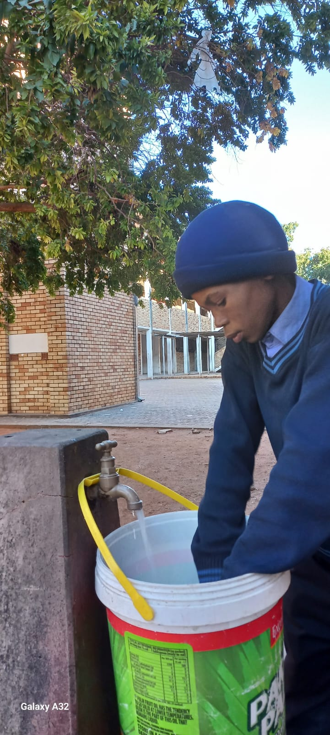*Figure 9: Leaners using a bucket and to wash their plates and cups to drink water after water police awareness at school.*

# **Materials**

10 x 20 litres buckets Donation from water and sanitation

5 x Silicon (270ml) = R60.00

Cups (Learners were requested to bring them at home)

4x rubber tap washer (15 mm) = R20.00

2x plastic taps = R80

## **Project Costs**

The total cost of the project is R400.00

# **Results and Discussion**

Results proved that a month after our awareness was conducted and leaking taps were fixed in our school bathrooms, the school water bill was reduced. Furthermore, learners are now very thoughtful when using water, because now there is less water overspilling around the school taps. The water that is collect with buckets that we have placed underneath the taps when learners wash their plates after eating, is now being used to water the vegetable garden that we recently started at our school.

The stagnated water from the carwash that was contributing to the cause of potholes and deteriorating road infrastructure is now minimal. Because MTN Bozza Car wash, have reduced the amount of water that were using, mostly wasting before our intervention. Furthermore, Nora-Dee Hair and Beauty Salon has become more conscious when washing client’s hair, they switch off taps in between unlike before they would let water run throughout their washes and that has minimized the amount of water that was being wasted.

Since we have recruited other leaners to be Water Police, the impact is very noticeable. The behaviour and attitude of the learners is positive towards water conservation, and everyone is taking accountability.

# **Conclusion**

The challenges that we experienced on this project we were able to tackle them head on and we were able to reach our objectives. The budget was also not available; however, we were innovative to by initiating fundraising events to ensure the availability of the needed budget.

Therefore, we are looking into making this initiative a continuous project and ensure that there are always funds for the Water Police project. As we have done in our school, we will keep on coming up with ideas to raise funds by having talent shows, sports events, business day etc.

In almost every corner in our community, there is a car wash or a salon, these establishments are part of the economic development in our country hence water is the main resource for these businesses. Therefore, Water is a very important part of human’s lives, not only for consumption, also for business purposes. Furthermore, schools cannot function without water.

In that regard, water should be conserved, and it is everyone’s responsibility, regardless of age, as we young people have took an initiative to be Water Police. This awareness made us realise that everyone can be a custodian of water. Creating an awareness of this nature, can make a huge difference in people’s lives.

# **Recommendation**

We would like to see Water Police project implemented in other schools and business communities in South Africa. We also wish that those who are educated can invent something (e.g., a model) from our project.

# **References**

An Introduction to global water wastage. Retrieved from: <https://eponline.com/articles/2022/08/11/global-water-wastage.aspx>

Bernard, B. and Joyfred, A., 2020. Contribution of rainfall on rooftop rainwater harvesting and saving on the slopes of Mt. Elgon, East Africa. *The Scientific World Journal, 2020.*

Chowdhary, P., Bharagava, R.N., Mishra, S. and Khan, N., 2020. *Role of industries in water scarcity and its adverse effects on environment and human health. Environmental Concerns and Sustainable Development: Volume 1: Air, Water and Energy Resources*, pp.235-256.

Department of Water and Sanitation (2023). Retrieved from: <https://www.dws.gov.za/>

Gawande, S.M. and Sarode, D.D., 2019. Reuse of Wastewater to Conserve the Natural Water Resources. In *Proceedings of the 1st International Conference on Sustainable Waste Management through Design: IC_SWMD 2018 1* (pp. 353-367). Springer International Publishing.

Monney, I., Donkor, E.A. and Buamah, R., 2020. Clean vehicles, polluted waters: empirical estimates of water consumption and pollution loads of the carwash industry. *Heliyon*, 6(5), p.e03952.

South Africa has had lots of rain and most dams are full, but water crisis threat persists: Retrieved from: <https://theconversation.com/south-africa-has-had-lots-of-rain-and-most-dams-are-full-but-water-crisis-threat-persists>

United Nations Sustainable Development Goals. 2022. Retrieved from: <https://www.un.org/sustainabledevelopment/water-and-sanitation/>.

# **Annexures**

8.1 Interview guide

8.2 Municipal rates and taxes of Emang Mmogo High School

8.3 Posters

8.4 Videos