Project: Ozonolysis and Photocatalytic Oxidation Treatment of Effluents with Organic Contamination
Student Authors: Llorden, Lucia Madroñal, Anahel
Institution: E.E.S.T. Nª 2 de San Martín – Pcia. Bs. As- Argentina
The work carried out was aimed at assisting oxidative processes, for the treatment of water effluents with organic substances contamination. The methodology employed was consistent with a primary oxidation by the action of ozone (ozonolysis), followed by a photocatalytic oxidation, by the action of photocatalysts activated by ultraviolet radiation.
To check the efficacy of the proposal, an experimental pilot plant was designed to test and evaluate the process under scale conditions, providing as an advance the specificity of the photoactive catalysts by ultraviolet light, in conjunction with an ozone producer as a coadjuvant of the process.
The technological development was verified through a simulation in the prototype with a river effluent with high organic pollution, testing the progress of the process through Chemical Oxygen Demand (COD) measurements.
The results obtained showed a high degradation rate of organic matter, above 70%, with a 3rd order reaction kinetics. These values give us an optimistic expectation when it comes to choose a viable treatment for this type of effluent.

Design of the redox process to be achieved
The chemical reactions that were simulated with this equipment were:

Removal of pollutants by ozonolysis: by oxidative mineralisation of organic matter, by the action of atomic oxygen generated by the decomposition of ozone

O₃ ⇌ Oº + O₂

Ozone atomic oxygen molecular oxygen

Possible photocatalytic activation reactions:
TiO₂ + hν ⇌ TiO *
2
Titanium Photon Energy Activated
dioxide Titanium dioxide
O₂ + TiO * ⇌ 2 Oº + TiO Oxygen from Titanium Activated atomic Titanium the air dioxide Oxygen dioxide Possible oxidation reactions of organic substances:
2 2
O₃ ⇌ Oº + O₂ Ozone decomposition

Ozone atomic oxygen molecular oxygen

Organic Matter + Oº Oxidised (mineralised) Organic Matter + n e⁻
Atomic oxygen

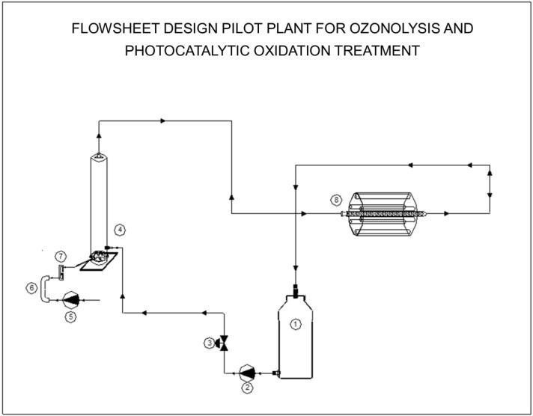
Equipment Used: The equipment used was made by coupling an ozone generator to an existing laboratory equipment used to test photoactive catalysts by ultraviolet
light action.
References:
- Pumping well where the liquid with organic matter load is recirculated
- Fluid circulation pump
- Flow control valve
- Ozonation chamber, with microporous diffusers
- Air compressor
- 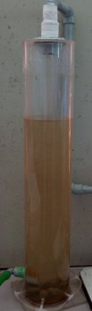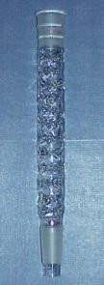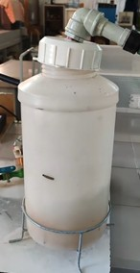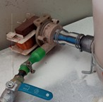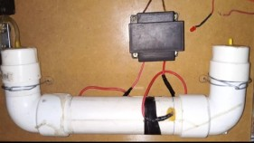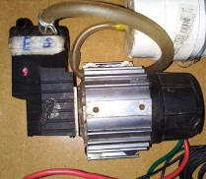Ozone generator
- Ozone flowmeter
- Photoreactor with UV lamps and TiO₂ columns supported on borosilicate glass
9

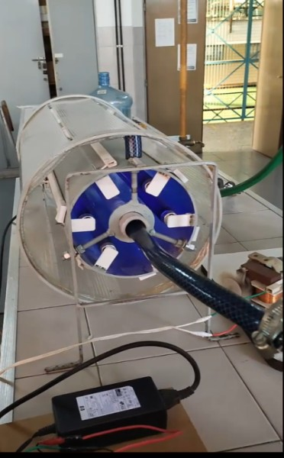
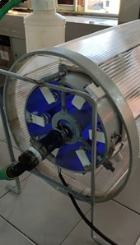
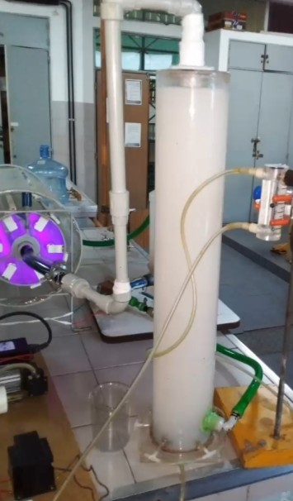

Methodology used in the trial:
To test and see the performance of the process, we proceeded to simulate the treatment with a sample of the effluent from the Reconquista River (local river with high organic pollution loads) and to extract samples in the pumping well at different working times of the equipment.
The extracted samples were tested with a marker parameter that characterises the progress of the process, that is, the COD (chemical oxygen demand) analysis, which expresses the amount of oxygen necessary to oxidise the organic compounds, by quantitative equivalence with another more energetic oxidant such as dichromate ion in an acid medium, catalysed with silver ion and acting on the organic sample for 2 hours at 148ºC.
Data collection and evaluation of the results obtained: If the COD values of organic matter are plotted as a function of time, the following results are obtained:
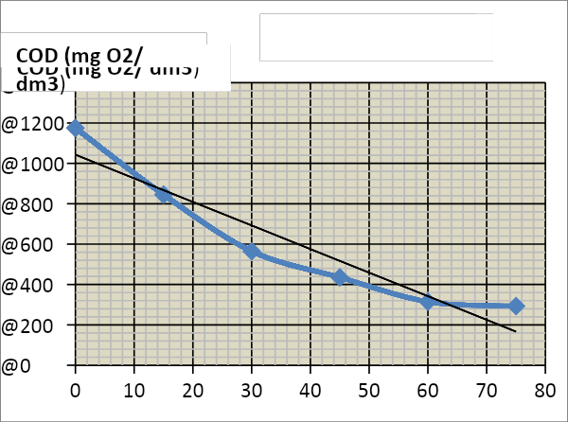
Time (min) | COD  (mgO₂/ dm³)
0 | 1175
15 | 845
30 | 565
45 | 435
60 | 315
75 | 293
From an analysis of the empirical mathematical expression, it can be seen that it is representative for
determining the expression of the reaction kinetics. It follows that the independent term corresponds to the initial COD (COD₀), therefore the general expression would have the following format:

COD = -5.10⁻⁶ t⁴ + 2.10⁻⁴ t³ + 0,19 t² - 25,70 t + 1177
COD = -5.10⁻⁶ t⁴ + 2.10⁻⁴ t³ + 0,19 t² - 25,70 t + COD₀
Equation expressing how COD varies as a function of time.
If this expression is derived to give the reaction rate: v= -d(COD)/dt

v= -d(COD)/dt= 2.10⁻⁵ t³ - 6.10⁻⁴ t² - 0,38 t + 25,70
It can be seen that it is a cubic function, corresponding to a 3rd order kinetic equation, which governs the oxidation reaction of mineralisation of organic matter by ozonolysis, combined with oxidation by heterogeneous photocatalysis. Expression showing the remediation of polluted waters with organic load as a function of time, very useful to develop a process of oxidation of organic matter, evaluate the time and efficiency of the process.
Analysing the percentage of organic matter degradation during the simulation time (75 minutes), a COD decrease of 75.1 % process efficiency is obtained.

Conclusions on the process of oxidation by ozonolysis and photocatalysis in organic effluents
It can be seen that in the pilot experiment, carried out on simulated effluents with organic pollutants, by means of a batch process of ozonolysis combined with heterogeneous photocatalysis with specific ultraviolet light irradiation, the organic matter loads were reduced by oxidation by up to 75% in a period of 75 minutes and it is concluded that the reaction kinetics are viable for the proposed treatment.
The values obtained give rise to encouraging expectations when choosing a feasible treatment for this type of effluent.

