Project Current

Remote Sensing of River Levels using LoRa

for Predictive Flood Management

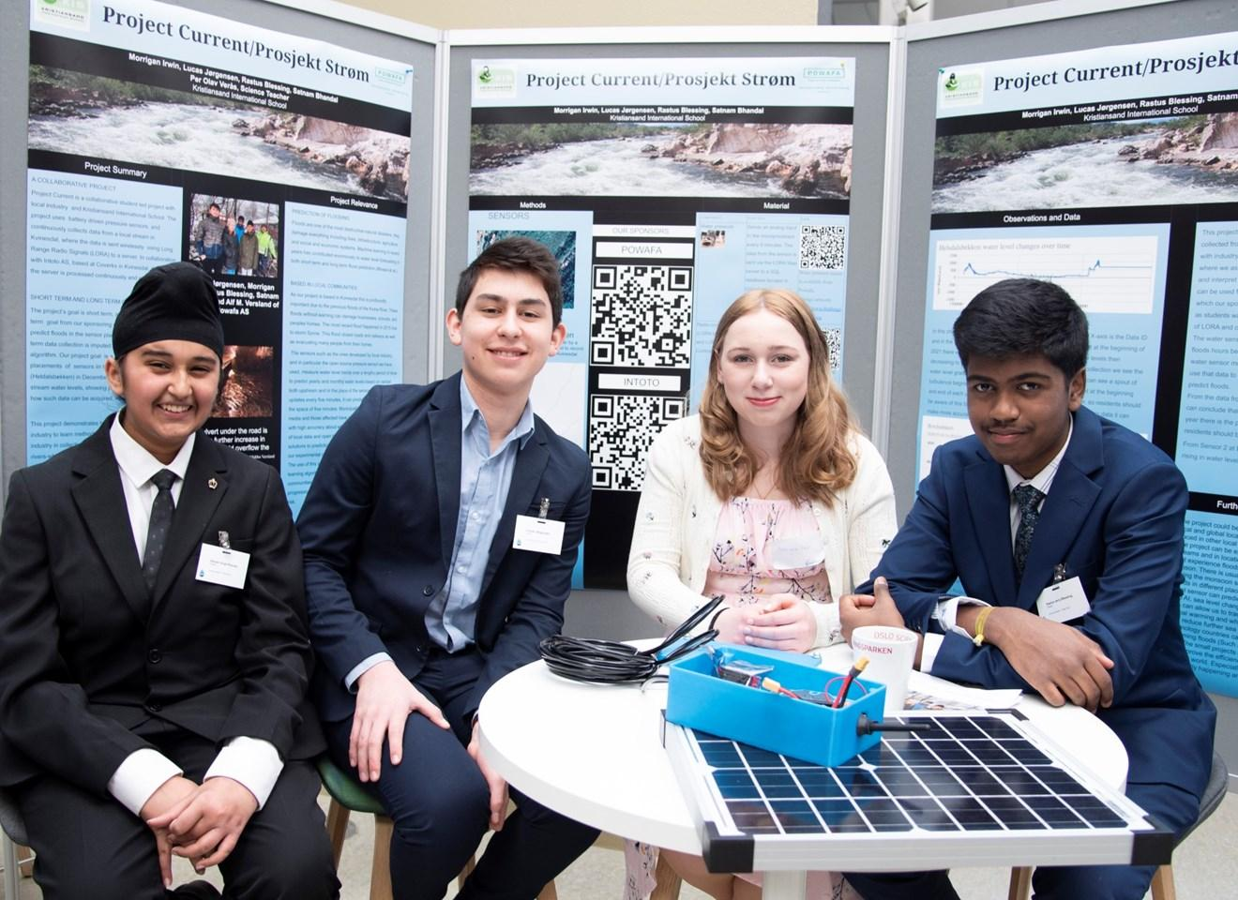

Satnam Singh Bhandal, Lucas Jørgensen, Morrigan Irwin, Rastus Blessing

Norsk Junior Vann Pris 2022
Kristiansand International School
Per Olav Verås, Science Teacher and Coordinator

PROJECT SUMMARY

Project Current is a collaborative student led project at Kristiansand International School in collaboration with local industry. The project uses relatively low-cost battery powered commodity pressure sensors, to collect data from local streams in the Kvinesdal area in Southern Norway. The data is collected continuously at sensor points and periodically sent wirelessly using Long Range Radio Signals (LORA) to a server located at Coverks in Kvinesdal, where Intoto AS is based. The collected data is utilised for different purposes including contributions to Intoto’s more extensive database on water levels.

The project had both short- and long-term goals. The former goal is to predict floods in the sensor placement area. After long term collection, data will, in the future, be imputed into a machine learning algorithm to help predict floods and warn inhabitants. This aspect is out of the scope of the initial work.

The placement of a sensor in the Heldalsbekken watercourse (See in methods) in December 2021 is a demonstration pilot project for collecting data on the stream’s water levels. This is to demonstrate how such data can be acquired, interpreted, and shared practically in the short term. A secondary long-term goal is to demonstrate how students and young people can in a practical way, collaborate with industry in our local communities and use cost effective and innovative technologies such as these, to highlight natural resources and discover new and cost-effective ways to collect data about them.

PROJECT RELEVANCE

Floods are one of the most destructive natural disasters, they damage everything including lives, infrastructure, and agriculture, as well as have a significant social and economic impact. Machine Learning in recent years has contributed enormously to water level forecasting for both short term and long-term flood prediction (Mosavi et al.). This project demonstrates how such technology can eventually assist communities in predicting flooding events through machine learning by consistently uploading new data on streams and river water levels.

As our project is based in Kvinesdal (Figure 1) this is profoundly important due to previous flooding of the Kvina River as shown in Figure 2. The most recent significant flood happened in December 2015 due to storm Synne. This flood resulted in closed roads and railways and forced many people to evacuate from their homes. According to the USGS, there was also widespread flooding in the central and southern United States (Fitzpatrick et al.). Other examples of floods can be seen throughout the world including in places that have a monsoon season and other areas of the world affected by natural disasters like these such as Suriname, and The Netherlands. These floods without warning can damage businesses, schools, and people’s homes (The Local Norway). More recently significant flooding has been seen in Australia.

Sensors developed by local industry, like the pressure sensor we have used, can be used to measure water level trends over long periods of time. In turn, this data can be utilised to predict river levels based on upstream readings and/or in conjunction with rainfall data in the sensor placement area. As the sensor updates every two minutes, it can potentially detect flash floods within short periods of time depending on the rate of change in the readings. Municipalities, residents, the media, and those affected have access to real-time information with high accuracy about what is happening in relation to water levels near them. This project is not only relevant within our experimental region but can also be used around the world. The global use of this sensor could help to develop machine learning algorithms that function to predict and warn for floods and help communities around the world to better understand their water resources. This could also be used to show global warming progression through sea-level changes near coastal regions at risk.

Using students as grass-root activists engaging with technology can inspire other students to engage locally and come up with solutions for the problems caused by climate change and river flooding.
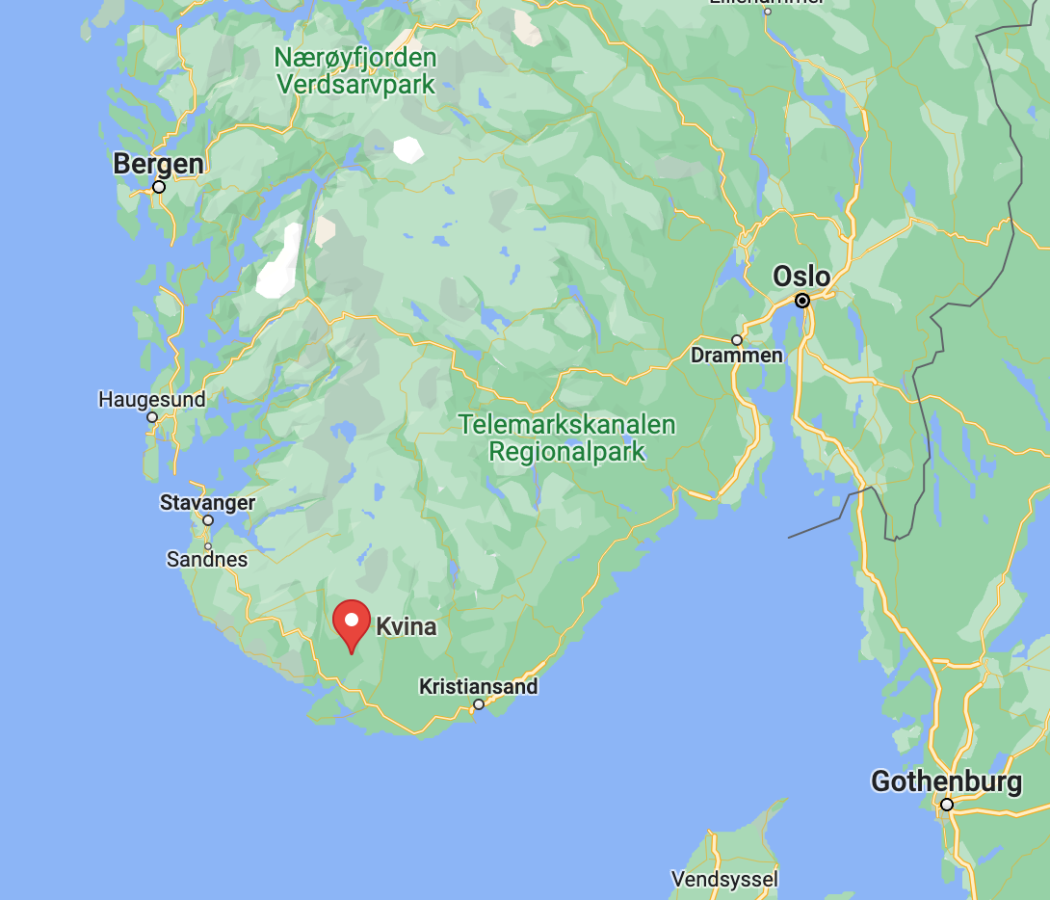
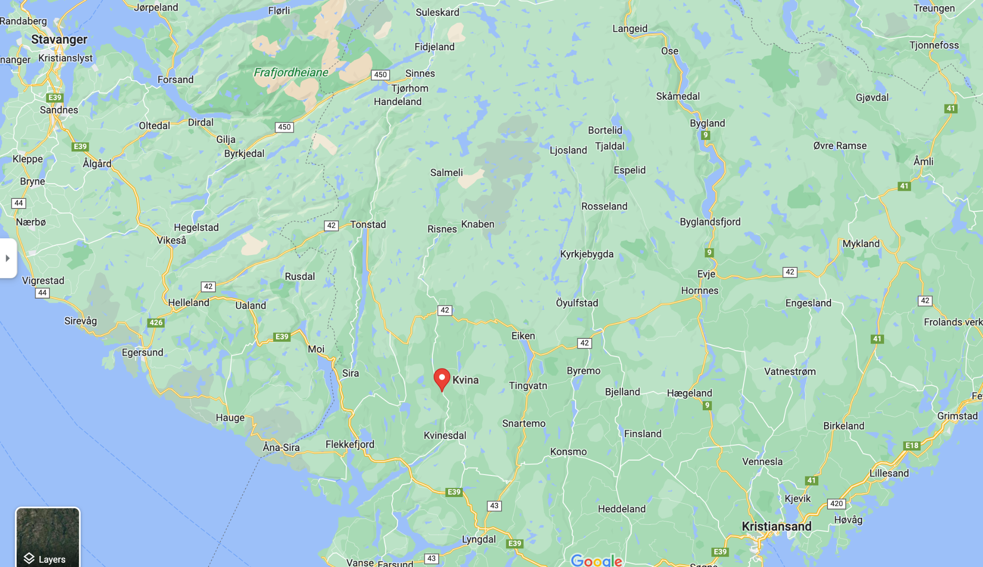
Fig. 1: The Kvina river placement on a map, in southern Norway.

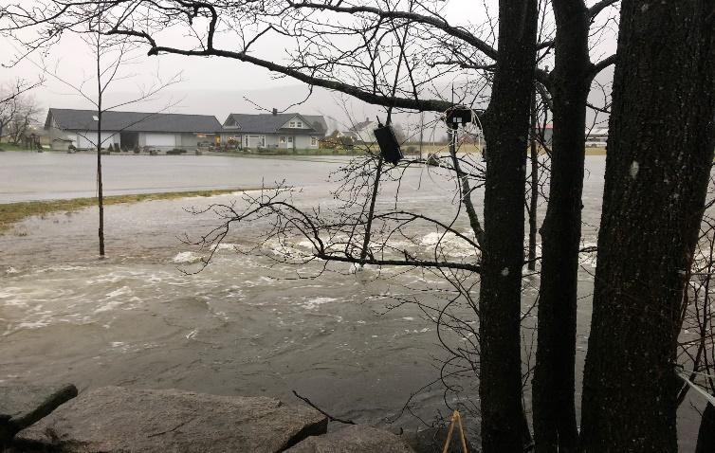
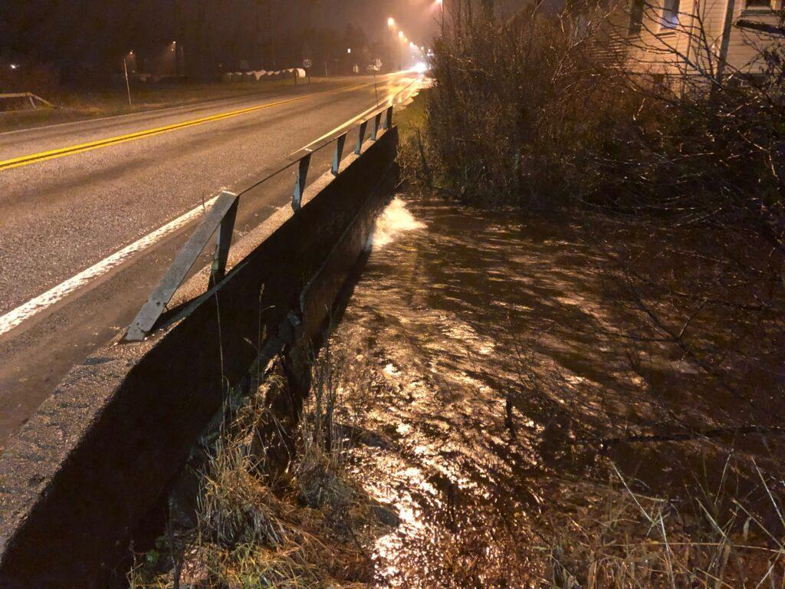
Fig. 2: a) Flood in Øyebekken in Kvinesdal The culvert under the road is full and a further increase in water flow would have catastrophic consequences for more homes. b) Kvina River near Barnehage.
Pictures curtesy of Alf Magne Midtbø Versland, Powafa.

METHODS

The project uses two sensors, located both upstream, and downstream of that placed by us. An overview of the Kvinesdal Municipality is shown in Figures 3 and 4.
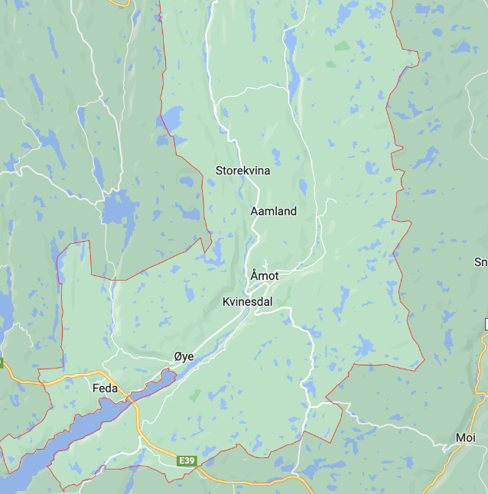
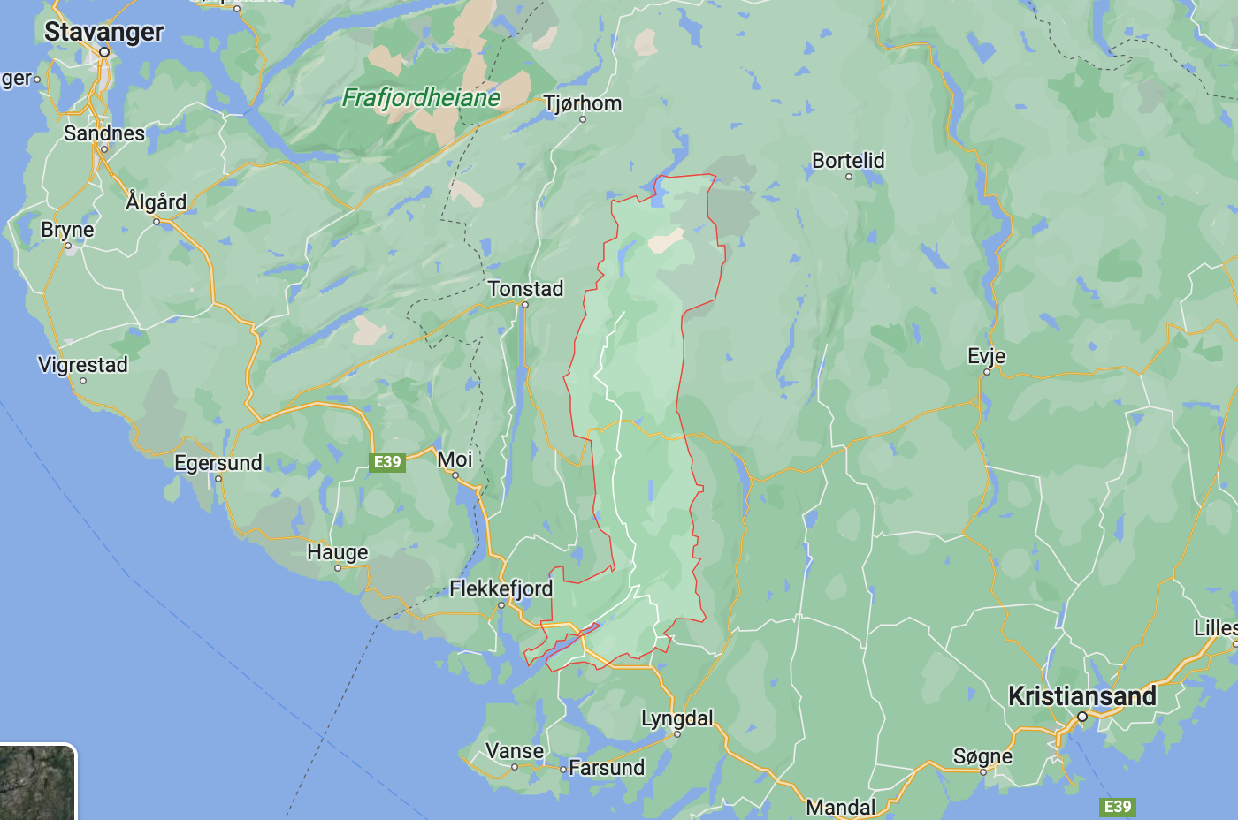
Fig. 3 Overview of Kvinesdal Municipality (red) Fig. 4 Closer view of Kvinesdal Municipality showing sensor locations

Downstream Sensor Location | Heldalsbekken
Sensor One:  We placed our sensor downstream in a small river by Knerten kindergarden. This downstream sensor is used to record the pressure levels in a small river located in Kvinesdal. | 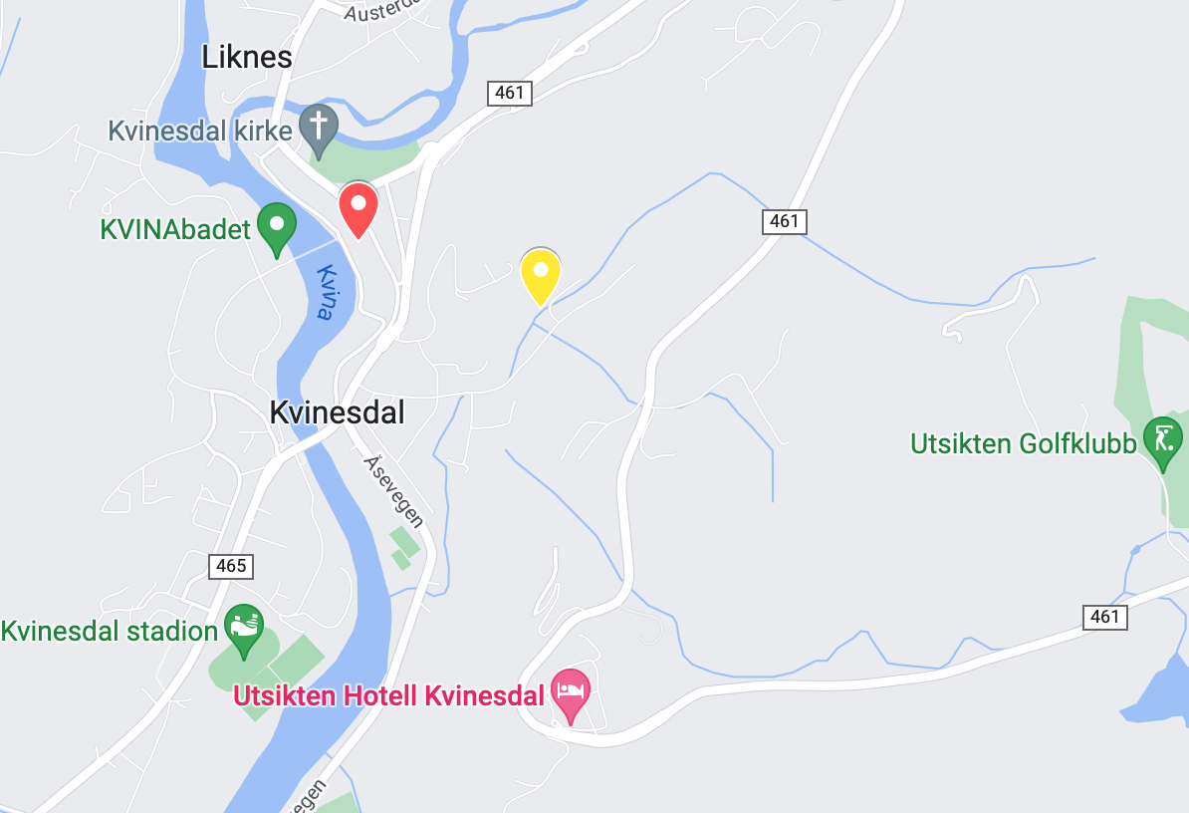  Sensor One, in Heldalsbekken (Yellow marker) is conveniently located within walking distance to Coverks (Red Marker), where the data collection and local server is located. These are sponsored by Powafa, AS.

Upstream Sensor Location | Breibekken
Sensor Two:  This sensor was placed by POWAFA. The data is from further upstream, and is shared with the Project Current members, to provide a baseline of data with which we can compare our downstream data. | 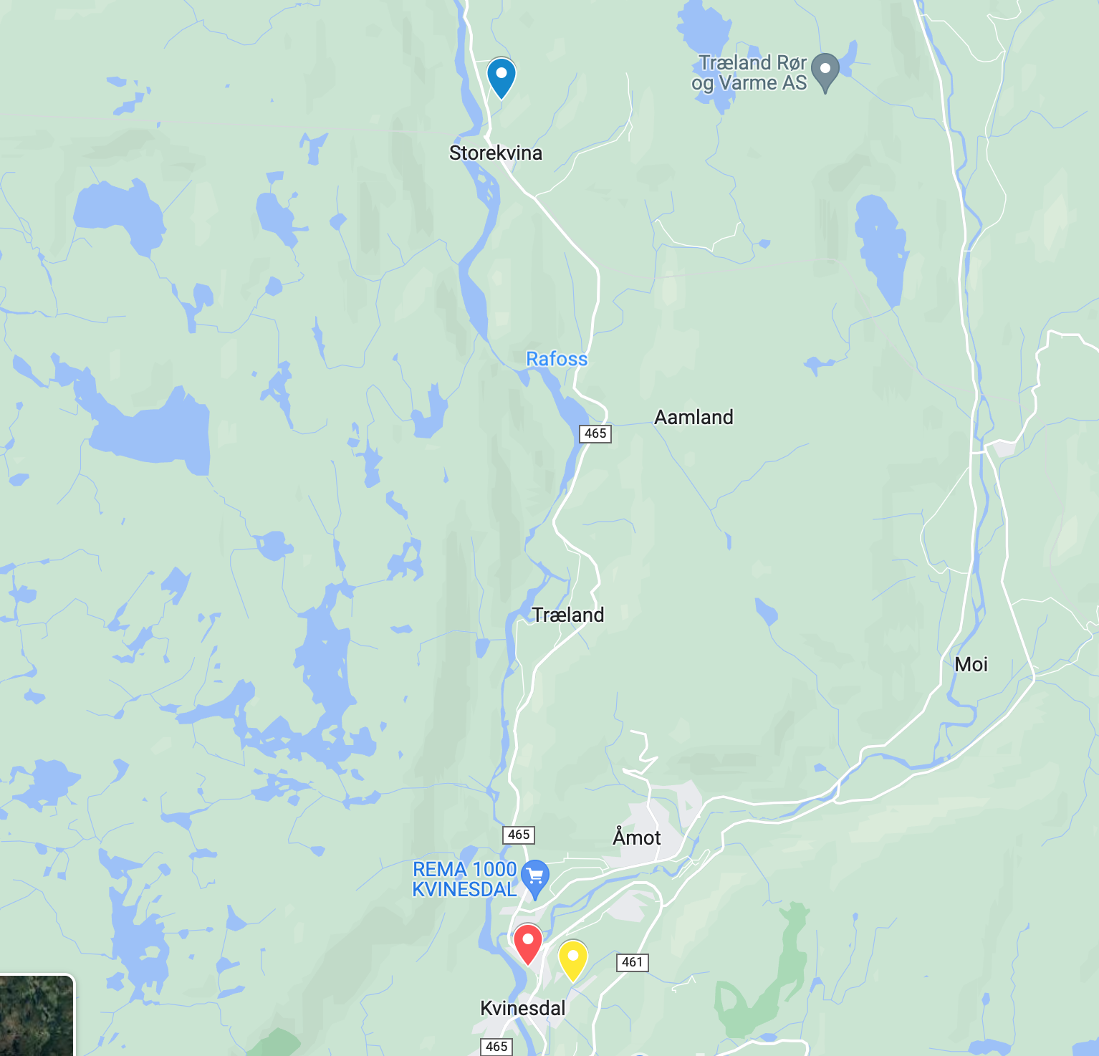  Breibekken (blue marker) is located upstream from the town of Kvinesdal. The second sensor is located downstream, in Kvinesdal, in Heldalsbekken.
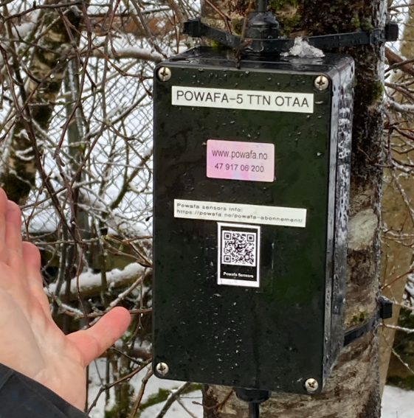
Data from sensors are collected in a watertight box (Fig. 5), which is easily mounted. The battery must be replaced every 10 to 21 days.

The Dragino LT-22222 (is a hardware device that manipulates LoRa technology to transmit water levels to its assigned TTN(footnote – the things network id number) app which identifies it on the LORA network. It is built with a small circuit board to connect the radio chip and microprocessor which are powered through a small battery. These power and allow the water level sensor to read levels and send those levels to the assigned TTN.
Fig. 5 Watertight box containing the components of the sensor

Steps to measuring water levels:

- Register the device on the TTN app EUI using the given OTAA keys
- Place the sensor at whichever water source you want to measure water levels at
- Connect the battery and the sensor will automatically connect to your local TTN
- The battery must be changed every 10-21 days

Refer to the manual for any necessary assistance found at LT Series LoRa IO Controller User Manual - Document Version: 1.4.2 Image Version: v1.4
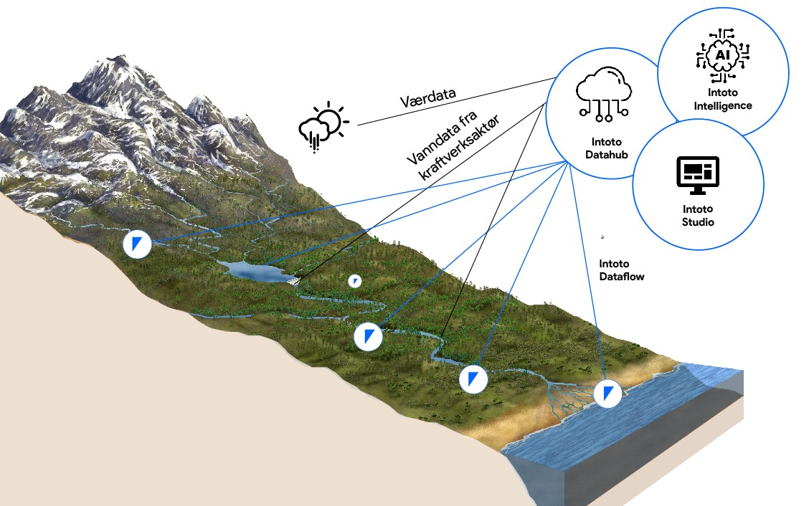
Fig. 6 Image sourced from Intoto AS

The use of LoRa:
LoRa stands for Long Range Radio and allows connections from several applications to run on the same network.
- Long Range transmission
- Low power consumption
LoRa technology is very useful when it comes to further development of the sensor technology in more remote areas. If a long use battery was developed or a battery that can be powered using solar energy is used in the sensor, sensors could be placed in more rural or remote areas. This is because the long-range signal and low power consumption of LoRa would allow for fewer battery changes or none at all. The data could then be sent to the nearest internet connection. This sensor can send a signal as far as about 5 km, however, more power can increase the signal distance.

MATERIALS
COMPONENT | FUNCTION  For more information and links to components see Appendix A
Water pressure sensor  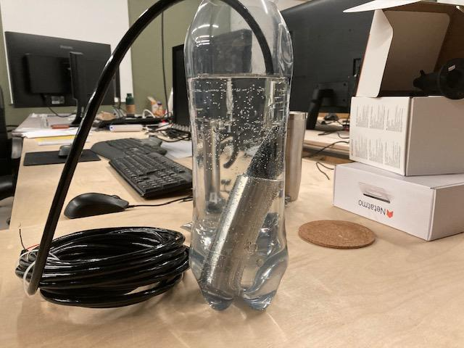 | Sends an analogue input to the microprocessor every 5 minutes. The data from the sensor is sent via the LORA Wan server to a SQL database located in Coverks in Kvinesdal. Our project is a pilot project hoping to inspire other students to collect data using our methods with data sent to our Kvinesdal database, or a database of their own choosing.
Radio component (LORA transmitter) | It sends a radio signal to POWAFA, so we can collect data. The LORA io controller operates at a frequency of 868 Mhz.
STM32 Microprocessor  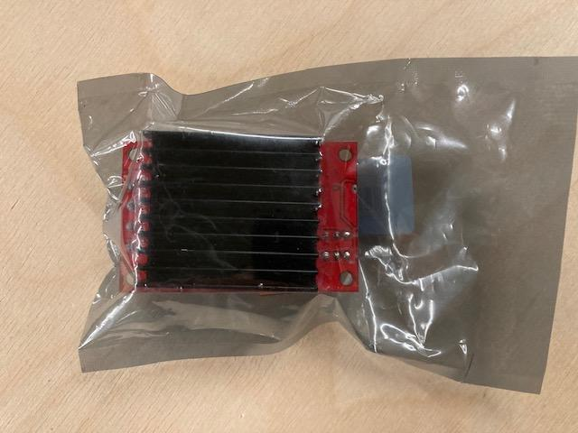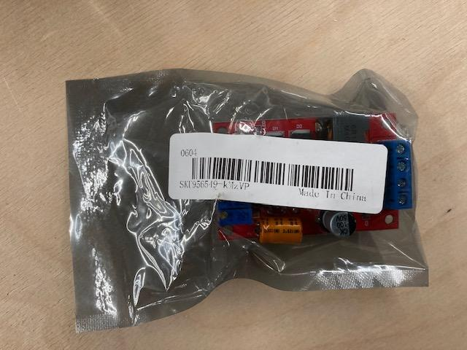 | Microprocessor - Takes the input data from the sensor and uses the radio to transmit the information to Coverks. The data is processed in the cloud on Powafa’s Azure cloud database located in Coverks, in Kvinesdal. The STM32 is an ultra-low power microprocessor meeting the power/performance requirements for smart applications. The device can operate from –40 to +85 °C from a battery power-supply.  This microprocessor is an extremely smart component that is soldered onto a circuit board along with the rest of the components to properly function.  https://www.st.com/en/microcontrollers-microprocessors/stm32l072cz.html

11.5 V Battery (5000 mAh) and charger  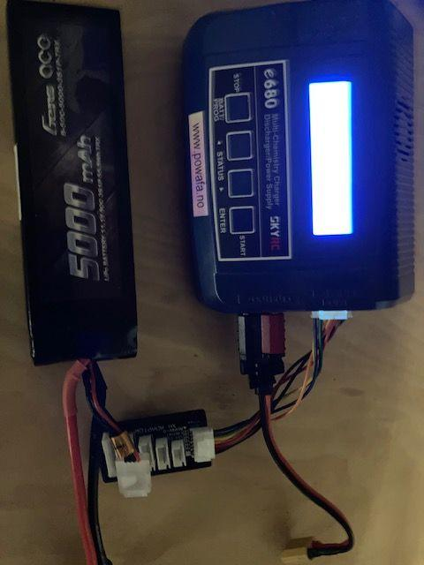 | Powers the microchip (Has to be changed every 10 days)
POWAFA manufactured box | This is used to connect everything and hold everything in one place
Dragino LT-22222  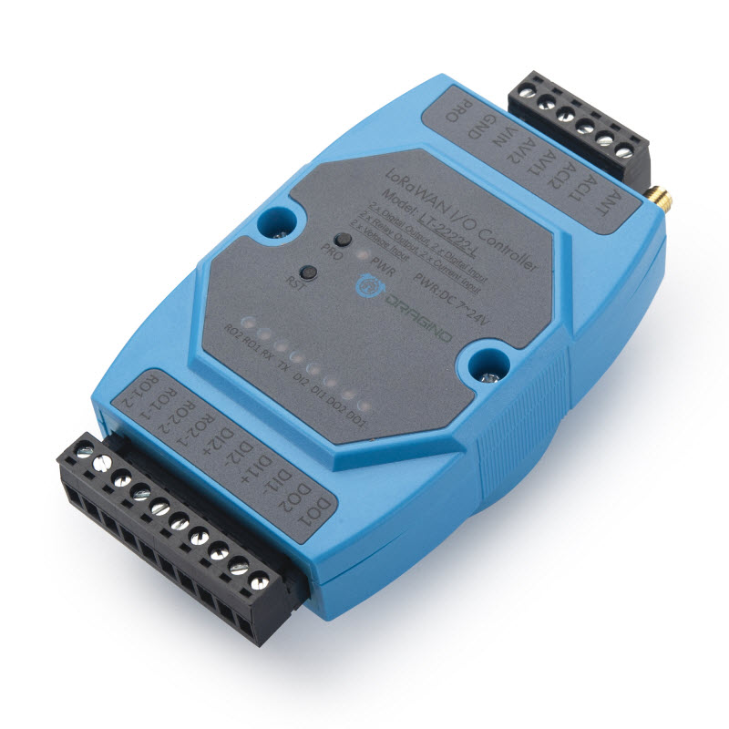 | The platform uses an STM32L072CZT6 MCU SX1276/78 Wireless Chip. This manages the reading and transmission of water level data to POWAFA via LORA  Sends readings every 2 minutes by default.

The transmitter: The transmitter is what sends the measured pressure levels to the receiver, it’s powered by a microcontroller which takes the input from the sensor and uses the transmitter, it operates on an 11.5V battery which needs to be changed every 10 days. Because the transmitter is what consumes most of the battery power it is activated every 5 minutes to be more efficient and less battery consuming.

The Receiver: The receiver processes and inputs the data into an excel document, the data received includes Sensor ID, Value MM, Reading ID, and Datestamp (with time).

OBSERVATIONS AND DATA

What do we do with this data?
At Coverks, Camilla Wagner, a graduate student from France, assisted us in our understanding of the local rivers in Kvinesdal, and the resources they provide to the community. Fig. 7 shows our meeting to discuss the use of data. This helped our understanding of what the data is useful for.

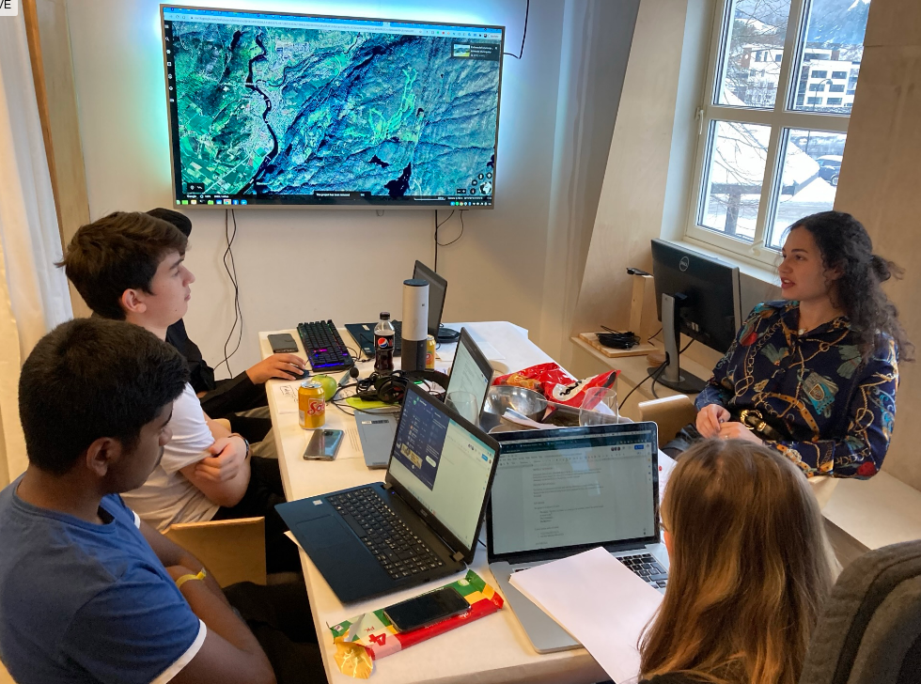

Fig. 7 Our groups meeting with Camilla Wagner (Doctoral Student)

Project Data is cloud-based, located on POWAFA Azure. All data is sent to Coverks via a radio signal and inputted into the cloud for Powafa where the data is interpreted then sent on to the next stage. Which is a machine learning AI that thethingsnetwork.org is developing that can predict floods.]] As the AI gets more data from the sensor it can become more efficient at predicting floods to the point where residents can be notified of a flood; hours or even days before it occurs.

When conducting our own analysis on analysing data for this project we found many negative values in the data and sometimes found other measurement anomalies. We are unsure why this happened, but it can be expected that radio signals may, very occasionally, be misinterpreted, and communications lost. We also found that as a result of this, some hours or days had more readings than others. To solve this problem, we developed a python script to process the raw CSV datasets provided and to remove the negative values and average the hourly and daily readings. This produced more usable graphs for our own analysis. Similar methods would be needed before processing of the data by machine learning processes in any case. The code developed is available at: https://github.com/06defChuli/project_currentdataSort

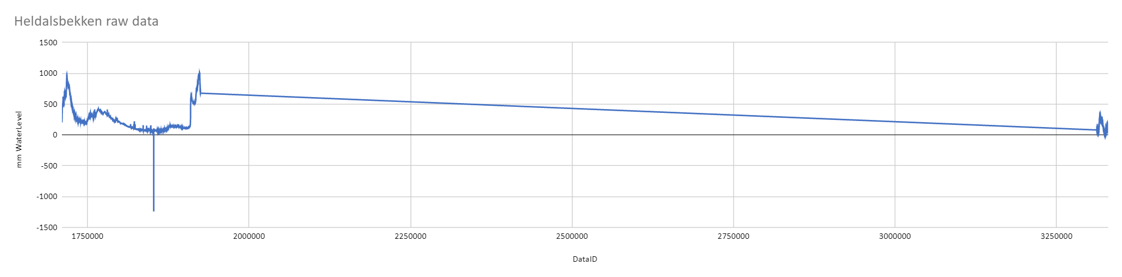Fig. 8 Raw Heldalsbekken data
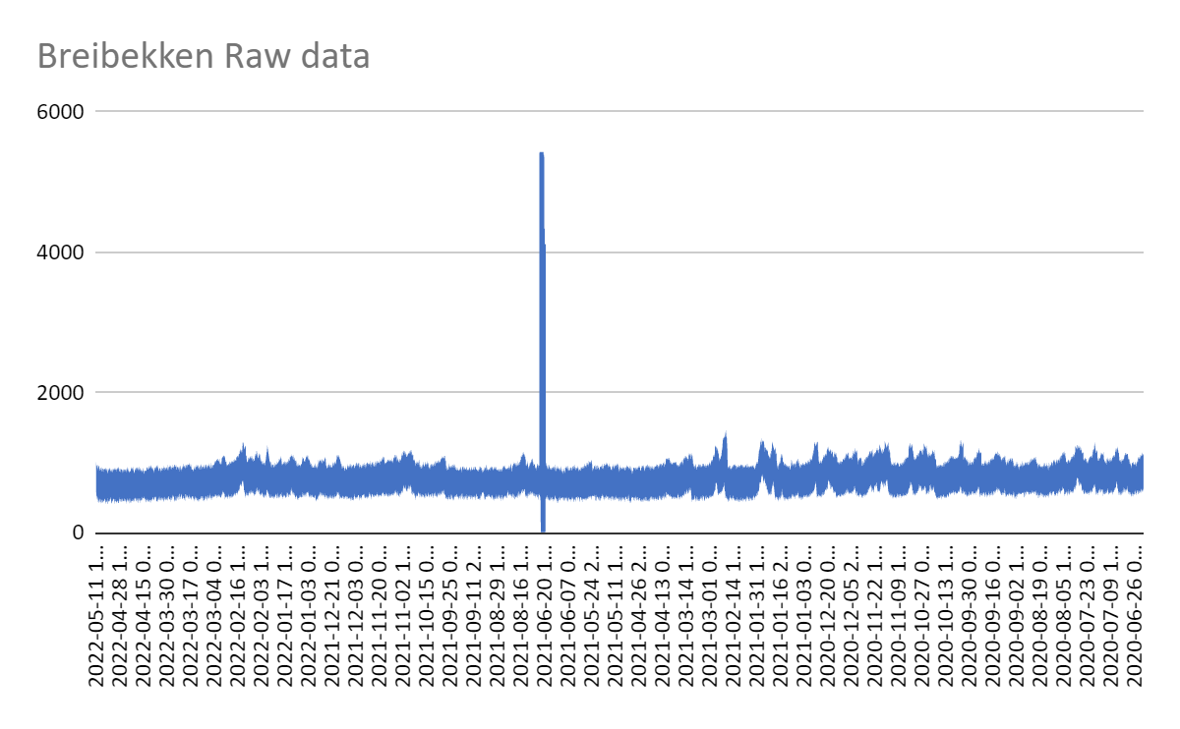
Fig. 9 Raw Breibekken data

Figures 8 and 9 show the noisy data before it was refined using the code above. Figure 8 has a long slope indicative of missing data in the raw datafile provided. This is discussed in more detail below. To clean the data, we removed any negative numbers and calculated the mean water level of each hour of data that was recorded. This was based on the number of viable readings in each hour which varied depending on missing values or having removed the readings with clear errors

Observations:
Exploratory data analysis of the two sites is presented below along with some discussion. This made use of additional historical data provided by our partners.

Heldalsbekken
Period of Data Collection | 21st January 2021 - 31st December 2021

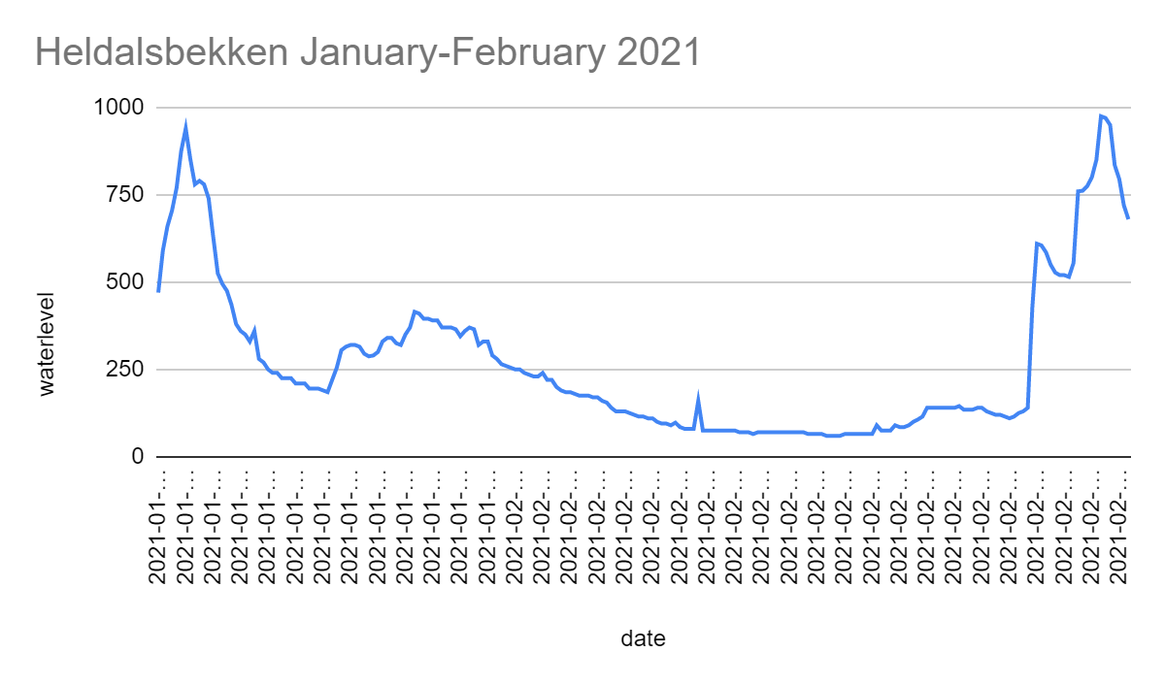

Fig. 10 Heldalsbekken – January-February 2021
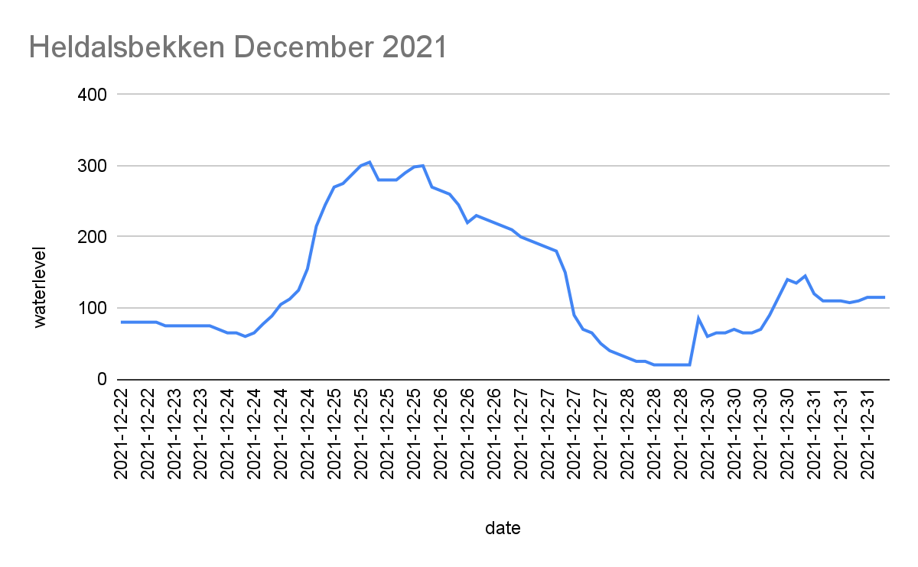
Fig. 11 Heldalsbekken – January-February 2021

In the plots shown in Figures 10 & 11 we can see the water level changes over time as expected. The X-axis is the Date collected and the Y-axis is the water level in mm as interpreted from the pressure sensor readings. In this data set we see that there is no data from March until November (as shown by the slope in Figure 8), this is most likely due to the battery or other issues prior to the sensor being re-installed in December. At the beginning of 2021 there were a lot of changes in water level, rising to extreme levels then decreasing to very low levels. Throughout the year’s data collection we see the water level gradually decreasing. In around February we can see another extreme rise in water levels, this may point to either normal monthly rainfall, snowmelt or if it were to continue increasing, a flood. 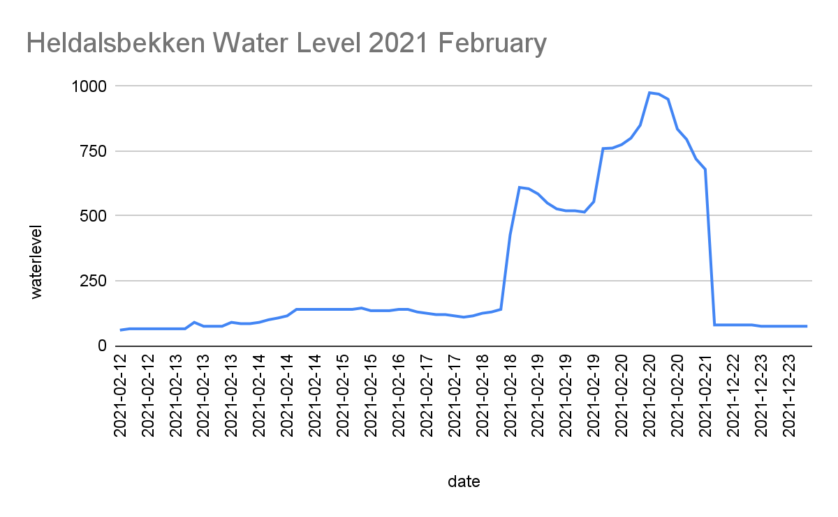

Point A
Fig. 12 Zoomed section of February 2021 Heldalsbekken

Here is a zoomed section of the data from February 2021. At Point A in fig. 12, the water level starts to rise dramatically. If the rate of change is worked out, higher rates of change in water levels might point to a flood if the same rate of change is kept up. This data is fed into an AI model so with long term data it can make more accurate predictions for the inhabitants of the area.

Breibekken
Period of Data Collection | July 2020 - June 2022

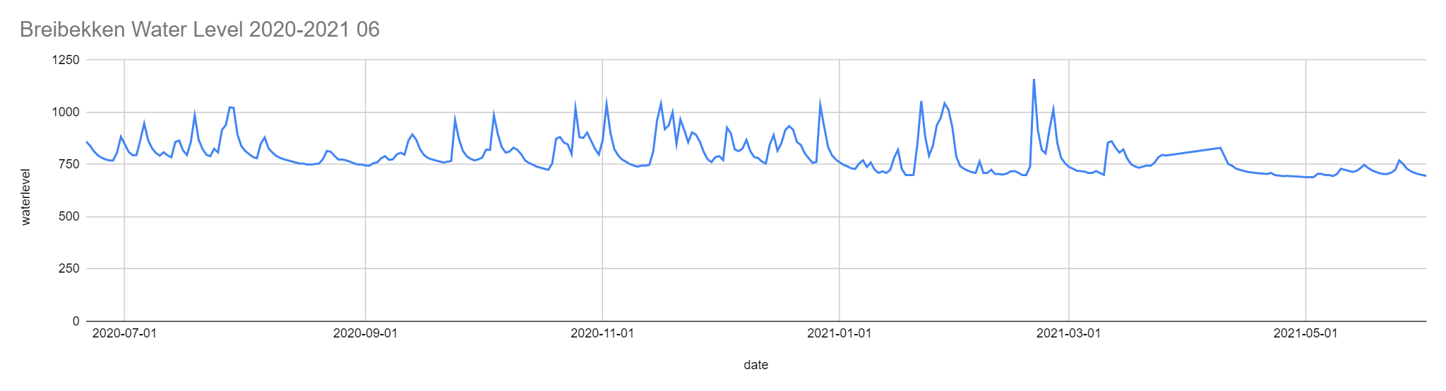Fig. 13- Breibekken – July 2020 – June 2021

Fig. 13 shows a year long data set collected from the Breibekken sensor (we are using data collected by Powafa and their previously placed sensors). Throughout this half year we can see on the first graph that there is a pattern of monthly rises and falls in water levels which suggests regular rainfall throughout each month. But this pattern quickly seems to break down as the water levels flatten out during the second half of 2021 (Fig. 14/17). Around March (Fig. 13) there is a slightly higher water level than most monthly averages, this could be attributed to snow melt at the time or higher rainfall levels at the time.

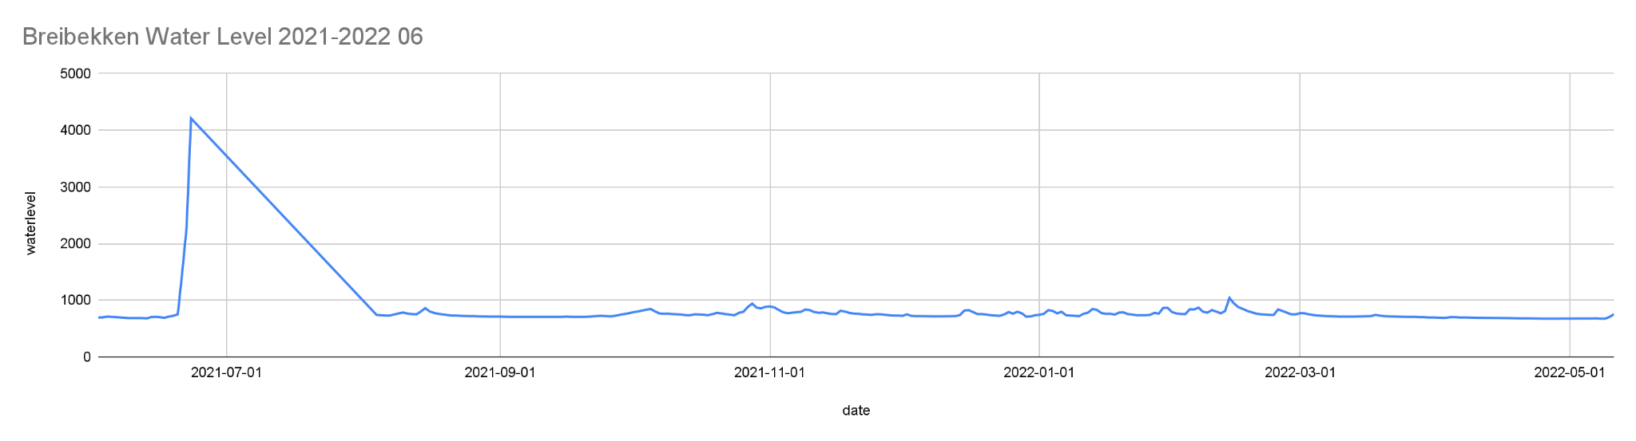Fig. 14

Fig. 15

Fig. 14: 11 months of data - second half of 2021 and the first half of 2021. We can mostly see a steady water level throughout the year of readings. In the July to August readings we can see a big spike and then an immediate downfall. This is shown in Fig. 15. The spike in Fig. 15 is shown, however, the gradual downfall of the water levels is a product of the graph because there is missing data so the space is automatically filled on the graph by google sheets.
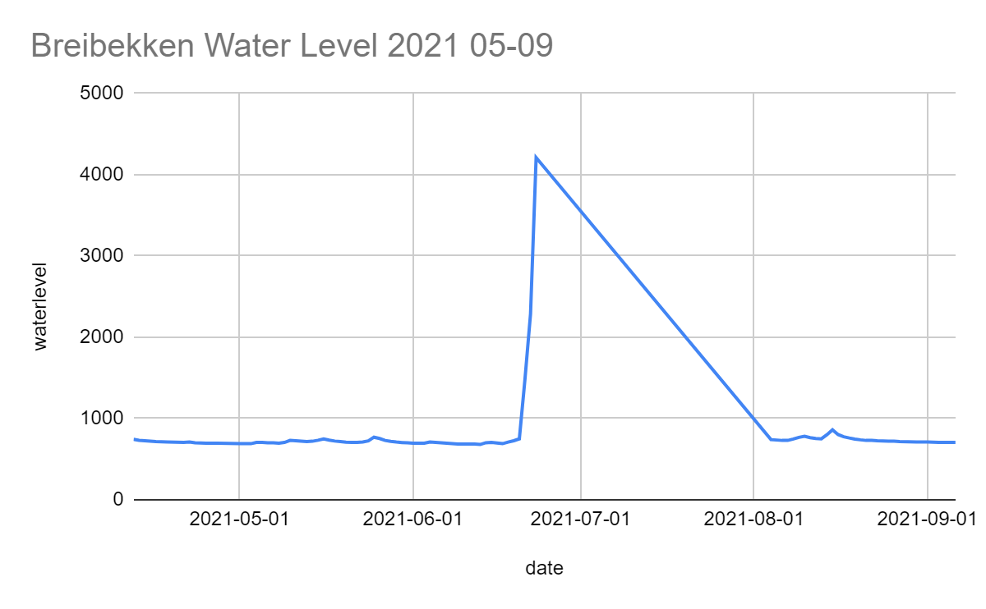
Fig. 15 – Zoomed view of missing Data

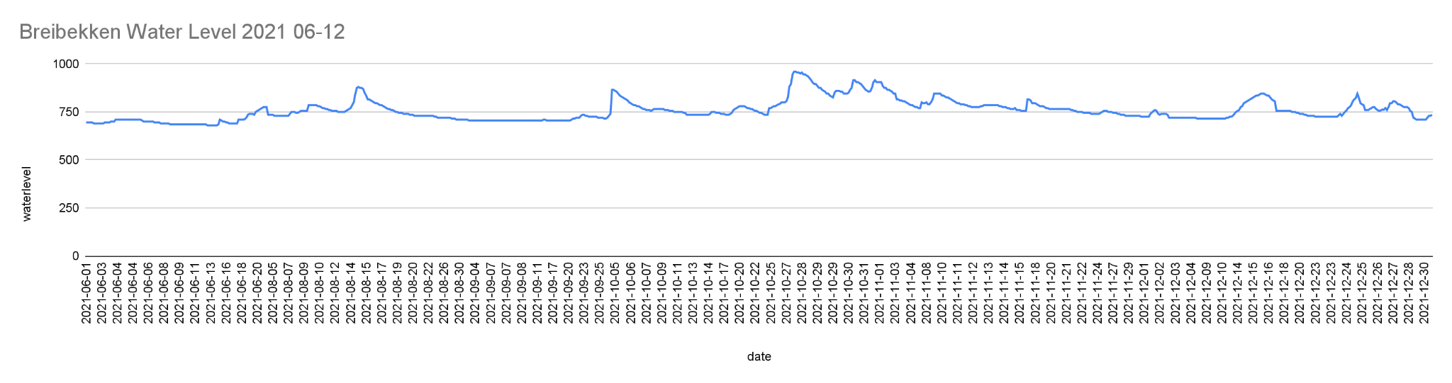Fig. 16 Resulting cleaned data for Breibekken data

After further investigation, we concluded that the sharp increase in water levels around July of 2021 was an anomaly however, if we average out the anomalies in the graph it would look less eventful as seen in the graph in Fig. 16.

Both tributaries lead directly into the Kvina river. Each set of data could impact the river level in the main river. However, these two rivers do not directly correlate. If the sensors were placed in the same stream or river, they would be more effective at predicting floods downstream.

CONCLUSIONS

This project's goal is to predict floods in the sensor placement area after long term data collection is imputed into a machine learning algorithm. The water sensor will be able to effectively predict floods hours before they occur. For this to happen the water sensor must send enough data over time and use that data to develop an AI model that can learn to predict floods. The purpose of the project is to predict floods and help ensure the safety of those vulnerable to the predicted floods.

State the results:
From the data from Sensor 1 in Helsdalsbekken we can conclude that at the beginning and end of each year there is the potential for flooding in this river, so residents should be aware of this fact. We can also see that there is a decrease in water level throughout the year. In the data from the Breibekken sensor (Sensor 2), we can see a regular pattern of rising water levels roughly twice monthly. This tells us that this area is likely to get regular rain which increases the water level and if water levels rose enough it could potentially flood the road and the Barnehage (kindergarten) that is near the Heldalsbekken stream.

Connect the results to the main project:
The results show the effectiveness of the sensor. This means placing another sensor in a different location could reach the goal of the main project and enable the user to predict floods with the two sensors. This is exactly what the project aims to do, gather data and use the data with developing AI to predict floods in the future within a matter of minutes.

FURTHER DEVELOPMENT
The project could be expanded to multiple locations both local and global. Multiple sensors can be placed in other areas that are prone to floods. The project can be expanded to oceans, rivers, streams and locations in countries such as India, that experience floods during the summer monsoon season. There is usually heavy rain during the monsoon season, which contributes to many floods in and around India. However, this sensor can also be used in other places that experience floods. The water level sensor can predict, through machine learning and AI, sea level changes due to global warming, this can allow us to track both the progression of global warming and help us to find out what we need to do to improve and reduce further rising sea levels. With this technology countries can find a solution to potential upcoming floods (Such as evacuation plans for citizens etc). Other locations such as the Philippines experience flooding which is due to increased water levels. Student’s and industries’ small projects to measure water levels could help predict flooding and improve the efficiency of safety precautions all over the world. Especially as we experience this global climate crisis.

The future development of this project could involve collaboration with schools and their local communities. As a project where students from other schools can duplicate the open-source technology, connect with local industry, identify streams and rivers of interest, and go out into the field and place the sensors. More sensors could be placed further upstream to warn those downstream of rising water levels with adequate time to evacuate the downstream area.

SUPPORT RECEIVED
We received support from our teacher and supervisor Per Olav Verås. Due to the Covid restrictions at the time we were unable to go to Kvinesdal to place the sensor. Our teacher and Alf Magne Midtbø Versland from Powafa, Kvinesdal, undertook the physical placement of the sensor for us. We received further support from Alf Magne as he explained how the batteries are changed and what the sensor was built to do. Powafa provided us with the necessary equipment we needed and allowed us to use previously collected data. Powafa also provides services to the Norwegian Environmental Agency and Intoto. When Covid allowed it, a student’s mother drove us to Kvinesdal to learn about the sensor and replace the sensor’s battery. At Coverks, Camilla Wagner, a graduate student from France, assisted us in our understanding of the local rivers in Kvinesdal, and the resources they provide to the community. Barry Irwin helped us to manipulate and understand the data and data cleaning when doing the observations for the project. Finally, we would like to thank the Principal of our school Mark Case for encouraging us throughout the project.
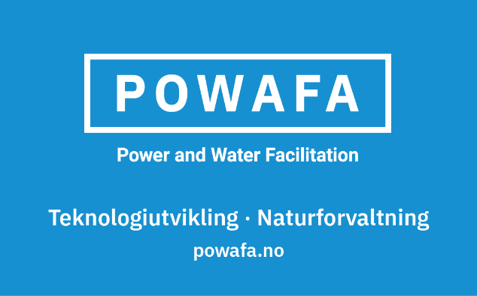

REFERENCES and RESOURCES
- “8.4V 5000mAh - Bronto SP TAM - Ni-Mh - Elefun.no - Radiostyrt Hobby.” Www.elefun.no, www.elefun.no/p/prod.aspx?v=14518. Accessed 20 Jan. 2022.
- “Dragino Lt-22222-l Lora I/O Controller - Support Eu868mhz Frequency.” Www.electromaker.io,
- Fitzpatrick, Faith A, et al. “Historical Flooding | U.S. Geological Survey.” Www.usgs.gov, 28 Feb. 2019, www.usgs.gov/mission-areas/water-resources/science/historical-flooding. Accessed 4 June 2022.
- LT Series LoRa IO Controller User Manual LT Series LoRa IO Controller User Manual Document Version: 1.4.2 Image Version: V1.4.
- Versland, Alf Magne Midtbø. “POWAFA Sensorer – POWAFA.” Powafa, 11 Jan. 2020, www.powafa.no/prosjekter/powafa-sensorer/. Accessed 16 Jan. 2022.
- Mosavi, Amir, et al. “Flood Prediction Using Machine Learning Models: Literature Review.” Water, vol. 10, no. Flood Forecasting Using Machine Learning Methods, 27 Oct. 2018, www.mdpi.com/2073-4441/10/11/1536, https://doi.org/10.3390/w10111536. Accessed 16 Jan. 2022.
- Network, The Things. “The Things Network.” The Things Network, www.thethingsnetwork.org. Accessed 20 Jan. 2022.
- Powafa. “Powafa Sensor Tilgang – POWAFA.” Powafa, www.powafa.no/powafa-abonnement/. Accessed 20 Jan. 2022.
- “RF-LORA: The 50km Radio Module.” Www.rs-Online.com, www.rs-online.com/designspark/rf-lora-the-50km-radio-module. Accessed 20 Jan. 2022.
- “STM32L072CZ - Ultra-Low-Power Arm Cortex-M0+ MCU with 192-Kbytes of Flash Memory, 32 MHz CPU, USB - STMicroelectronics.” Www.st.com, www.st.com/en/microcontrollers-microprocessors/stm32l072cz.html. Accessed 4 June 2022.
- The Local Norway. ““200-Year Flood” Ravages Southern Norway.” The Local Norway, 7 Dec. 2015, www.thelocal.no/20151207/200-year-flood-ravages-southern-norway/. Accessed 8 Jan. 2022.
- “The Things Indoor Gateway.” The Things Network, www.thethingsnetwork.org/docs/gateways/thethingsindoor/. Accessed 20 Jan. 2022.

Appendix A
Links to sensor components
https://www.powafa.no/powafa-abonnement/ (Information on the sensor from Powafa AS)
Pressure Sensor:
https://www.ebay.com/itm/392899885503
Components can also be found on Things network:
https://www.thethingsnetwork.org
RF-LORA: The 50km Radio Module (rs-online.com)
Link LoRaWan i/o controller:
https://www.electromaker.io/shop/product/lt-22222-l-lora-io-controller-support-eu868mhz-frequency
https://en.wikipedia.org/wiki/STM32The microprocessor is integrated into the Things network. The LoRa Wan server is used to receive the signals -which are then fed into the Things network, a network used by Coverks, the company that cosponsored our project.
The Things Network:
https://www.thethingsnetwork.org/docs/gateways/thethingsindoor/
The battery can be bought at Elefun in Norway (https://www.elefun.no/p/prod.aspx?v=14518)or here:lipo battery 11.5v - Buy lipo battery 11.5v with free shipping
POWAFA – Power and Water Facilitation
https://www.dragino.com/products/lora-lorawan-end-node/item/156-lt-22222-l.html

Powafa AS (https://www.powafa.no/) and Intoto AS (https://intoto.io/) are two of Agder’s innovative companies involved in acquiring live river level data.

