Entry to the Stockholm Junior Water Prize 2022
Performance of human hair as a natural bio sorbent for treating oily water

Author: Shegufta Mehjabeen
Class:11, Adamjee Cantonment College, Bangladesh

I. Abstract
Oily-water problem is a rising problem with the rapid industrial and economic growth. Oily wastes are one of the major pollutants in the aquatic environment and are causing serious problems. The conventional methods such as skimming, siphoning, or burning, can be costly, take several days, and have less efficiency. Human hair can be utilized to deal with the oily water problem using the adsorption process. The purpose of this study was to introduce a system that could efficiently purify oily water by separating oil from the water. This paper reviews the methods, efficiency, and mechanics of using human hair to clean up oil-contaminated water. Human hair was collected from a nearby salon and was utilized to make hair booms. When the hair booms were dipped into the oily water, the hair booms were successfully able to adsorb more than 5 times their mass of oil. This method was able to successfully separate oil from the water by adsorption in a rapid time frame.

II. Table of contents
Chapter Title Page number
Abstract 2
Preliminary Matters 4
Introduction 5-8
Materials and Method 8-10
Experimental Results 10-14
Discussion 14-18
Conclusion 18
Bibliography 19-20

III. Keywords
adsorption, oily water, cleanup, human hair, animal fur, feathers, hair mats, hair booms
IV. Acknowledgments
I would like to sincerely thank Professor Dr. Tanvir Ahmed of the Department of Civil Engineering at Bangladesh University of Engineering and Technology (BUET) for mentoring me. I am thankful to the Stockholm Junior Water Prize for providing me with a platform to represent my research. I am thankful to my parents for constantly supporting me and inspiring me.
V. Biography
Shegufta Mehjabeen is a student of class 11 at Adamjee Cantonment College in Dhaka, Bangladesh. From a very young age, she loved doing science projects and always used to participate in all types of science-based competitions. Shegufta hopes to work in the field of environmental science and come up with new innovative ideas for solving different environment-related problems all around the world.

Introduction
Oil and economy are two words entangled with one other. Oil production and transportation are vital to a country's economy, and the success of a country ultimately depends on the economy. All over the world, the widespread uses of oil are seen because of the great benefits it provides. Oil accounts for almost 3% of GDP, and it is one of the most important possessions of the world [22]. Everything from personal protective equipment, plastics, chemicals, and fertilizers – to petroleum products can be found.
The use of oil comes with the very tough work of handling oils. While production in different industries or transporting oils, the environment has been negatively impacted. Some of the notable causes of oily water problems include oily wastes from the sources such as -petrochemical industries, metallurgical industries, oil and gas industries, and refinery industries. Again, oil transportation and domestic sewage play a notable role in this problem [2]. Moreover, the unintentional spills caused by different water vehicles in the terminals or motor oil spills that drip from cars on the road (up to 180 million gallons per year) and oil spills from engines are also a big part of this pollution [21].
Many oil spillages took place and are taking place in Bangladesh and all over the world over the years. Some of the adverse effects of this oily water problem persist for not having any effective solution. Some of the notable oil spillages of Bangladesh are – the 2014 Sundarbans Oil spill that occurred on December 9 2014, at the Shela River in the Sundarbans. 350,000 liters of furnace oil was spilled (Figure 1.a). The oil had spread over a 350 km² (140 sq mi) area. Only 70,000 liters were able to be cleaned. This harmed the animals there [15]. Again, during the Karnaphuli Oil Spillage that occurred on October 25, almost 10,000 gallons of heavy fuel oil poured into Bangladesh's Karnaphuli River, covering a distance of more than 16 kilometers (Figure 1.b). Hundreds of fish species are at risk as breeding habitats for the highly endangered Ganges dolphin [16]. Many more oil spills occur in this river, both on small and large scales (Figure 1.c). Another one was the oil spillage on the Meghna river on October 10, 2018. The oil spill occurred in the Meghna river, causing many species' death in the river [17]. The cleaning of the oily water was not done due to the absence of a cost-effective solution.
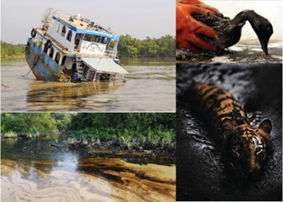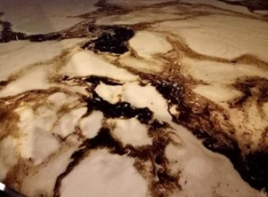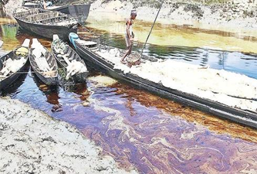
Figure 1(a)Sundarbans Oil Spillage [15] (b) Karnaphuli Oil Spillage [16] (c) Karnaphuli Oil Pollution [16]
A significant amount of oil waste is spilled from different industries. In Bangladesh, these spillages are done by different types of industries. The Eastern Refinery and other related industries are generally situated on the river bank, and they use fresh water in the product cooling section. The water used is returned to the source. But this returned water contains petroleum products, crude oil, and mineral salts as contaminants. The important rivers of Bangladesh, such as the Meghna, the Shitolakhkha, the Buriganga, and the Karnaphuli, are massively polluted by the petroleum industries [23].
Again, many notable oil spillages took place around the world. Some of the notable ones are The Amoco Cadiz Oil Spill (1978), the Castillo de Bellver Oil Spill (1983), the Incidents at the Nowruz Oil Field (1983), the Kolva River Spill (1994), the Mingbulak (or Fergana Valley) Oil Spill (1992), the Atlantic Empress Oil Spill (1979) the Ixtoc 1 Oil Spill (1979), BP's Deepwater Horizon Oil Spill (2010), the Persian Gulf War Oil Spill (1991) [18].

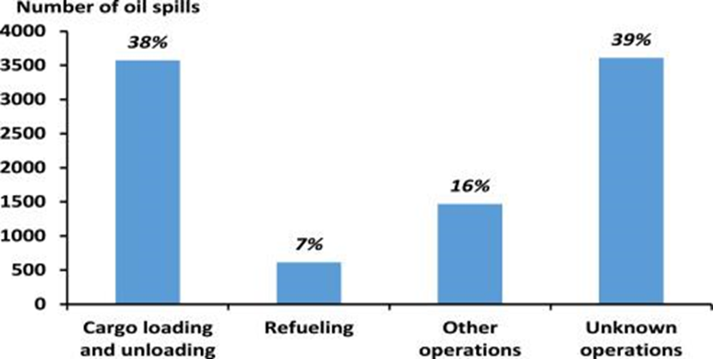
Figure 2 : Oil spill from global tankers [19]
Events of oil spillage have made it necessary to find a solution for mitigating the worst possible environmental impacts. Marine animals are being extinct because of its adverse effects. The food chain among marine species is also being interrupted. Marine animals are being malnourished. Photosynthesis of aquatic plants gets interrupted. Water buoyancy and salinity or pH levels get disturbed. Moreover, oil can coat a bird's wings and leave it unable to fly or strip away when the bird comes to collect their food (Figure 4). The pure water crisis may rise too [20]. The effect of oil spills is very long-lasting.
Figure 3 below shows us the effects of oily water pollution:
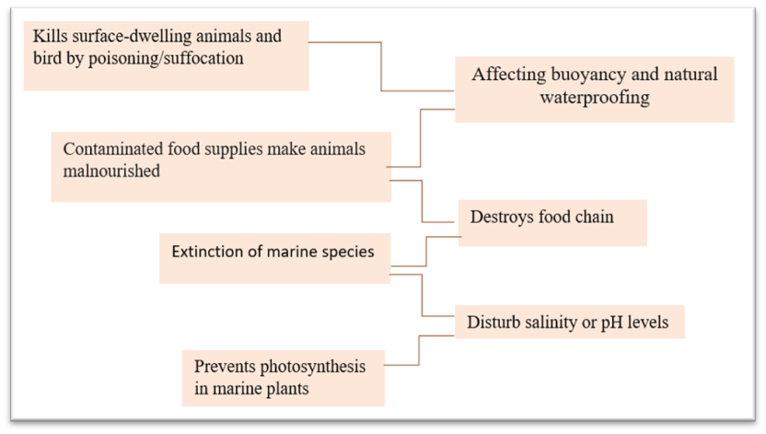
Figure 3: Effects of Oily water pollution (photo by author)
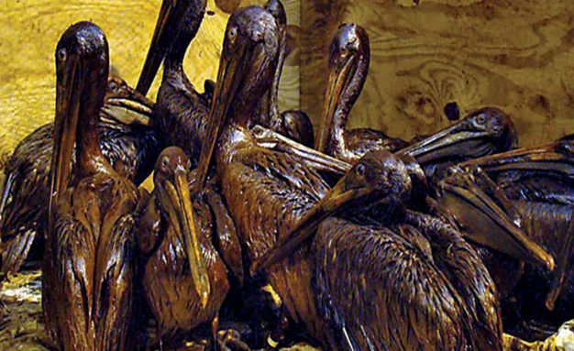
Figure 4: Victim of an oil spill (Britannica)
Therefore, it is to be said that oily water is a notable problem and should be dealt with effectively. Several methods have been employed to separate or treat oily water, including oil booms, skimmers, sorbents, dispersants, manual labor, or bioremediation [4]. But none of them were efficient enough to deal with this problem effectively. Also, the cost of these methods is high, and they harm the environment. But using hair as a bio adsorbent can be a possible solution to the problem. The idea of using human hair to clean up oil spills was initiated by Philip McCrory, an Alabama hairstylist, in 1989 during the Exxon Valdez disaster [12]. Much research has not been done regarding this, and as this solution of using the adsorption process to treat oily water problems has many positive aspects, more research has to be done, which is the fundamental motivation of this research.
Human hair (50-100 um in diameter) is a natural bio-sorbents consisting of dead cells made up of the cuticle, water, lipids, trace elements, and 65-95% proteins, main polymers of amino acids such as keratin and cysteine, medulla and cortex. The overall chemical composition of hair is 45 % carbon, 28 % oxygen, 15 % nitrogen, 7 % hydrogen, and 5 % Sulfur [6]. The hair shaft is essentially composed of keratin. Hair keratin is hard, compact, and strong. This fibrous protein is gradually formed inside cells from the germinal layer [1]. Animal furs are also natural fibers made of keratin proteins. Feathers also consist of the same structure. The cuticle is very hydrophobic, meaning it repels water. It also features a very porous cortex and many peptide linkages and in oily water, as the amount of water is more than oil, the hair was supposed to take in more water than oil. But the opposite is seen when studied under a microscope. The hair repels water and prefers to adsorb oil in more amounts.
The adsorption process works with human hair, animal fur, fleeces, or feathers [13]. Here in the experiment, human hair was used, but animal fur or feathers that have similar hair properties can also be used. In this process, the oil from the water can be easily separated as human hair or furs, and feathers can adsorb oil. They hold the oil in them, and the oil can be retrieved again from them by applying other methods. The reuse potential of hair makes this process attractive .
Materials and Method
Making the hair boom
For making a hair boom, the human hair was collected from a nearby local salon. Then the hair was separated from dirt like paper or pins. Then it was cleaned using detergent and water. After that, the hair was dried and packed using nylon thread before using them.
Methodology of experiment no. 1
In a container, 1 liter of water was taken. Seven hair booms of a mass of 20 g were made using human hair. The first experiment was done 7 times using the 7 hair booms of mass of 20 g hair, after adding 20 g, 40 g, 60 g, 80 g, 100 g, 120 g, and 140 g of vegetable oil, respectively, to 1 liter of water. It was seen that the hair was able to adsorb the oil. The adsorption factor was determined using the following formula:
Adsorption Factor = $\frac{w4-w3-(w1-w2)}{w3}$
Here,
W1=Mass of water
W2=Mass of water after oil adsorption
W3=Mass of hair boom
W4=Mass of adsorbed oil + hair boom + absorbed water
- Methodology of experiment no. 2
This experiment took 5 hair booms of different masses: 5 g, 10 g, 15 g, 20 g, and 25 g. In a container, 1 liter of water was taken. Oil was gradually added to measure the adsorption capacity of hair booms of different masses. Thus, the maximum adsorption factor could be obtained for each hair boom. The calculation was done by using the given formula:
Adsorption Factor=$\frac{w4-w3-(w1-w2)}{w3}$
Here,
W1=Mass of water
W2=Mass of water after oil adsorption
W3=Mass of hair boom
W4=Mass of adsorbed oil+ hair boom+absorbed water
Figure 5 below shows the experimental methods using the hair booms:
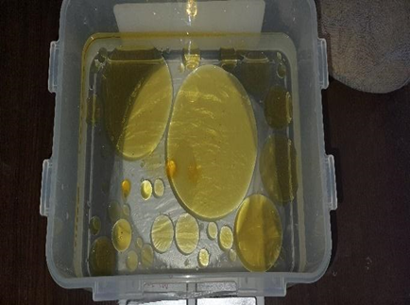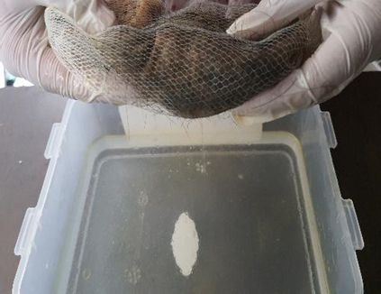
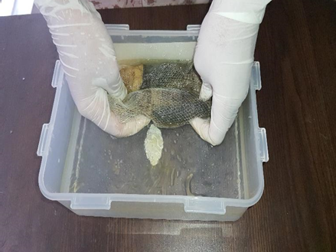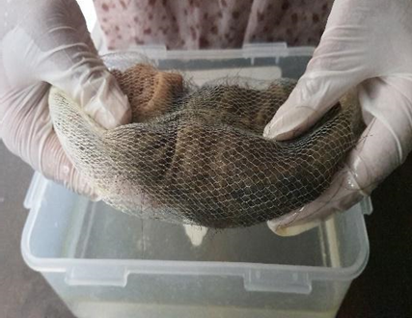
Photo by author
Figure 5: Oil and water separation using hair boom
Experimental Results
Experiment no. 1 results:
The data below shows the result of the experiment:
Table 1: Data of oil adsorbed by the hair and adsorption factor
Oil adsorbed by the hair (grams) | Average oil adsorbed per gram of hair (grams)  (adsorption factor)
20 | 1
40 | 2
60 | 3
80 | 4
100 | 5
120 | 6
140 | 6
The graph below shows the data for the adsorption factor:
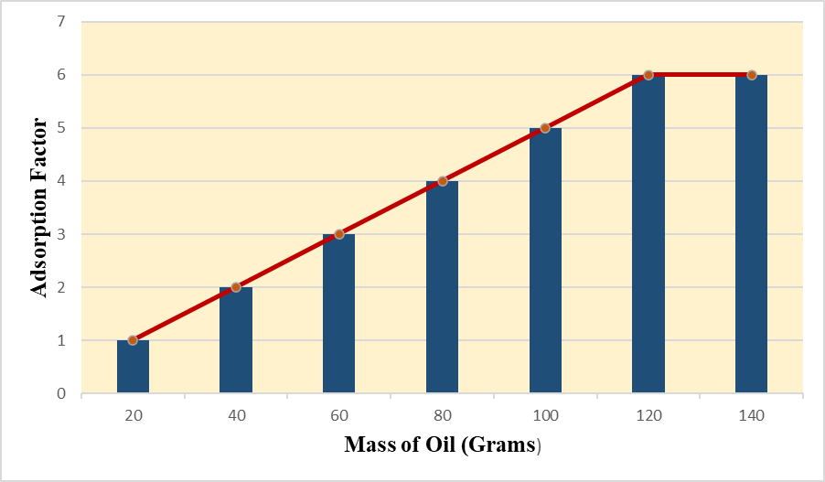
Figure 6: Adsorption factor vs. mass of oil graph (Data by author)
In the above figure 6, the mass of the hair boom was kept constant. During the experiment, each of the hair booms of mass of 20 g was dipped into oily water, and it was seen that the 1st hair boom was able to adsorb all of the 20 g of oil from the water. Again the 2nd hair boom could adsorb all of the 40 g of oil. The 3rd, 4th, 5^{th,} and 6th hair booms were also able to adsorb 60 g, 80 g, 100 g, and 120 g of oil from the water. The graph had a linear increase as the adsorption factor increased with the increase in oil. But the 7th hair boom couldn't adsorb all of the 140 g of oil from the water. This shows that a hair of a certain mass has a certain maximum adsorption capacity. The hair booms were able to adsorb a maximum of 6 times of oil of its mass.
This is possible for hair-black or blonde, straight or curly, and animal furs and feathers.
Experiment no. 2 results:
The data below shows the results of the experiment.
Table 2: Mass of hair, oil adsorbed, and adsorption factor data.
Hair mass (grams) | Oil adsorbed by the hair (grams) | Average oil adsorbed per gram of hair (adsorption factor)
5 | 26 | 5.2
10 | 61 | 6.1
15 | 79 | 5.3
20 | 126 | 6.3
25 | 173 | 6.9

Five hair booms of mass 5 g, 10 g, 15 g, 20 g, and 25 g were taken during the experiment. They were dipped into the oily water. The oil was added gradually to test the maximum adsorption capacity, and it was seen that the 1st hair boom was able to adsorb a maximum amount of 26 g of oil. Then again, the other hair booms were dipped into oily water, where oil was added gradually. It was seen that the 2nd, 3rd, 4^{th,} and 5th hair booms were able to adsorb a maximum amount of 61g, 79g, 126 g, and 173 g of oil, respectively. This shows us that hairs of different masses and different types have different maximum adsorption capacities. But in every case, the maximum adsorption factor is above 5. Figures 7 and 8 below show us the results:
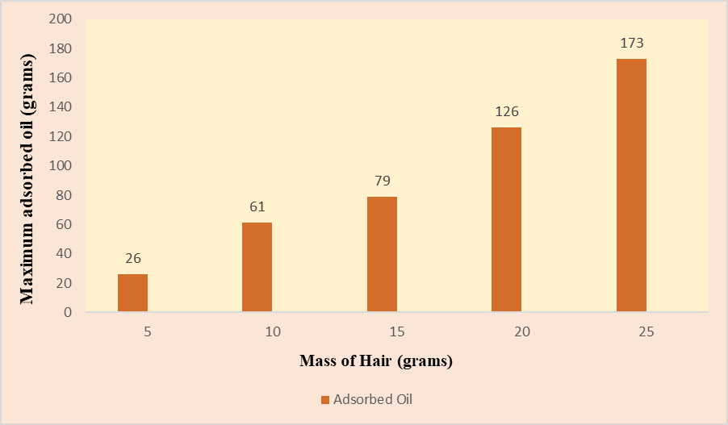
(Data by author)
Figure 7: Mass of maximum adsorbed oil vs mass of hair graph
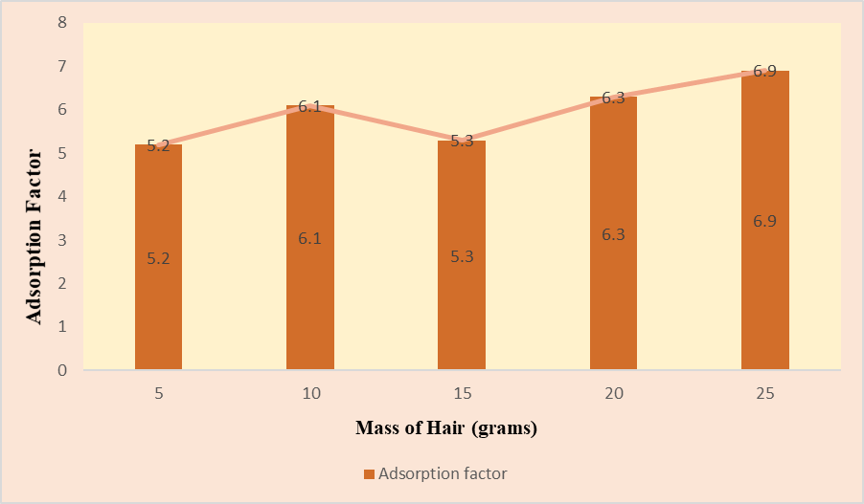
(Data by author)
Figure 8: Adsorption Factor vs mass of hair graph
Hair is termed as a waste product in salons and hairdressers. Any hair below 6 inches cannot be used to make wigs. So, the small hair is thrown away. So, collecting small hairs below 6 inches, and using these hairs for making hair networks is the best possible use of them as hair can adsorb a high amount of oil within a short period.
Discussion
The purpose of the first experiment of this study was to create hair booms that were capable of separating the oil from the water. At first, the mass of the hair boom was kept constant to find the maximum amount of oil that the hair of constant mass could adsorb. It was seen that at a certain amount, the hair could not adsorb any more oil, and thus, the maximum capacity was found. But this maximum capacity is not the same for all types of hair. That is why to find out the average adsorption factor the second experiment was done where the mass of hair was different in each of the five hair booms. Oil was gradually added to the solution to test the maximum adsorption factor. It was seen that every time the adsorption factor was above 5. All the hair booms were successfully able to separate oil from oil-contaminated water. All the experiments did not take more than five minutes to separate all the oil. As oil concentration can vary, the time required will also vary. This discussion was not done before in previous studies.
Adsorption is the process of a solid surface holding a gas, liquid, or dissolved solids molecule and forming a thin film. Hair, whether human or animal, can adsorb a wide range of oils, many of which are potentially harmful. This includes motor oils and crude oils with a high likelihood of spilling. Because of the numerous cracks on its surface, hair can hold oil molecules. Oil molecules accumulate in these crevices and form hydrogen bonds with the protein keratin, which is responsible for the hair structure's skeleton. As water is taken in larger concentrations than oil, it is more probable for water to be adsorbed in larger quantities than oil, but the reverse is true when experiments are conducted. Moreover, when the phenomenon is studied under an optical microscope, oil replaces water from the hair surface. It can be explained in terms of selective physical adsorption. The adhesive forces between oil and hair are greater than those existing between water and hair. Thus, hair selectively adsorbs oil in the presence of oil and water. Thus, oil is separated from water when a mixture is passed through a hair bed. The adsorption might be taking place on the glassy membrane, a non-cellular portion . As a result, the oil and water are separated. Experiments have shown that as the concentration of oil increases, the degree of adsorption on the hair surface increases. As a result, this procedure is particularly effective for significant oil spills and oily water treatment, and any minor oily water treatment [2], [7], [9],[14]. The amount of oil absorbed is determined by the mass and absorption capacity of the hair, not by the width of the hair network. Animal furs and feathers have the same qualities as each other.
For making a hair network, the human hair or fur, or feather has to be collected, cleaned, and packed before using them. Human hair can be collected from various sources. One of the primary sources is from the barbers and hair stylist shops. Long hairs above 6-7 inches are used to make wigs. But the other short hair is thrown away and termed as waste. That hair could be used for making hair meshes and can be obtained at a very low price or even for free. Again, hair can also be collected from religious places or hospitals too. The hairs obtained from these sources are generally of very good quality and hair networks can easily be made from them. Animal furs or feathers can also be used in making the network, which is collected from pet shops, slaughterhouses, etc. After collecting, appropriate cleaning is required to eliminate any moisture, pathogens that could hurt the handlers or the marine ecology, oil, and any toxic chemicals, to extend the hair's shelf life and prevent undesirable microbial development. While washing the hair, you should do the following.
Separation | Washing | Cleaning,
First, of all, the hair/fur/feathers should be separated from any other waste materials attached to them like paper or any other waste. This separation process has to be carried out manually. Then these need to be washed using any kind of detergents or chemicals. Lastly, the hair needs to be properly dried before making any booms, mats, or packaging and then stored in a dry place.
For using the hair booms, they are laid on the water surface. But as the oil or other particles are heavier, it will weigh down the hair, making it sink. Thus, they have to be replaced periodically when they start sinking. To avoid the spillage caused by motor oils, the hair booms can be placed beside the drainage. Again, in factories, the oily water can be treated using the hair network before spilling them.
Meshes that have just been produced can be stored without special care, although they should be kept clean and dry. However, the meshes must be made oil-free and thoroughly cleaned before being dried and stored after usage. Before discarding the mesh, it can be used 34 times [11]. Because of this maximal utilization, the process is more renewable.
Cost Analysis
There are many methods for the management of oil spills. Some of the notable methods are- skimming, siphoning, burning, foam sponge, etc. Using hair mesh is a very effective method, and it is also very cost-effective compared to other methods. The figure below shows the cost comparison of different methods.
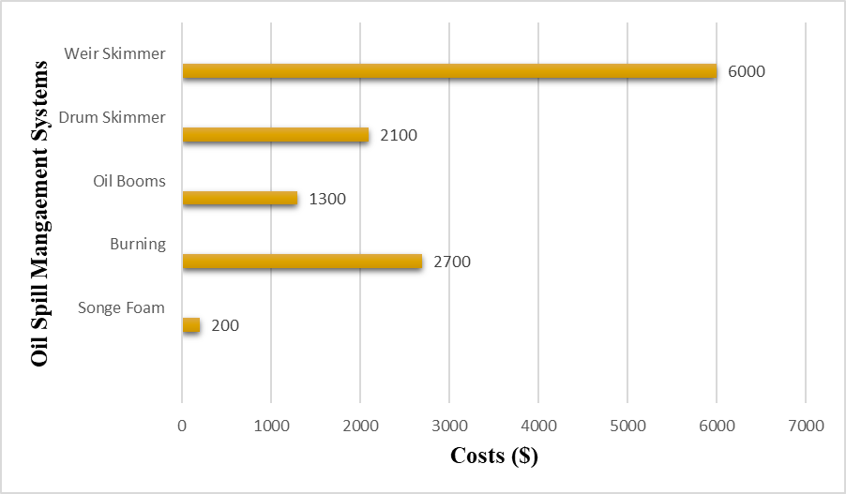
Figure 9: Costs of different oil spill management systems (in USD $) [10],[5],[8],[24]
The graph shows the cost of managing a medium oil spill. It can be seen that the cost of using these methods is high [10], [5], [8], [24]. Although the cost of using sponge foam is lower, using sponge foam has other environmental effects. But hair mesh can be a possible solution. As hair is a waste product, it is a cost-friendly solution. Hair mesh is a good option considering other environmental factors as it is completely biodegradable. So, after cost analysis, it can be said that hair mesh is our best possible option.
Efficiency analysis
Efficiency is a very important factor to be considered while performing any work. For oil spill management, if we calculate the efficiency of different methods, we can understand that hair mesh is a much better option to consider if we want to achieve our goal of cleaning up the oil spill.
The figure below compares the efficiency of different oil spill management methods.
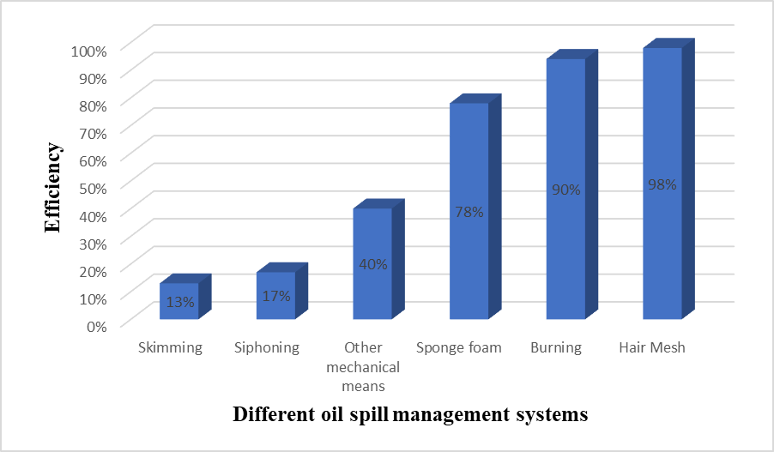
Figure 10: Efficiency of different oil spill management systems [26], [25],[11]
The efficiency of using a skimmer is 13%, and siphoning is 17% only. Again, although burning gives us an efficiency of 90%, it comes with other adverse environmental effects like producing different harmful greenhouse gasses [25]. Using sponge foam is efficient upto 78%. [26]. It can be seen that using hair mesh gives us an efficiency of 98% [11]. So, after comparing efficiency, hair mesh still seems like the best option to achieve our goal.
The oil adsorbed can be recovered again. The retrieved oil can be used to run machines in any factories or run power plants. And after the maximum use of hair networks, the hair can be buried in the soil or can be used as a fertilizer. As hair is completely biodegradable, the hair will not be causing any harm to the environment. This entire process makes the idea a more renewable, greener, and profitable approach. Several methods in which the adsorbent can be recovered and reused, e.g. compression, centrifugation, and solvent extraction [3]. The solvent extraction method can be employed in this research. In evaluating the reusability of human hair for oil sorption, the adsorbent has to be first washed with hot and cold water. All remaining oil then has to be extracted using n-hexane. The recovered adsorbent then has to be dried and reused for the batch adsorption experiments in four continuous cycles after each desorption test [3]. The oil adsorbed from the total process of oily water treatment can be recovered by applying certain methods. After retrieving the oil, the hair network can be used a maximum of 34 times. More than 90% of oil can be retrieved [1]. There are different methods by which the adsorbent can be recovered and reused. The two methods generally used are the chemical method and the physical method. The chemical method can be performed by using different chemical treating agents. Again, the physical method includes applying compression or solvent extraction. This ensures maximum oil recovery.
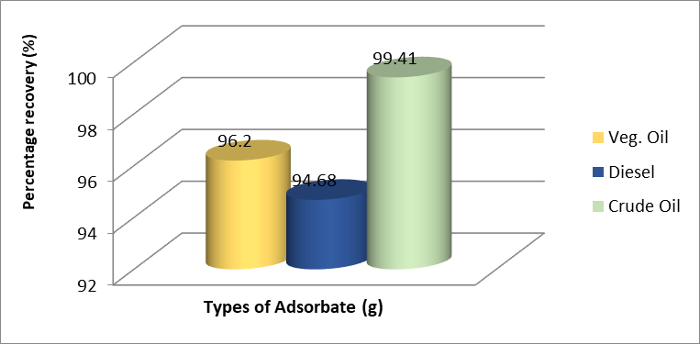
Figure 11: Oil recovery experiment for vegetable oil, crude oil, and diesel fuel [1]
Figure 11 which is based on previous studies shows a percentage recovery of 99.41% for crude oil, 94.68% for diesel, and 96.2% for vegetable oil respectively. This indicates that the process is not 100% efficient, although crude oil showed a very high percentage recovery.
Using human hair as a natural bio sorbent for oily water treatment was successful in various areas of interest. After doing the oil adsorption experiment, 200 ml of water sample was tested, and it was seen that only 0.04 ml of oil remained in the solution proving how much purity was obtained using this adsorption process by hair network. It was seen that a hair could absorb the oil amount five times more than its weight. Again, as small hairs or many furs and feathers are considered a waste product, this solution is cost-effective. Moreover, this solution has high efficiency and is environmentally friendly. This solution can be implemented both on large and small scales. Local people can treat oily water by making and using these simple hair booms. Again, different industries, mills, and factories can also implement this solution to treat their oily wastewater. Government can use this solution to deal with large-scale oil spillage. As this solution is very easy to implement, any type of oily water problem should not be left untreated. By doing more research, innovations can be made to this research.
Conclusions:
The capacity of human hair to adsorb crude oil, vegetable oil, and diesel fuel was reviewed to establish its potential for oily water treatment.. Human hairs are low-cost adsorbents and can be used as the best adsorbents for removing oil from wastewater. We can minimize the cost by using low-cost adsorbents instead of using costly chemicals or adsorbents. Low-cost adsorbents improve the treatment process without affecting the chemical characteristics of wastewater. This is timely not just because of the need to remove contaminants from the environment without due diligence to its impact, but because it is environmentally friendly and encourages the principle of converting waste to wealth. Hence, this indicates that human hair can be modified into boom and used as a low-cost, environmentally friendly adsorbent for cleaning up oil spills, especially considering its potential for reusability without significantly altering the sorption features.
This study on hair as an adsorbent can open the door for further research designed to increase adsorption efficiency. Moreover, if the comparison is made from different oily water treatment methods, hair is the most cost-effective, highly efficient, and environmentally friendly method. Burning, using sponge foam, or using microorganisms to treat oily water may be effective, but the environmental effects caused by them are fatal. But this adsorption method opens up a new horizon to this huge problem. Large-scale use of this method should be implemented, and more research is to be done about this to increase its efficiency.
References
[1] Peter Rowland Ukotije-Ikwut, Akpevwe Kelvin Idogun, Christopher, Tubuyai Iriakuma Abiye Aseminaso and Tamunotonjo Obomanu, (2016) "A Novel Method for Adsorption using Human Hair as a Natural Oil Spill Sorbent"

[2] Khaled Abuhasel, Mohamed Kchaou, Mohammed Alquraish, Yamuna Munusamy, Yong Tzyy Jeng, (2021), "Oily Wastewater Treatment: Overview of Conventional and Modern Methods, Challenges, and Future Opportunities"
[3] Maria Luisa Soto, Andres Moure, Herminia Dominguez, Juan Carlos Parajo, (2011) "Recovery, concentration and purification of phenolic compounds by adsorption: A review"
[4] Mayur Agarwal , '10 Methods for Oil Spill Cleanup at Sea', Marine Insight, (2021)
[5] Stephen Gandel, "Cleaning Up on the Oil Spill: Who's Making Money?" (2010)
[6] Carmen La Torre, Bharat Bhushan, (Epub 2005), "Nanotribological characterization of human hair and skin using atomic force microscopy"
[7] V.Nitilesh Kumar, Anup C Halekote, Hemanth Kumar BJ & Akshay, (2019) "Adsorption of Natural Oil Spills Using Human Hair As Sorbent"
[8] Dagmar Schmidt Etkin, "Worldwide Analysis of Marine Oil Spill Cleanup Cost Factors" (2000)
[9] A S Jadhav, M Y Naniwadeka, N H Shinde, S V Anekar, (2011), “Study of adsorption of oil from oily water using human hair”
[10] "What would the economic cost of an oil spill would be?", Sacred Trust
[11] Janvi Manish Shah, (2020), "Use of hair mesh for oil spill management"
[12] Blair S. Walker, 'A hairy way to clean up the gulf oil spill' AARP Bulletin, (2010)
[13] Y. Artioli, "Adsorption" Encyclopedia of Ecology (2008)
[14] Augustine Osamor Ifelebuegu, Tuan VuAnh Nguyen, PeterUkotije-Ikwut,Zenebu Momoh, (2015), "Liquid-phase sorption characteristics of human hair as a natural oil spill sorbent"
[15] ‘2014 Sundarbans Oil Spills', Wikipedia
[16] Shamsuddin Illius, 'Oil spill in Bangladesh's Karnaphuli River a threat to critically endangered Ganges dolphins', Firstpost
[17]' No step taken yet to stop oil spillage in Meghna', The Financial Express (2018)

[18] John P. Rafferty, '9 of the Biggest Oil Spills in History', Britannica

[19] Jihong Chen, Weipen Zhang, Zheng Wan, Sifan Li, Tiancun Huang, Yijie Fei, (2019), "Oil spills from global tankers: Status review and future governance"

[20] Charlotte Edmond, "This is how oil spills damage our environment", World Economic Forum
[21] Gina Barton, "How your split ends can help clean oil spills" Vox (2018)

[22] Maciej Kolaczkowski, Amy White, "Why do oil prices matter to the global economy? An expert explains", World Economic Forum (2022)

[23] Md. Shajedul Islam, M. G. Mostafa, (2021), "Environmental Hazards of Petroleum Refinery in Bangladesh: A Review''

[24] Derek Yurgaitis, "How Much It Costs to Clean Up an Oil Spill" (2017)

[25] "Fighting oil spills with fire", International Fire Fighter,(2017)

[26] Chandrashekhar S.Patil, Vaibhav R.Patil, Sanket N.Anbhule, Chandrakant J.Khilare, Govind B.Kolekar, Anil H.Gore, “Waste packaging polymeric foam for oil-water separation: An environmental remediation” (2018)

