ST. MARY’S SCHOOL-LIMASSOL-CYPRUS

ENTRY TO THE STOCKHOLM JUNIOR WATER PRIZE 2022

Cyanobacteria harmful blooms (cyanoHABs) in water reservoirs, effect of humics concentration and treatment with peroxide granules

Mikaella Skordi
Michaela Michael

Collaboration with Dr. Maria G. Antoniou, and Mrs. Eleni Keliri
Water Treatment Laboratory-Aqua, Department of Chemical Engineering of the
Cyprus University of Technology

“We would also like to express our deep gratitude to our chemistry professor Mrs. Irini Louca Papantoniou, who offered constant support and encouragement throughout this study.”

February 2022

Abstract
Cyanobacteria are photosynthetic microorganisms found mainly in surface water environments. High concentrations of nutrients (mainly nitrogen and phosphorus), lead to the formation of harmful cyanobacterial blooms known as “cyanoHABs”. These harmful cyanobacteria have the capability of releasing a plethora of cyanotoxins which can have adverse effects not only on the human and animal health but also on the aquatic ecosystem. This study aimed to examine the effect of humics on calcium peroxide (CaO₂) granules treatment to suppress the proliferation of the Microcystis sp. bloom in a surface water matrix (Kouris Dam, Limassol, Cyprus). Collected surface water samples were checked for their water quality characteristics, and spiked with Microcystis sp. and 1, 5, and 10 ppm of humics to perform the treatment experiments. Through our experimental process, we concluded that CaO₂ granules were the most efficient at 10 ppm of HASS owing to a complete decline in the phycocyanin fluorescence (Ft) and quantum yield of PSII (Fv/Fm). Although there was a partial decrease of cyanobacteria in the other concentrations of HASS (1, 5 ppm), we observed that after some time the cyanobacteria had restored their photosynthetic ability, indicating that they were not entirely distructed by the applied chemical. The current study emphasizes the necessity of developing an efficient and affordable treatment approach to eliminate cyanoHABs that may be present over wide areas of water and have the ability to threaten the aquatic ecosystem. Since our experimental treatment indicated successful cyanobacterial destruction, and that humic content can increase the treatment efficiency, CaO₂ granules are a promising solid oxidant for mitigating cyanoHABs but further investigations are needed in future studies, in order to evaluate other parameters regarding its safety before it could be used in the field.

Table of Contents
Abstract 2
1 INTRODUCTION 4
2 EXPERIMENTAL PROCEDURE 8
2.1 Sampling of water 8
2.2 Water characterization 9
2.3 Kouris matrix spiked with humic acid sodium salt 10
2.4 Hydrogen peroxide (H₂O₂) release experiments in surface water enriched with HASS 10
2.5 Kouris matrix spiked with HASS and cyanobacteria culture 11
3 RESULTS & DISCUSSION 13
3.1 Water quality characteristics 13
3.2 HASS effect on H₂O₂ release by CaO₂ granules 13
3.3 Treatment of Microcystis sp. In Kouris water spiked with HASS 14
4 CONCLUSIONS 17
5 REFERENCES 18

INTRODUCTION
Cyanobacteria (or blue-green algae) are phytoplankton microorganisms that appear to be one of the most well-known photosynthetic organisms [1-2]. About 3.5 billion years ago, evolution enabled them to give out oxygen as a by-product and oxygenate the earth’s atmosphere[1-3]. They contain different photosynthetic pigments such as chlorophyll-a, chlorophyll-b, phycocyanin, and carotenoids which enable them to capture light energy from the sun and proceed with photosynthesis. Due to said years of evolution and adaptation, cyanobacterial blooms can now survive in extreme conditions such as hot and cold environments. They can be found in saltwater, freshwater, or brackish water [4] but they develop and reproduce best under warmer conditions with plenty of nutrients, mainly in the presence of phosphorus and nitrogen. Stagnant water such as ponds, lakes, and still rivers allow cyanobacteria to easily accumulate on their surface with CO₂ and sun-light favoring their further and rapid growth which leads to the formation of cyanobacterial harmful blooms (cyanoHABs)[5].
Climate change and global warming will affect the future immensity of cyanobacterial blooms. The Earth’s temperature increased due to the release of greenhouse gases like CO₂, methane, and water vapor from fossil fuel burning, industries, gas emissions, and other human activities. In combination with current contamination of surface water, the growth of cyanobacteria microorganisms in the aquatic environments is promoted [4]. A repercussion of warmer seasons throughout the year is the higher water temperatures that mainly favor the growth of the prokaryotic cyanobacteria more than any other eukaryotic phytoplankton class. Since their optimum temperature for growth is above 25 degrees Celsius, their chances of survival project increased probability than other organisms. Extreme weather conditions such as rainfall can cause the transport and buildup of nutrients in calm waters benefiting these microorganisms’ growth. The proliferation of cyanobacteria can also occur during drought conditions since high evaporation levels increase nutrient presence in waters [4].
Problems start to emerge when cyanobacteria bloom in a more persistent way, due to the overabundance of nutrients in the water [5]. This excess load of nutrients can come from heavy rainfalls, soil erosion, or even from anthropogenic activities such as agricultural activities with the excessive use of fertilizers, urban planning and swage run-offs[1- 5]. The uncontrolled proliferation of cyanobacteria has resulted in the development of harmful algal blooms also known as cyanoHABs, which can then cause the degradation of the water quality leading to the formation of a hypoxic environment [1]. They have the ability not only to produce inadmissible odor and taste to the water but also to produce soluble toxic compounds known as cyanotoxins [6]. They are often released when algal blooms die and their cellular membrane bursts, releasing their toxins into the aquatic environment. Their toxins can have a negative impact on aquatic biodiversity as they directly affect fish and aquatic life wellness, as well as cause serious health effects on humans and animals that come in contact with the toxic water[1]. Neurotoxins produced by different cyanobacteria cause damage to the nervous system, dermatoxins are known to irritate the skin after contact, hepatotoxins injure the liver and there have been at least 50 reported deaths after exposure to microcystin toxins in kidney dialysis patients[4].
The most dominant toxic species of cyanoHABs which are most commonly found all over the world include Microcystis, Dolicho permum, Planktothrix, Raphidiopsis, and Aphanizomenon[5]. Microcystis appears to be the most common cyanobacteria genus, producing microcystin-LR which is the most toxic hepatotoxin as well as anatoxin-A toxins [5-6]. In drinking water microcystin-LR is regulated and must be <1 μg/L in EU regions[7]. The structure of microcystin is a cyclic heptapeptide and it has the ability to operate as tumor promoters[6-8]. They are also the only cyanotoxins for which there are drinking water guidelines levels set by the World Health Organization (WHO)[5].
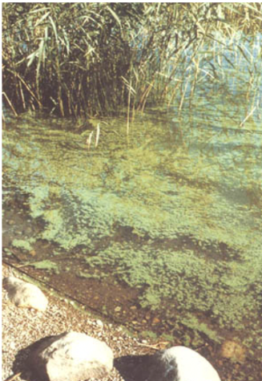
Scheme 1. Left: Cyanobacteria Harmful Algal Blooms in surface water,
Right: Microcystis sp. under the microscope [9]

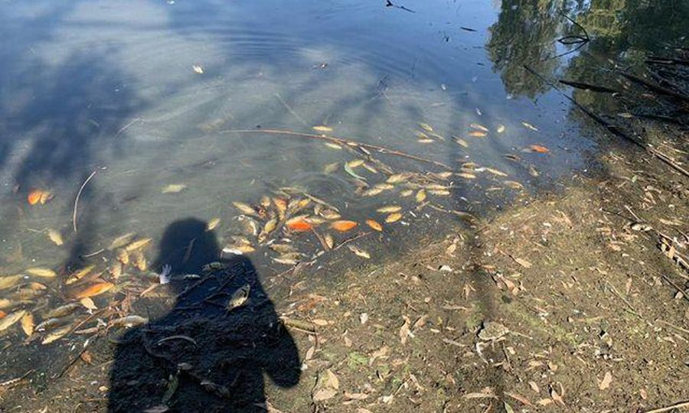
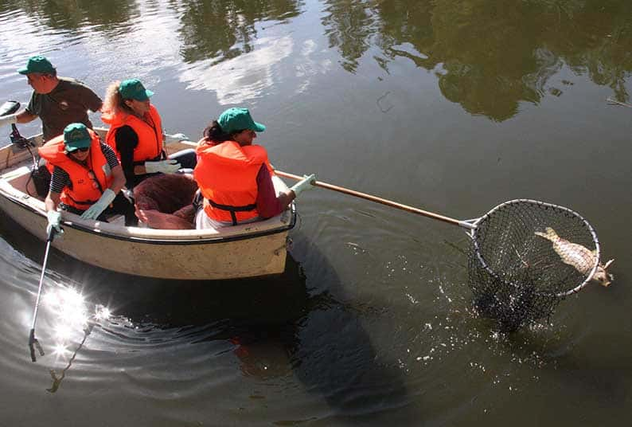
This grave issue was brought to our attention after the release of several articles from our local newspapers. These articles contained incriminating pictures of what neglected cyanobacterial blooms might cause to aquatic environments as shown in scheme 2. We thereby acknowledged that this issue is far more prominent than we previously thought once it reached the lake in Athalassa National park, located in Nicosia district here in our small island Cyprus. In September 2020, state authorities warned the public to avoid contact with the water at the lake in Athalassa National park, since sightings of dead fish floating upside down at the surface were reported, prompting officials from various state agencies to obtain water samples for testing. Examinations from members of the Forest Department of Cyprus concluded that the emergence of said dead fish at the lake’s shores was a result of the release of cyanotoxins from the heaps of cyanobacteria present in the lake. Government officials were not in the position to find viable solutions to this recurring matter so when faced with these dreadful news, we decided to optimally step up and become part of the solution to this grim and worldwide concern, always keeping in mind the salvage of the aquatic ecosystems and prolonging human health. Our main objective was an immediate and efficacious treatment method as the safeguarding of this biotope is of great significance to our country in order to avoid further contamination of nearby lakes.

Scheme 2. Lake in Athalassa National Park (Nicosia, Cyprus)

All of the aforementioned issues regarding cyanoHABs are of major concern and require effective treatment methods. Prevention of cyanoHABs by limiting nutrients availability into waterbodies is preferred than chemical and physical treatment options. But since contamination events are unpredictable, chemical and physical methods are required to mitigate cyanoHABs in source waters. Fountains or surface mixers are physical methods that are effective in small areas of water [5] as shown in Scheme 3. CyanoHABs proliferate easier in calm waters and various mixers create the opposite effect preventing their flourishing. Their high energy costs along with the accumulation of cyanobacteria right outside the mixing zones make this not a viable method on its own[5]. When it comes to other physical approaches, booms and oil screens as shown in Scheme 3, are used to accumulate floating blooms that can be easily removed by mechanical harvesting [2-5]. This treatment method has been observed recently in lake Taihu in China but its effectiveness is uncertain since it only creates abundant space for further cyanobacterial growth along with the possible contamination of deeper waters by cyanotoxins[2]. One well-known chemical treatment was copper sulfate algicide due to its lower cost, effectiveness and easy application. It showed immediate results in Lake Nanhu in China, but its use is no longer encouraged (regulated chemical in EU) due to the harmful effects of copper on fish and humans [2-5].
Shifting to more environmentally friendly treatment methods, the most promising chemical solution that has been proposed and applied for cyanoHABs mitigation in surface waters in recent years, is hydrogen peroxide (H₂O₂). For efficient bloom destruction doses over 5 mg L⁻¹ are required that again pose a threat to large lakes and their aquatic environments[1]. Said high doses do not only pose threat to various ecosystems but make this treatment method far from cost-effective[5].
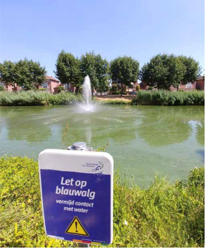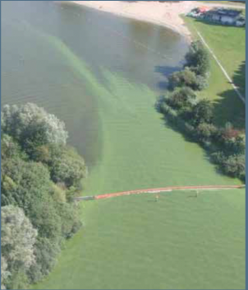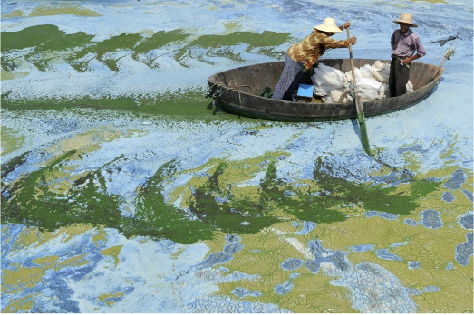
Scheme 3. Left to Right: Fountain method [5], Booms and oil screens [5], Copper sulfate treatment in Lake Nanhu, China
A recent study conducted at St. George Lake in Cyprus, in 2019, aimed to propose an effective treatment approach for in-lake application in order to restore the lake's water quality. The application of calcium peroxide granules (CaO₂) in comparison with liquid H₂O₂ were examined on a naturally occurred Merismopedia sp. bloom in St. George Lake. CaO₂ granules are a metallic and solid form of H₂O₂ that can be slowly released into the water, and therefore avoid instant high doses of oxidant that are now being applied into surface waters. Starting off with the lowest doses of H₂O₂, it was observed that the treatment was inefficient since the cyanobacteria continued developing gradually. Treatment with CaO₂ granules showed to successfully lower the photosynthetic activity (Ft) of the cyanobacteria cells as the pigment concentration was decreased at a significant level. The concentration that was shown to be the most effective was 3 g L⁻¹ as the quantum yield of PSII remained low after the treatment. Throughout the overall experimental treatment, CaO₂ granules were considered to be the more effective in-lake treatment for the destruction of the dense Mersismopedia sp. than the liquid H₂O₂.

This study aimed to examine the effect of humics on calcium peroxide (CaO₂) granules treatment to suppress the proliferation of the Microcystis sp. bloom in a surface water matrix (Kouris Dam, Limassol, Cyprus). We have firstly performed an experimental procedure on the release of H₂O₂ by CaO₂ granules in surface water enriched with different concentrations (0,1,5,10 ppm) of humic acid sodium salt (HASS). Then, collected surface water samples were checked for their water quality characteristics, and spiked with Microcystis sp. and 1, 5, 10 ppm of humics to perform treatment experiments. The goal was to observe the effect CaO₂ granules have on the photosynthetic activity of cyanobacterial blooms and therefore their efficiency on mitigating the bloom. The experiment was done for testing our hypothesis on the effect of humics on the mitigation efficiency of CaO₂ granules on cyanobacteria blooms, thus to propose a new, cost-friendly, and more effective treatment to the current best that still poses threat to aquatic environments and is inefficient in larger areas of water.

EXPERIMENTAL PROCEDURE

Sampling of water
Sampling was performed at Kouris Dam, located in Limassol district in Cyprus. Water was collected from the surface with the use of a 10 L bucket and a 4 m rope. The rope was attached to the bucket lid and thrown into a central part of the dam to collect water while avoiding collecting rocks and sediments. Samples of water were taken and preserved in 10 L polyethylene bottles for experimental purposes. All samples were stored under cool conditions and brought to the laboratory the same day.
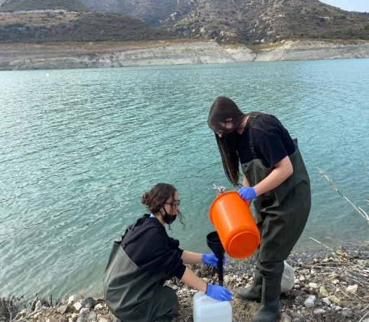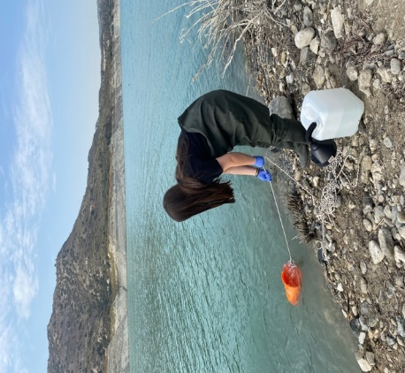
Scheme 4. Sampling process at Kouris Dam on 15/11/2021.

Water characterization
Samples collected were examined for their main physical, and chemical parameters (pH, conductivity, salinity, total dissolved solids). Parameters were measured using the ExStick probe (EXTECH), while total nutrients (total nitrogen and total phosphorous) were determined with the use of Spectroquant® cell test kits (Merck Millipore). Starting with the phosphate cell test kit, we pipetted 0.20 ml of the digested sample into a reaction cell and mixed it, while shaking the closed-cell intensely. We then added 5 drops of the reagent P-2K and we closed the cell tightly and mixed it. After adding 1 dose of the reagent P-3K, we closed the cell tightly and shook it vigorously until the reagent was completely dissolved. The samples were left to stand for 5 minutes at room temperature and their absorbance and direct quantification were performed in Spectroquant® Pharo 300 spectrophotometer (Merck). Continuing with the nitrogen (total) cell test, after digestion of sample was allowed to cool at room temperature in a test-tube rack. After 10 minutes, we shook briefly the cell and during this stage, turbidity or even precipitation can occur in the digestion solution. We added 1.0 ml of the digested, cooled sample and pipetted it into a reaction cell. After the addition of 1.0 ml of the reagent N-3K with the pipette, we closed the cell tightly and mixed it. The hot cell was left to stand for 10 minutes and then the absorbance and direct quantification was performed in Spectroquant® Pharo 300 spectrophotometer (Merck). Method detection limits (MDL) and method standard deviations (SD) were 0.50 mg/L for nitrogen cell tests, 0.05 mg/L for phosphorous cell tests, and ±0.15, ±0.027 mg/L, respectively.
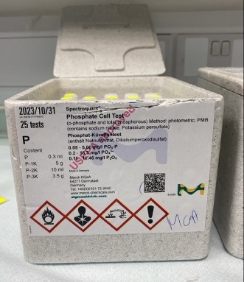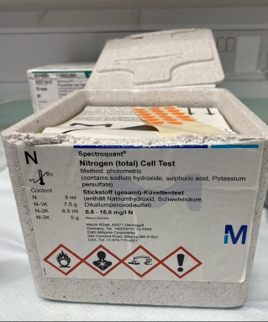
Scheme 5. Left: Spectroquant® cell test kits (Merck Millipore) for total phosphorus, and right: total nitrogen.

Kouris matrix spiked with humic acid sodium salt
Collected water from Kouris Dam was poured into glass containers (200 mL x 12 flasks). Each flask contained 200 mL of surface water spiked with 0, 1, 5 and 10 mL of humic acid sodium salt (HASS) to achieve 0, 1, 5, and 10 ppm HASS matrix, respectively. Humic Acid Sodium Salt stock solution was prepared 24 hours before the experiment by adding 0.2 g HASS into 1 L of extra pure (Milli-Q) water. The solution contained in a volumetric flask was placed on a stirring plate with a stirring magnet overnight to dissolve and then used for spiking.
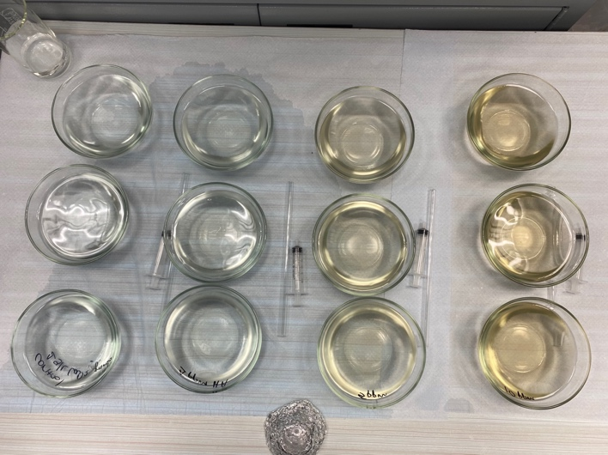
Scheme 6. Flasks with 200 mL of surface water (Kouris Dam) spiked with 0, 1, 5, and 10 ppm HASS.

Hydrogen peroxide (H₂O₂) release experiments in surface water enriched with HASS
To examine the effect of humics on the H₂O₂ release kinetics, in each of the flasks containing surface water with humics, a quantity of CaO₂ granules was added to achieve a final concentration of 1 g/L CaO₂ granules. After the addition of granules, water samples from each flask were collected with a syringe to quantify the released H₂O₂ concentrations at t=0,1,2,4,24 hours of release. The released H₂O₂ concentration was monitored through a colorimetric reaction [8]. For instance, 1 mL of sample collected during the experiment was reacted with 0.1 mL of reaction reagent (50 g/L C₄K₂O₉Ti · 2H₂O) and 0.1 mL of H₂SO₄ (1+17 v/v). In the presence of H₂O_{2,} a complex with a yellowish color was formed and samples were measured at λ=400 nm in a spectrophotometer to determine the instant concentration of H₂O₂. The absorbance of each sample was translated into concentration through a calibration curve (y=0.0197x+0.002). During the release experiment, physicochemical characteristics of the water matrix were measured with the EXTECH stick probe at t=0, 24, and 48 h.
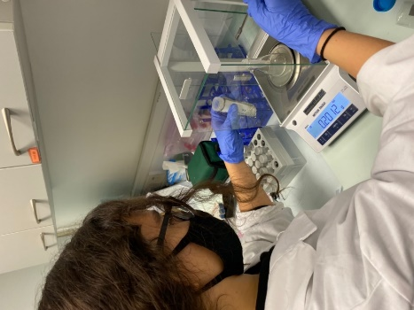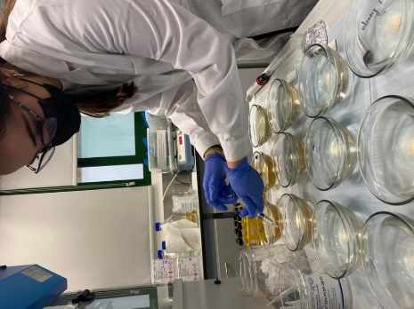
Scheme 7. Preparation of the flasks containing CaO₂ granules. Left: Michaela weighting granules, Right: Mikaella sampling at t= 0 hours.
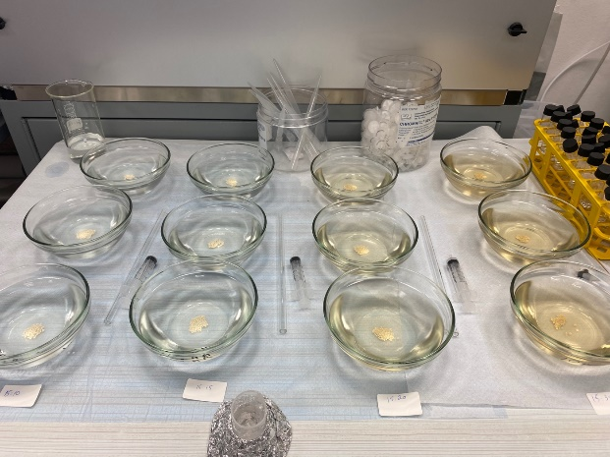
Scheme 8. Flasks with 200 mL of surface water spiked with 0, 1, 5, and 10 ppm HASS and 1 g/L CaO₂ granules.

Kouris matrix spiked with HASS and cyanobacteria culture
Water collected from Kouris dam was spiked with pure cultures of Microcystis sp. cultured at the Water Treatment Laboratory-AQUA of the Cyprus University of Technology. In order to maintain solely the cyanobacterial mass, Microcystis species were collected on a membrane filter following filtration to remove their growth medium and isolate the mass. The mass was then spiked and mixed with the water from Kouris dam enhanced with humic acid sodium salt at concentrations of 0, 1, 5, and 10 ppm HASS, and the water homogenized to obtain an equivalent initial phycocyanin fluorescence (8000 RFU) in each flask, as shown in Scheme 8.
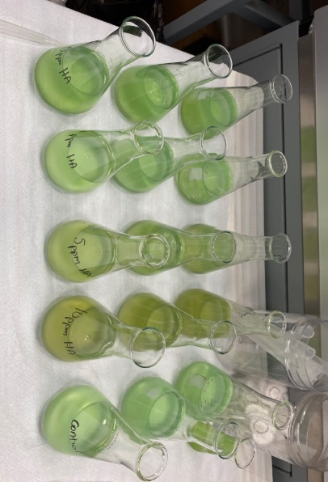
Scheme 9. Flasks containing 0,1,5 and 10 ppm of HASS and Microcystis sp. cultures.

The experimental treatment was carried out in 250-mL sterile borosilicate glass flasks, with granules added to achieve: 0 (control), and 1 g L⁻¹ of CaO₂ granules in each flask. The colorimetric approach was used to monitor the H₂O₂ residual concentration for all sample locations once again. Photosynthetic changes associated with granule additions, including instantaneous fluorescence (FT) and PSII quantum yield (Fv/Fm), were monitored using AQUAPEN at t= 0, 2, 4, 24, and 48 hours following oxidant addition to determine the efficiency of CaO₂ granules on mitigating Microcystis sp. in Kouris dam water enhanced with humics. Physicochemical properties including pH, conductivity, total dissolved solids, and salinity were assessed using the ExStick probe (EXTECH) before and after the experimental treatment.
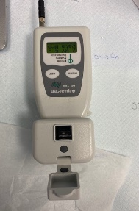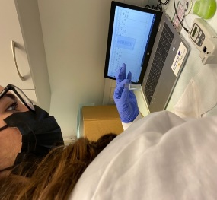
Scheme 10. Left: AQUA PEN instrument, right: Mikaella measuring the FT and QY.

RESULTS & DISCUSSION

Water quality characteristics
Water quality characteristics such as pH, conductivity, Salinity, and TDS were monitored before and after the treatment with the use of the ExStick probe (EXTECH). The measurements of physicochemical water characteristics are presented in Table 1.
Table 1. Physico-chemical characteristics of Kouris water collected on 15/11/2021, 2021
Sampling date | pH | conductivity | Salinity | TDS | TN | TP
 |  | μS/cm | g/L | mg/L | mg/L- N | mg/L-P
15.11.2021 | 8.48 | 627 | 301 | 437 | 3.5 | 0.80

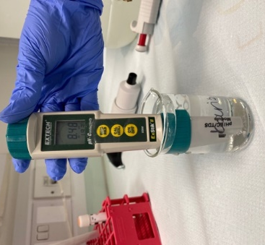
Scheme 11. ExStick probe (EXTECH) during water quality measurements.

HASS effect on H₂O₂ release by CaO₂ granules
The concentration of H₂O₂ released by CaO₂ granules was monitored during the release experiment and it showed that 1 g/L of CaO₂ granules released up to 6 mg/L H₂O₂ in the matrix free of HASS (0 ppm). The low concentrations of HASS resulted in similar release trends, but 1 ppm of humics resulted in reduced residual H₂O₂ in the matrix in comparison with 0 ppm of HASS. High concentrations of HASS (5, 10 ppm) had also the same releasing trend but differ with the one of lower concentrations. The difference was that the oxidant (H₂O₂) was released, then consumed and then released again into the matrix. We have observed that the more organic load (humics) in the matrix, the higher the release is but also the higher the consumption of the oxidant. As shown in Figure 1, the higher HASS content in the matrix achieved the highest release of H₂O₂ in the first two hours, meaning that the presence of humics enhances the release capacity of CaO₂ granules. Based on these results we expect that higher humic content will result in a better treatment efficiency.
Figure 1. Release of H₂O₂ by 1 g/L CaO₂ granules in Kouris water enriched with 1, 5, 10 ppm of HASS.

Treatment of Microcystis sp. in Kouris water spiked with HASS
The fluorescence of “phycocyanin”, a cyanobacterial pigment, had an initial reading of FT =8000 raw fluorescence units. During the treatment, the reading dropped as there was a destruction of the cyanobacteria cells indicating the removal of the pigments by the oxidant released by CaO₂ granules. But FT cannot stand alone since it is an indication for pigment concentration, therefore we need to combine the results of FT with Quantum Yield of the PSII. The quantum yield (QY) of the PSII is the ability of the cyanobacterial cells to absorb light energy and excite an electron in order to perform the photosynthetic reaction. The reading of QY in a healthy cell is around 0.4-0.5. If there is a drop of this value it means that the cyanobacterial cells lost their photosynthetic ability. As shown in Figure 2, at t=24 hours the QY for all the concentrations dropped but at 0 and 1 they reobtained their photosynthesizing ability since they have increased, except from the concentrations of 5 and 10 ppm which remained low. The most efficient treatment was at 10 ppm since it had the greatest decrease of QY out of all the concentrations, indicating the complete destruction of the cyanobacteria cells.
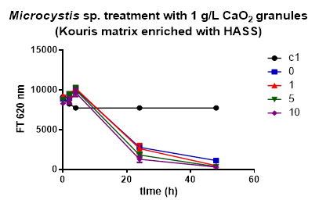
Figure 2. Measurements of Instantaneous fluorescence (FT).
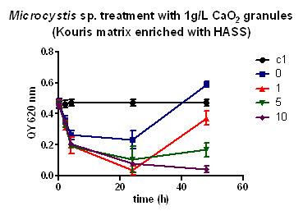
Figure 3. Measurements of photosynthetic quantum yield (QY).
After testing the effect of humics on CaO₂ treatment, we have concluded that greater efficiency was imparted by the presence of 10 ppm of humic acid (HASS). It is also apparent from the visual observations of the flasks in Scheme 12. As shown in Figure 3, all concentrations of humics caused an initial decrease in the QY value. After 24 hours it inclined again only at 0,1 and 5 ppm of humics showing that photosystem II has the ability to be restored and further photosynthesize. Said concentrations were not sufficient for the complete destruction of the Microcystis cells. The only humic concentration to accomplish their permanent destruction was 10 ppm ensuring that PSII has lost all its photosynthetic ability. This can be observed in Figures 2 and 3, where both FT and QY values decreased and showed no further augmentation after 24 hours.
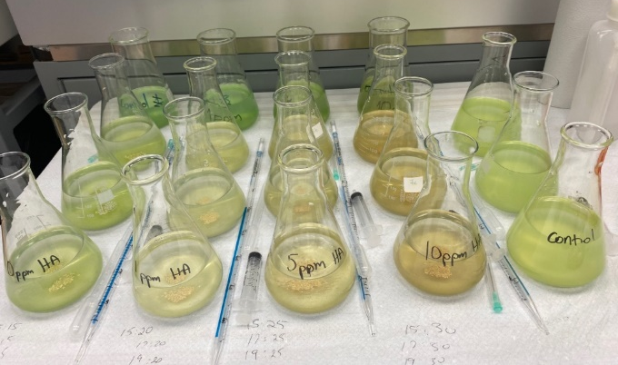
Scheme 12. Left: Treatment flask before applying CaO₂ granules, right: After 48 hours of treatment.

The released oxidant (H₂O₂) was monitored throughout the treatment, and it showed that in 5 and 10 ppm HASS, the CaO₂ granules released as much as 5 mg/L of H₂O₂. On the other hand, in 1 ppm HASS the concentration quantified at t= 2 hours was around 3.5 mg/L H₂O₂, while in 0 ppm it was around 3 mg/L. This explains the higher efficiency in the matrix containing humics, which enhanced the release of oxidant and thus, resulted in better treatment of cyanobacteria.
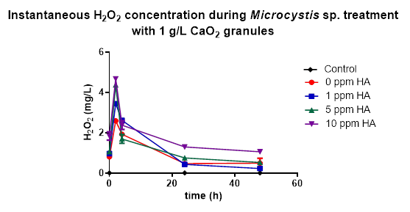
Figure 4. Oxidant (H₂O₂) concentration during treatment.

CONCLUSIONS
Treating cyanobacteria blooms is essential for safeguarding human and animal health and protecting the survival of all aquatic species. When considering potential treatment methods, we have to steer away from the possibility of further damaging the ecosystems and conduct all the necessary trials to ensure their safety. After our own experimental analysis, we concluded that CaO₂ granules provide an effective treatment for Microcystis, and when humics are present in the water the treatment efficiency is increased. The gradual release of H₂O₂ by CaO₂ granules makes this treatment more environmentally benign as it does not harm the aquatic creatures by an instant release of this strong oxidant. Therefore, it is a prospective treatment for future destruction of cyanoHABs. Calcium peroxide granules are cost-friendly since 1 kg of them can be purchased at a price of €0.0012. The overall cost of our experiment was low, costing less than 0.5 € for each bench-scale treatment, suggesting this is an affordable treatment method in larger areas of water. Despite these optimistic results, it is known that lab experiments are not ample to reach definite conclusions as we are only in the preliminary stages of finding a new and effectual treatment. Different doses should also be tested to determine whether this treatment is feasible when used long-term. One concern regarding this method is the small size of the granules that could be digested by the aquatic creatures, leading to their death and further disturbance of food chains. A more effective application of granules should be explored to avoid such issues. The promising results from our trials advocate that further research on this treatment method is requisite for all other genera of cyanobacteria.

REFERENCES
[1] E. Keliri et al., “Occurrence of a single-species cyanobacterial bloom in a lake in Cyprus: monitoring and treatment with hydrogen peroxide-releasing granules,” Environ. Sci. Eur., vol. 33, no. 1, 2021, doi: 10.1186/s12302-021-00471-5.
[2] A. Sukenik and A. Kaplan, “Cyanobacterial harmful algal blooms in aquatic ecosystems: A comprehensive outlook on current and emerging mitigation and control approaches,” Microorganisms, vol. 9, no. 7, 2021, doi: 10.3390/microorganisms9071472.
[3] W. W. Carmichael, “The toxins of cyanobacteria.,” Sci. Am., vol. 270, no. 1, pp. 78–86, 1994, doi: 10.1038/scientificamerican0194-78.
[4] I. Sanseverino, D. Conduto, L. Pozzoli, S. Dobricic, and T. Lettieri, Algal bloom and its economic impact. 2016.
[5] M. A. Burford, C. J. Gobler, D. P. Hamilton, P. M. Visser, M. Lurling, and G. A. Codd, “Solutions for managing cyanobacterial blooms,” Sci. Comm. Ocean. Res., pp. 1–19, 2019, [Online]. Available: http://www.globalhab.info/files/Cyano_mitigation_GlobalHAB2019.pdf.
[6] V. K. Sharma et al., “Destruction of microcystins by conventional and advanced oxidation processes: A review,” Sep. Purif. Technol., vol. 91, pp. 3–17, 2012, doi: 10.1016/j.seppur.2012.02.018.
[7] European Union, “DIRECTIVE (EU) 2020/2184 OF THE EUROPEAN PARLIAMENT AND OF THE COUNCIL of 16 December 2020 on the quality of water intended for human consumption (recast) (Text with EEA relevance),” Off. J. Eur. Union, vol. 435, no. December, pp. 1–62, 2020, [Online]. Available: https://eur-lex.europa.eu/legal-content/EN/TXT/PDF/?uri=CELEX:32020L2184&from=ES.
[8] Handbook of Cyanobacterial Monitoring and Cyanotoxin Analysis. 2016.
[9] M. H. Jang, K. Ha, G. J. Joo, and N. Takamura, Toxin production of cyanobacteria is increased by exposure to zooplankton, vol. 48, no. 9. 2003.

