SJWP – Stockholm Junior Water Prize 2020-2021

A novel advanced treatment process for the removal of antibiotics from wastewater
Student: Ioanna Karaiskaki
Supervisor: Aristodimou Christina

School: Lykeio Apostolon Petrou kai Pavlou

Contents

Acknowledgements……………………………………………………………………………3
Abstract……………………………………………………………………………………..…3
1 Literature Review……………………………………………………………………………4
2 Methodology……………………………………………………………………………...…6
2.1 Investigation of antibiotic concentration in wastewater through according to antibiotic substance and country…………………………………………………..…….……………6
2.2 Qualitative research on antibiotic consumption and antibiotic management policies in Cyprus………………………………………………………………………………………6

2.3 Preparation of biochar using slow pyrolysis…………………………………………....7
2.4. Selection of antibiotics and preparations of experiments and samples…………….….9
2.4.1 Chemicals and reagents…………………………………………………..……...9
2.4.2 Standards and stock solutions……………………………………………….…..9
2.4.3 Batch adsorption experiments………………………………….………..…..…10
2.5 Antibiotic concentration determination using UPLC-MS………………………...…..11
2.5.1 Analytical methods ……………………………………………………………..11
3 Results……………………………………………………………………………….….….12
4 Conclusion…………………………………………………………………………..…..….17
5 Discussion……………………………………………………………………………….…18
References……………………………………………………………………………………19

Acknowledgements
This project would not have been completed without the assistance and advice of individuals specialized and deeply involved in this scientific subject. Regarding the experiments related to biochar, we would like to give a special thanks to the director of the Nireas IWRC, Dr. Despo Fatta and chemical engineer and researcher of the Nireas IWRC Dr.Marinos Stylianou.
All of them gave the information and guidance in order to conduct experiments with accuracy, find a direction for the project and reach conclusions. Finally, I would like to thank Mrs. Christina Aristodimou, Physics Teacher at Lykeio Apostolon Petrou & Pavlou, for organizing and mentoring the team through the whole process and inspiring to work hard.

Abstract
Over the past few years, antibiotics have been considered emerging pollutants due to their continuous input and persistence in the aquatic ecosystem even at low concentrations. This phenomenon results in antibiotic-resistant bacteria, which are a serious threat to the treatment of bacterial diseases, as a result of exposure to antibiotics in clinical and agricultural settings.
To prevent this contamination, several processes to degrade/remove antibiotics have been studied, and one very promising method is the use of sorbents such as biochars.
Biochars can be characterized as low-cost sorbents from agriculture and food waste that can deliver innovative, cost-effective, environmentally safe solutions to a wide spectrum of challenges related to the release of antibiotics in the agricultural environment and their subsequent entrance to the food chain, as a result of treated wastewater (TW) reuse for irrigation and the application of biosolid as soil amendment.
The present study aims to present the relevance of antibiotic over-consumption in Cyprus as well as propose experimental data proving the efficiency of biochar on four antibiotics: Ampicillin, Clarithromycin, Sulfamethoxazole and Erythromycin.
For the conduction of the study two types of biochar were used: (i) Sludge Biochar (SB), and (ii) Manure Biochar (MB). The ideal concentration of biochar was also examined by using four different concentrations, ranging from 0.5g/L to 10g/L.
Lastly, the maximum exchange capacity of biochar was examined. With that, the capacity of the biochar to absorb antibiotic solutions was proved. Specifically, interesting results were presented for Ampicillin (75μg/g), Erythromycin (83μg/g) and Clarithromycin (82μg/g) Analysis of the absorption of antibiotic by the biochar sorbents was measured by UPLC-MS-MS.
The research took place between July 2018 and February 2020, Cyprus under surveillance of the Nireas-IWRC, University of Cyprus.

1 Literature Review
The 20th century is commonly described as the ‘Golden Age of Medicine’ by the science community, mainly because of the discovery of innovative treatments that improved the quality of health care drastically. The introduction of penicillin by Alexander Fleming in the early 20th century, heralded the dawn of a new era, providing strong and reliable treatment to infections that previously seemed to be decimating humankind.
Antibiotics by definition, are considered to be the potent medicines that have been utilized since the beginning of the 20th century by humanity, for the therapeutic remedy of infections related diseases. (Sapkota et al., 2008).
Ever since, humanity has utilized this so called ‘revolutionary’ innovation to its advantage, coping with numeral health care threats. However, antibiotics’ consumption has increased dramatically in the last decades, emerging worrying concerns in the scientific community (Kasprzyk-Hordern et al., 2009). Worryingly, according to the European centre for Disease Prevention and Control, Cyprus has the second largest antibiotic intake among the other countries of the European Union.
The above phenomenon can be extremely concerning, since antibiotic usage produces residues that are released into the aquatic and terrestrial environments (Sarmah et al., 2006). The exposure of humans to antibiotic residues even at low concentrations can result to antibiotic resistant genes (ARGs) and antibiotic resistant bacteria (ARB) (Dantas et al., 2008). Antibiotic resistance can be achieved by horizontal acquisition of resistance genes, by recombination of foreign DNA into the chromosome, or by mutations in different chromosomal loci (Davies J. E. et al., 1997).
Therefore, the above indicates the inability of some antibiotics to perform effectively against infectious diseases, and a growing number of patients to develop immunity to them (Gislene G. F et la.,2000). Drug resistant bacteria are an increasing threat to public health, as highlighted even by a recent study that estimates that in the US methicillin-resistant Staphylococcus aureus (MRSA) may contribute to more deaths than HIV (Bancroft EA).
The potential role of wastewater reuse as an alternative source of water supply has been well acknowledged and embedded within European and national strategies to alleviate water stress. Wastewater reuse is now a top priority area in the Strategic Implementation Plan of the European Innovation Partnership on Water, and maximization of wastewater reuse is a crucial objective in the achievement of a sustainable wastewater reuse framework (Salgot & Huertas, 2006). In order to make wastewater reuse a safe and widely applied practice, potential risks towards human health and environmental matrices must be monitored.
Moreover, the European Union laws for drinking water production and wastewater treatments vary. Wastewater treatment plant (WWTP) processes vary, but the most common mechanisms for removing micropollutants from wastewater are biological and/or chemical (chlorination). These do not fully remove antibiotics, which have been found in surface and groundwater in several countries ("Science for Environment Policy": European Commission, 2016). Drinking water production uses chemical mechanisms as chlorination, a commonly used disinfection technology, which can contribute to the enrichment of antibiotic resistant bacteria (ARB) and resistance genes (ARGs) (Armstrong et al., 1982).
The development of Urban Water Treatment Plant (UWTP), which have the potential to remove the persistent microcontaminants such as antibiotic residues, ARB & ARG in wastewater effluents, has taken place in the last few decades. Among these processes is biochar which as an adsorption processes is very efficient (Hao et al., 2012; Zhou et al., 2012), simple to design and operate.
Therapeutic groups | Analgesic/Anti-inﬂammatories | Lipid regulators/Antihypertensives | Psychiatric drugs/Stimulants | Antibiotics
Compounds | Acetaminophen Diclofenac | Bezaﬁbrate  Propanolol | Caffeine  Amitriptiline | Clarithromycin  Sulfamethoxazole  Trimethoprim  Erythromycin  Ampicillin
Biochar can generally be produced by obtaining several types of agricultural solid waste, such as sludge, manure, wheat with little cost. (Xu et al., 2013). These kinds of treatment convert the biomass materials into products with a high surface area owing to porous structure. Biochar can act as an absorbent to several compounds and substances as highlighted by 2017 research (Miriam Biel-Maeso). The table below presents some of them. Thus, biochar can be considered quite a promising solution to the issue of antibiotic accumulation even at low concentrations.
Table 1: Compounds that biochar can act as an absorbent
Biochar’s ability to act as a successful absorbent lies within its porous structure and enriched surface functional groups (Rajapaksha et al., 2014).
As a result, the overall aim of this study was to explore the decontamination potential of biochar to remove high concentration antibiotics, which contains a mixture of antibiotics, namely ampicillin (AMP), clarithromycin (CLA), erythromycin (ERY), and sulfamethoxazole (SMX).

2 Methodology
2.1 Investigation of antibiotic concentration in wastewater through according to antibiotic substance and country
A JCP Technical Report ‘State of the Art on the Contribution of Water to Antimicrobial Resistance’ presents the existence of antibiotic residues in wastewater, drinking water and agricultural water. Specifically there are data on different types of antibiotics found on different countries. Some of them are listed below. No data for Cyprus were found.
Antibiotic | Country | Antibiotic concentration (μg/L) | Reference
Clarithromycin | Switzerland  Spain | 0.004  0.004 | López-Serna et al., 2010  Huntscha et al., 2012
Erythromycin | USA  Portugal  Spain | 0.40  0.005  0.154 | Focazio et al., 2008  de Jesus Gaffney et al., 2015  Cabeza et al., 2012
Sulfamethoxazole | USA  Netherlands  Japan | 0.003  0.013  0.019 | Benotti et al., 2009  Houtman et al.,2014  Simazaki et al.,2015
Table 2: Antibiotic residues found in wastewater across the globe
2.2 Qualitative research on antibiotic consumption and antibiotic management policies in Cyprus
The research’s purpose was not only limited to the experimental part. Exploring the issue of antibiotic consumption, specifically in the Cypriot community was of vital importance to better conceptualize the dangers of excessive use of antibiotics as well as the existence of antibiotic residues in wastewater. Taking that into consideration, communication with specialists in various sectors seemed ideal.
Firstly, a pharmaceutical company, that specializes in the production and sale of pharmaceutical products, was willing to participate in the research. The goal of that interview was to learn more about the production of antibiotics and the actions taken for outdated ones.
Later, a pharmaceutical waste management company, working on collecting and processing pharmaceutical waste, contributed in gathering significant information about the topic. Lastly, it was only reasonable to contact the medical community both in the public and private sector. Hospitals are hotspots of large antibiotic concentration due to the number of patients on antibiotics.
The pharmaceutical company informed about the creation of a contract with pharmacists, so that outdated antibiotics are collected and sent to be destroyed. It was interesting enough to discover that no specific law is implemented concerning these products in Cyprus, despite the existence of such a law within the EU.
It was, then enlightening to find out through the pharmaceutical waste management company that there are specific antibiotic management instructions from the EU, not being implemented though. Their experience shows that the volume of antibiotic consumption seems extremely large. It was then added that not enough attention is given to the issue and the dangers of antibiotic overuse.
Doctors seemed to know that Cyprus is among the first European countries in antibiotic consumption. They claim that patients themselves are inclined in taking antibiotics, without them being necessary for their recovery. Additionally, they appear to be unaware of the dangers of antibiotic accumulation in the environment.
Finally, when contacting a private clinic, it was encouraging to find out that there are certain filters in the drainage system. However, these do not include biological waste, which seems to maintain antibiotic concentrations. Moreover, the specific hospital cooperates with a pharmaceutical waste management company, collecting dangerous or outdated drugs, antibiotics not included. Instead, antibiotics are simply dismissed.
All in all, the interviews illustrated that the problem of antibiotic usage in Cyprus is relevant. What is more, insufficient legislation on waste management provokes even more dangers, expressing the need of easy and innovative waste management remedies.

2.3 Preparation of biochar using slow pyrolysis
Slow pyrolysis was used in order to produce biochar. In order to achieve that, sludge and cow manure were used. These materials have high availability, they are produced in large volumes and have limited end use. They are ideal, not only because many fields of agriculture and livestock farming exist in Cyprus, so large amounts of sludge and cow manure can be easily accessible, but also to reinforce the principles of ‘circular economy’. The foundation of ‘circular economy’ in the idea that resources can be kept in use for as long as possible, then recover and regenerate products and materials at the end of each service life. This idea has been of particular interest in the European Union in the last few years, with the publication of a new policy entitled Circular Economy Closing the Loop (European Commission, 2015).
Sludge samples were collected from a wastewater treatment plant (Anthoupoli, Nicosia) and cow manure samples from a cattle farm (Agia Varvara, Nicosia). Samples were dried naturally at approximately 35ºC. Pyrolysis is a thermal conversion process in which organic materials are converted into a carbon-rich solid in the absence of oxygen. The proportion and quality of pyrolysis products depend on different conditions of pyrolysis such as temperature, reaction time, heating rate, pressure (Zaman et al., 2017). Slow pyrolysis is characterized by low heating rate, relatively long residence time and usually quite low temperatures. A biochar of porous structure was desirable so that it can act as an effective sorbent for the removal of antibiotics from wastewater.
The characteristics of the preparation of biochar using slow pyrolysis methodology, affected the results of the adsorption rate and removal potential greatly.
Sludge and manure samples were slowly pyrolyzed in a small-scale kiln; the samples were then placed in 8 shelves in the internal compartment of the kiln (Schematic 1). The samples were heated under no oxygen conditions (nitrogen atmosphere) up to the desired temperature (500-600˚C) and held for 1-1.5h. The biochar yield was then calculated. Produced biochars, sludge biochar (SB) and manure biochar (MB), were gently ground and sieved to less than 125μm before stored in polyethylene bottles until further use.

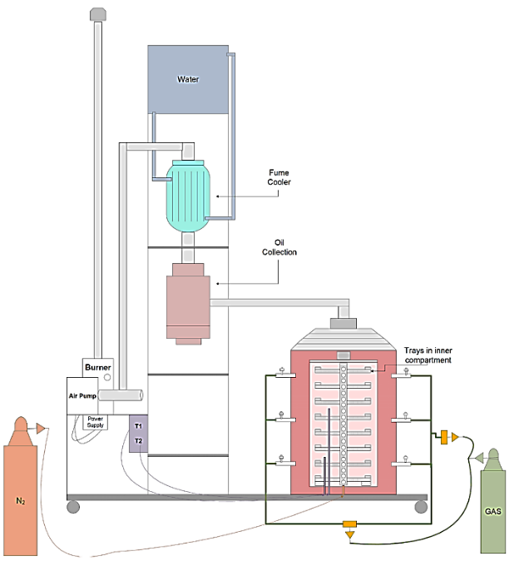 | 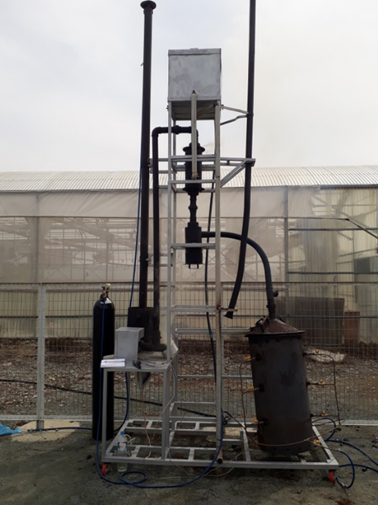
Schematic 1: The pilot-scale plant used for the production of biochar

2.4 Selection of antibiotics and preparation of experiment and samples

2.4.1 Chemicals and reagents
According to the European Commission and the Science for Environment Policy, antibiotics are potentially one of the most significant pollutants, as their presence could be involved in development of antibiotic resistance. The EU watch list focuses on three macrolide antibiotics (azithromycin, clarithromycin and erythromycin) which are widely used in human and veterinary medicine. Therefore, two of them available on the laboratory, clarithromycin (CLA) and erythromycin (ERY) were selected to examine their effectiveness in biochar experiments. In addition, after input of Cyprus’ doctors and the Annual Epidemiological Report -Antimicrobial consumption for 2017 of the European Centre for Disease Prevention and Control, two more antibiotic substances, sulfamethoxazole (SMX) and ampicillin (AMP) were selected.
Thus, three different classes of antibiotics macrolides (clarithromycin and erythromycin), penicillins (ampicillin) and sulphonamides (sulfamethoxazole) selecting specific antibiotics that are highly utilized both in EU and Cyprus.
2.4.2 Standards and stock solutions
All antibiotics studied (ampicillin, clarithromycin, erythromycin and sulfamethoxazole) were of high-purity grade (more than 90%) and were purchased from Sigma-Aldrich (Steinheim, Germany).
About 50 mg of each individual standard was accurately weighed and placed in 10-mL volumetric flask. Ampicillin was dissolved in Milli-Q water, whereas all the other analytes were dissolved in methanol. In ofloxacin standard solution, drops of formic acid was added to enhance solubility. Stock solutions of each compound at 5,000 mg/L were produced and stored at -20 °C. The selection of the volume antibiotic taken was calculated by the dilution calculator equation.
Concentration(start) x Volume(start) = Concentration(final) x Volume(final)
A multicomponent solution of the four compounds was obtained by diluting the stock solutions in methanol to a final concentration of 100 mg/L, and it was also stored at -20 °C. Final working solution was prepared by gradient dilution of the multicomponent solution at 100μg/L and calibration standards were prepared in concentrations ranging from 10 μg/L to 1000 μg/L.
Methanol of LC-MS grade was purchased from Merck (Darmstadt, Germany). PVDF filters (0.45 μm) from Millipore (Bedford, MA, USA).

2.4.3 Batch adsorption experiments
For the kinetic studies, 1g and 10g of adsorbent was firstly added into 1L antibiotics solution which contained the four antibiotics, 100μg/L per antibiotic. The adsorption was carried out at 25ºC, with an agitation of 200rpm (under dark). Also, an electronic clock was put between the two sections so that we know when the right time to take the samples is. Samples were collected at various time intervals with a max of 360min and then filtrated (to ensure no biochar residues) for the determination of antibiotic concentration (analysed by UPLC-MS-MS). The samples taken were put into vials, which had a capacity of 1.5ml. The vials were closed with caps that could be screwed. Blank samples were also performed to exclude the degradation process. All experiments were performed in the dark in order to avoid their exposure to light and furthermore, photodegradation.
For the second set of experiments, that had the purpose of investigating the ideal concentration (in gr/L) of biochar, similar procedure was followed. The biochar was added into 1L antibiotic solution. The concentrations of biochar used were: 0.5gr/L, 1gr/L, 5gr/L and 10gr/L. The samples were collected after a time interval of 6 hours and again the results were analysed by UPLC-MS-MS.
Finally, for the experiments concerning the maximum exchange of biochar with regard to CECs. The latter will facilitate the determination of the saturation life of biochar during its application in TW-irrigated fields under real agricultural conditions.
Studies were conducted by repeated batch equilibrations as follows: a measured quantity of biochar (0.1–10 g) was added in a vessel containing measured volume of antibiotics solution (100 mL) at an initial concentration of 100ppb. Every 7 days the solution was analysed for antibiotic concentration and then replaced with fresh solution until no further uptake from the biochar was observed.
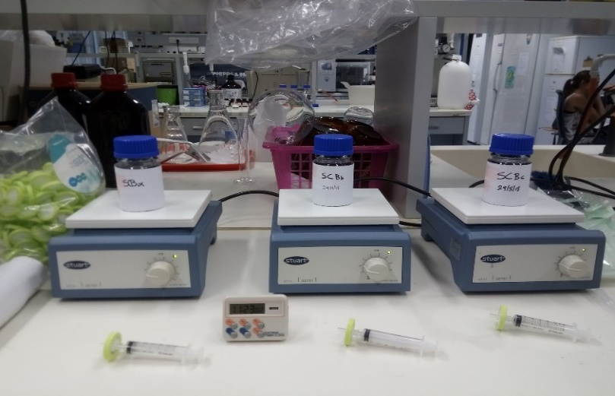
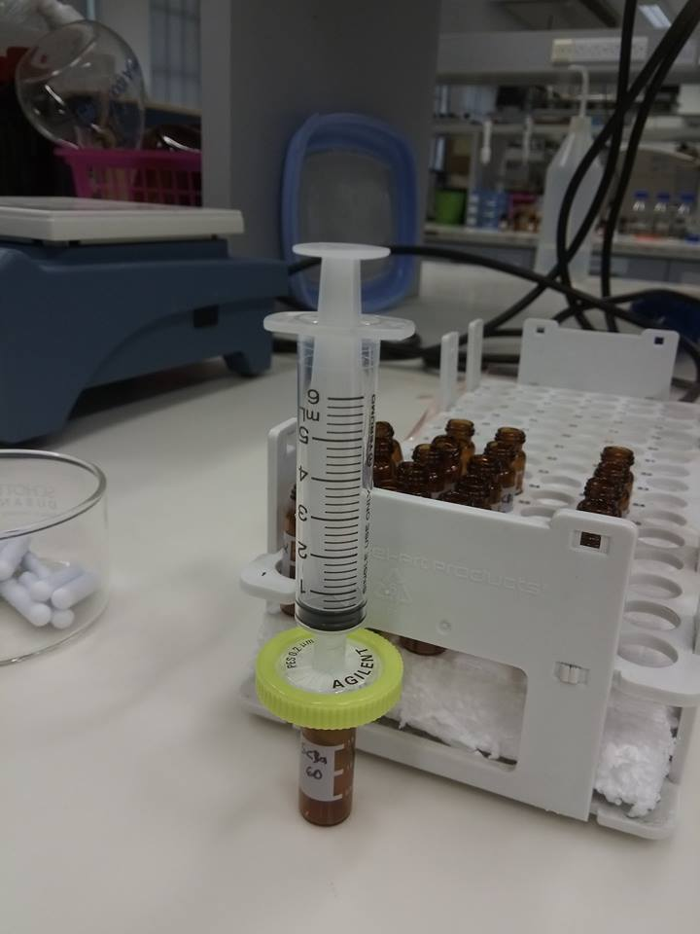

Antibiotic solution with biochar

Filtration of antibiotic samples to remove biochar

2.5 Antibiotic concentration determination by UPLC-MS
2.5.1 Analytical methods
Analysis was carried out using an ACQUITY Ultrahigh Performance Liquid Chromatography (UPLC) system interfaced to an ACQUITY Triple Quadrupole Detector (TQD) mass spectrometer (Waters Corporation). Data acquisition and data treatment was performed with MassLynx 4.1 software.
An ACQUITY UPLC BEH C18 column (1.7 μm, 2.1 mm×50 mm, Waters), protected by a van-guard pre-column (1.7 μm, 2.1 mm×5 mm), was used at a constant flow rate of 300 μL/min. The mobile phase for the positive electrospray ionization (ESI) detection consisted of water containing 0.1 % (v/v) formic acid (solvent A) and methanol (solvent B).
The gradient elution programme for the chromatographic run in positive ionization mode was 10% B (0 min), 90% B (8 min), 100% B (8.10 min), 100% B (10 min), 10% B (10.10 min) and10% B (12 min). It should be marked that 100% organic content was kept during two minutes in the elution gradient to clean the column and to avoid carry over contamination. The time necessary for the re-equilibration of the analytical column was two minutes, the column was thermostated at 40 °C, and the loop injection volume of the extract was set at 2.5 μL (partial loop with needle overfill mode).
The ESI parameters for MS tuning were the following: capillary voltage, 3.00 kV; cone voltage, 40 V; source temperature, 150 °C; desolvation temperature, 350 °C; desolvation gas flow, 500 L/hr; cone gas flow, 50 L/hr.
The mass spectra and analyte-dependent parameters, such as collision energy (CE) and cone voltage (CV), were obtained for each compound separately by direct infusion of individual standard solutions at a concentration of 1 mg/L in 0.1% formic acid–methanol (50:50, v/v), in positive ionization mode. More specifically, after the selection of the precursor ion for each analyte, optimization of CV and CE was performed automatically with Intellistart Console.
Multiple-reaction monitoring (MRM) was used, and detailed parameters for MRM acquisition, which are used later in MRM method, are presented in Table 1. The selected precursor ions in positive ESI mode were protonated ([M+H)+] molecular ions. Two transitions were selected for identification, and the most intense one was used for quantification

3. Results
Biochar was produced in several batches, in a small scale kiln through pyrolysis under specific parameters (Table 1) resulting in two different materials with high pH value and high (in relation to the initial material) specific surface area (m²/g), which is a property of solids defined as the total surface area of a material per unit of mass.
For sludge biochar the biochar yield (%) = 18.6 and for cow manure biochar the biochar yield (%) = 41.6.
Table 3. Pyrolysis parameters and final product properties
Parameter | SB | MB
Pyrolysis Temperature | 500-600 ºC | 500-600 ºC
Pyrolysis atmosphere | Nitrogen | Nitrogen
Time of pyrolysis | 1.5-2h | 1.5-2h
Biochar Yield (%) | 18.60 | 41.61
pH | 9.77 | 10.43
EC (μS/cm) | 687 | 4123
BET surface area (m²/g) | 4.0 | 11.5
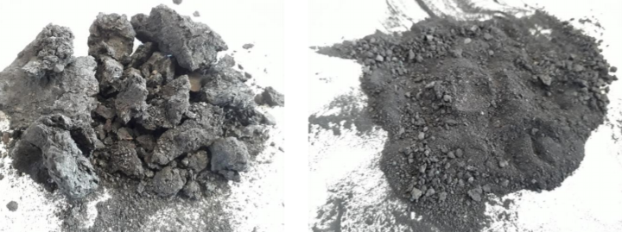

Cow Manure And Sludge Biochar Samples

Biochar was produced in several batches, in a small scale kiln through pyrolysis under specific parameters resulting in two different materials with high pH value and high (in relation to the initial material) specific surface area (m²/g), which is a property of solids defined as the total surface area of a material per unit of mass.
For sludge biochar the biochar yield (%) = 18.6 and for cow manure biochar the biochar yield (%) = 41.6. The remaining percentage was the oil derived from the slow pyrolysis process.
It was important to keep in mind some parameters like temperature, yield percentage, pH, electroconductivity and BET surface area. Temperature is a vital parameter for the efficiency of the absorbent. Whether increasing the temperature of pyrolysis process may be favourable for the absorption of some antibiotic substances, decreasing the temperature may be favourable for others. It is also known that pH affects the removal process, because pH changes affect the degree of ionisation of the adsorptive molecule and the surface charge of the adsorbent. Electroconductivity expresses how the absorbent can form chemical bonds (like hydrogen bonds) with the antibiotic substances. Lastly, having high BET surface area is an indication of porous structure of biochar and high expectations of antibiotic removal (M.T. Yagub et al.,2019)
A rapid, sensitive and reliable method was developed for trace analysis of four antibiotics using and UPLC-MS/MS. UPLC-MS/MS optimization results indicated that well separation of four and 2 blanks analytes was achieved within 10.0-12.0 min.
Table 4: Results of UPC-MS analysis of the four antibiotics

Class | Compound | Precursor ion | Product ion 1 | CE | Product ion 2 | CE | CV | Retention time (min)
Macrolides | Clarithromycin | 748.5 | 158.1 | 34 | 590.3 | 20 | 30 | 6.11
 | Erythromycin | 734.5 | 158.1 | 32 | 576.1 | 20 | 30 | 5.48
Penicillins | Ampicillin | 350.1 | 106 | 20 | 160 | 12 | 23 | 2.83
Sulfonamides | Sulfamethoxazole | 254 | 156 | 16 | 108 | 24 | 27 | 2.64
 | CE: Collision Energy, CV: Cone Voltage

The batch experiments seemed successful with considerable results.
The table below summarizes the %removal of each antibiotic substance both in 0.1gr/L and 1gr/L of biochar adsorbent.

SB | 1gr/L | Clarithromycin (82.45%) > Erythromycin (64.59%) > Ampicillin (11.80%) > Sulfamethoxazole (3.27%)
 | 10gr/L | Erythromycin (97.36%) > Clarithromycin (96.87%) > Ampicillin (92.43%)> Sulfamethoxazole (13.21%)
MB | 1gr/L | Clarithromycin (93.35%)> Erythromycin (87.97%) >Ampicillin (61.92%)> Sulfamethoxazole (4.23%)
 | 10gr/L | Ampicillin (99.21%) > Clarithromycin (97.41%) >Erythromycin (97.27%) > Sulfamethoxazole (10.37%)
Table 5: %Removal of biochar on each antibiotic substance, from more to less effective
Interestingly, Clarithromycin and Erythromycin had absorbed the most antibiotic compared to the other two antibiotic substances, except ampicillin in manure biochar in 10gr/L, where 99.21% of the antibiotic was absorbed by the biochar absorbent. Clarithromycin and Erythromycin are two antibiotics of the same class of macrolides. it is only reasonable to assume that they react similarly when placed in contact with the specific biochar produced. Ampicillin, which is included in the class of penicillin antibiotics, appeared to also have satisfying results in the %removal. Lastly, sulfamethoxazole did not have very high %removal. It can only be assumed that if the conditions of slow pyrolysis and generally the method preparing biochar were to be altered (different temperature, different pH and different time of pyrolysis) the results for the specific antibiotic substance could be optimised.
When using higher concentration of absorbent, 10gr/L, results seemed slightly better as far as the %removal is concerned. However, this does not mean that when using 1gr/L no visible absorption percentages were noted.
As far as the absorption rate is concerned, it should be noted that most of the %removal was complete in the first 180min. The above indicates the fact that initially there are many active sites on the surface of biochar for absorption and the remaining vacant surface sites are hardly occupied due to the development of repulsive forces or decline of attractive forces between the solute molecules on the solid and bulk phases (K.K. Beltrame ).
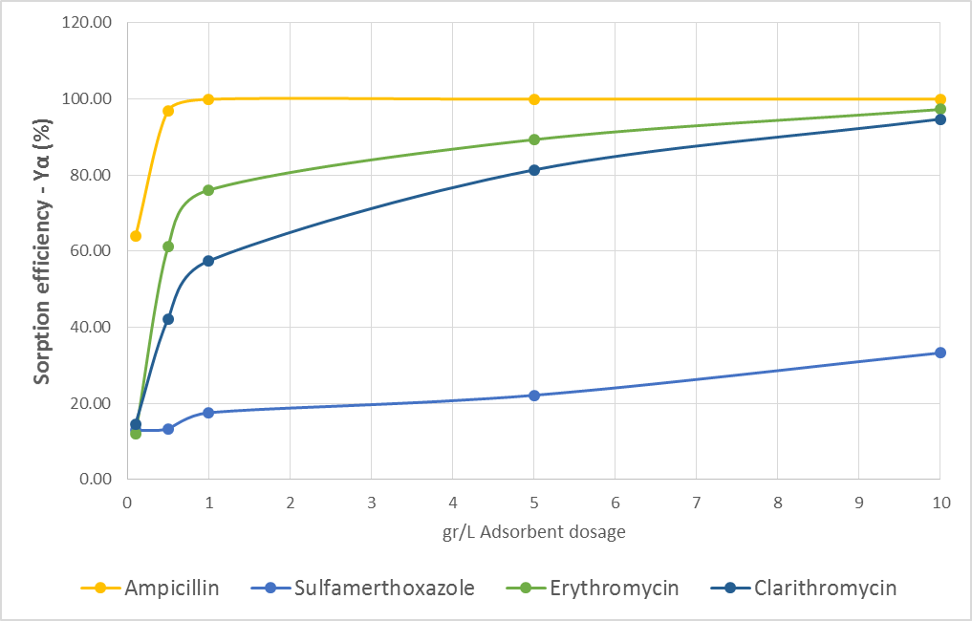

Sorption Efficiency On The Four Antibiotic Substances

Ya(%)=[(Co-Ct)/Co]*100
where:
Co=initial concentration
Ct=final concentration
Ya=adsorption efficiency

For the second set of experiments, where the efficiency of absorption was examined, using four different adsorbent dosages: 0.5gr/L, 1gr/L, 5gr/L and 10gr/L, the results seemed to come in some agreement with the previous results, where %removal was examined. The significance of this experiment must be highlighted, since it gives promising results to real-life applications, where biochar is desired to provide sufficient absorption results, with minimum cost (thus smaller dosage of absorbent).
Ampicillin had the best efficiency of sorption in this experiment, with most of the absorption happening even at very low concentrations of biochar (0.5gr/L), following Erythromycin and Clarithromycin with most of the absorption being complete when 5gr/L of absorbent was used. Again, the biochar prepared was not optimal and effective when sulfamethoxazole antibiotic is considered. Other types of methods of biochar could have different results.
It must be added that the two control samples (blank samples) that contained the biochar alone and the antibiotic solution alone did not show any signs of absorption. Therefore, it was proven that all other parameters (eg. Light degredation) remained constant.
For the last set of experiments, maximum exchange capacity of biochar was investigated. To complete that a different antibiotic solution was replaced every 7 days.
Biochar has negatively charged sites on its surface which absorbs and holds positively charged ions (cations) by electrostatic force. Antibiotic substances can get positively charged, due to their amino groups.
From the result table it can be concluded that the biochar had largest capacity to absorb Erythromycin, Clarithromycin and Ampicillin. The maximum capacity of biochar to Sulfamethoxazole was much lower. These results indicate the preference of the absorbent, biochar, to absorb specific substances. In this case, Clarithromycin and Erythromycin showed best results, which means that the biochar produced could form stronger bonds more easily with the above antibiotics, thus preferring them.
Ampicillin | Qe=μg/g | 75
Sulfamethoxazole | Qe=μg/g | 8
Erythromycin | Qe=μg/g | 83
Clarithromycin | Qe=μg/g | 82

Table 6: Maximum Exchange Capacity of Biochar on each antibiotic substance

4. Discussion
In this project, the effect of two types of biochar, sludge and cow manure were investigated on four antibiotics. The results presented sufficient results for most of the antibiotics examined.
The overall project is thought to be economical. To produce a 2kg biochar 1/3 tank of heating gas cylinder (lpg) is needed which costs about 5euros. The biochar materials, sludge and cow manure are waste materials, thus economically sustainable.
Therefore, the method of antibiotic treatment using biochar can potentially be used in hospital wastewater to decrease the amount of antibiotics in wastewater, since hospitals can be considered hotspots of high concentration antibiotics. Α large tank can be installed in the sewer system of hospitals, where a biochar amount can then be added. An agitation from a tank agitator could be also placed to stir the biochar across the whole tank and successfully remove antibiotic residues from hospitals’ wastewater.
Another proposal is the implementation of biochar as a filter (Schematic 2). Due to our everyday use of antibiotics, effluent with low concentration exists in the sewer system’s tubes. Waste generated by healthcare facilities, specifically in hospitals, is filled with antibiotics due to their excessively consumption by patients. Thus, biochar can be added in the drainage system tubes of hospitals. To succeed more effective absorption, an agitation could also be placed inside the tubes. As a result, biochar could be stirred all-over the tube. Biochar will then successfully remove an efficient amount of antibiotics before letting water be release out of the filter.
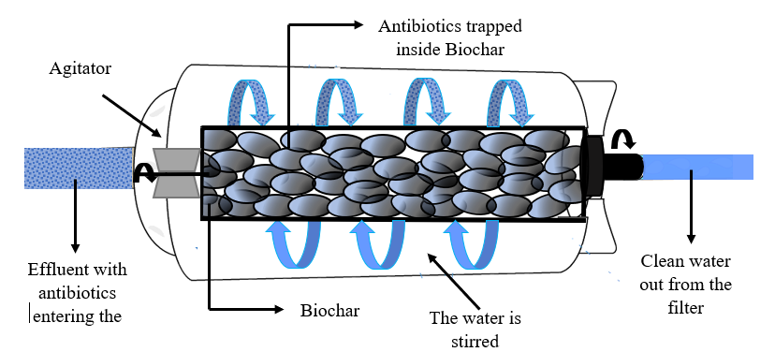
Schematic 2: Βiochar as a filter

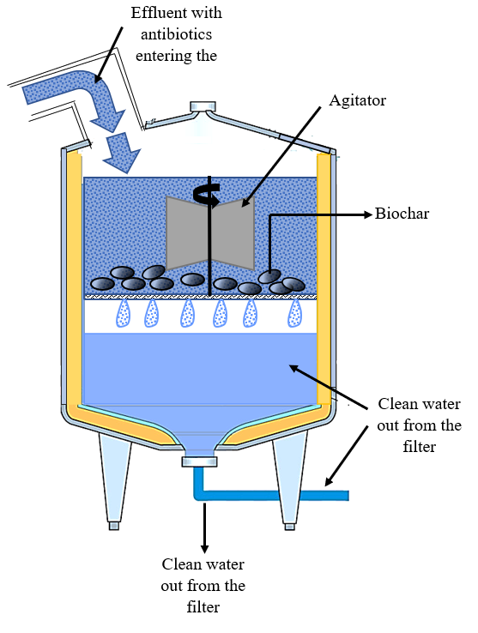
Schematic 3: Tank agitator with Βiochar

5. Conclusions
At first, bibliographic research showed the existance of antibiotic residues, derived from several classes of antibiotics, in wastewater of several countries. European data did not report any data concerning Cyprus. Qualitative research process indicated the need to further investigate the issue of over-consumption of antibiotics generally around the globe and especially in the Cypriot community.
With Cyprus being the second country in antibiotic consumption in the EU and the lack of proper legislation to wastewater treatment being established, exploring innovative wastewater treatments seems urgent.
Hospitals and health centres are specifically hotspots of antibiotic accumulation in wastewater. Thus, antibiotic residues are extremely likely to be in hospitals’ wastewater at very large percentages.
The above research on biochar brings light to the capabilities of it to absorb antibiotics in very small concentrations successfully, as well as to present a small-scale idea of how biochar could be implemented in real life.

References

A. Junza et al., 2011. Journal of Chromatography B, Comparative study of the LC–MS/MS and UPLC–MS/MS for the multi-residue analysis of quinolones, penicillins and cephalosporins in cow milk, and validation according to the regulation 2002/657/EC. Available at: www.elsevier.com/locate/chromb
American Association of Avian Pathologists, N. J. Stern et al., 2002. Effect of Drinking Water Chlorination on Campylobacter spp. Colonization of Broilers.
Bing Li et al., 2009. Analytica Chimica Acta, Rapid analysis of 21 antibiotics of multiple classes in municipal wastewater using ultra performance liquid chromatography-tandem mass spectrometry. Available at: www.elsevier.com/locate/aca
D. G. Joakim Larsson, 2014. Antibiotics in the environment. Upsala Journal of Medica Science May; 119 (2): 108–112.
James A. Ippolito et al., 2012. Journal of Environmental Quality, Environmental Benefits of Biochar.
L. Høibye et al., 2008. Water Science & Technology—WST, Sustainability assessment of advanced wastewater treatment technologies.
N. J. Stern et al.,2002. Effect of Drinking Water Chlorination on Campylobacter spp. Colonization of Broilers, Avian Diseases, 46(2):401-404
Mahtab Ahmada et al., 2014. Chemosphere, Biochar as a sorbent for contaminant management in soil and water. Available at: www.elsevier.com/locate/chemosphere
Mandu Inyang& Eric Dickenson, 2015. Chemosphere 134 232–240, The potential role of biochar in the removal of organic and microbial contaminants from potable and reuse water. Available at: www.elsevier.com/locate/chemosphere
Martin Geissdoerfer et al., 2016. Journal of Cleaner Production, The Circular Economy- A new sustainability paradigm? Available at: www.elsevier.com/locate/jclepro
Mikael Skou Andersen 2006. Integrated Research System for Sustainability Science and Springer An introductory note on the environmental economics of the circular economy, Available at: https://www.environmental-expert.com/Files/6063/articles/15091/art12.pdf
Mohammad Boshir Ahmed et al., 2015. Science of the Total Environment, Adsorptive removal of antibiotics from water and wastewater: Progress and challenges.
Peng Shi et al., 2012. Metagenomic insights into chlorination effects on microbial antibiotic resistance in drinking water. Available at: www.elsevier.com/locate/watres
Shannon M. Mitchell et al., 2014. Journal of Environmental Chemical Engineering, Evaluation of 27 different biochars for potential sequestration of antibiotic residues in food animal production environments. Available at: www.elsevier.com/locate/jece
Woods, W. I. et al., 2006. Nature, Black is the new green Available at: https://biochar.co.nz/images/BIOCHAR-FILES/Black_Is_The_New_Green__Nature_10.Aug.06.pdf

