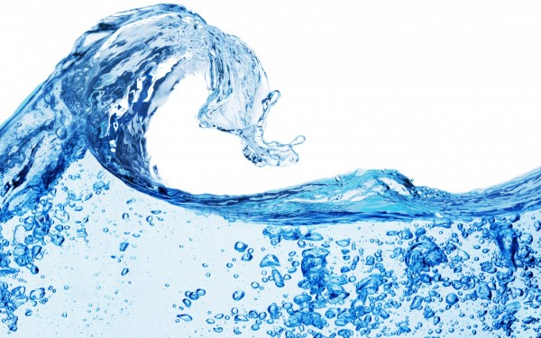

Water from Air: The Rainmaker

South African Youth Water Prize (2018)

Kwazi Zwezwe (Grade 09)

Ixopo High School

KwaZulu-Natal

South Africa

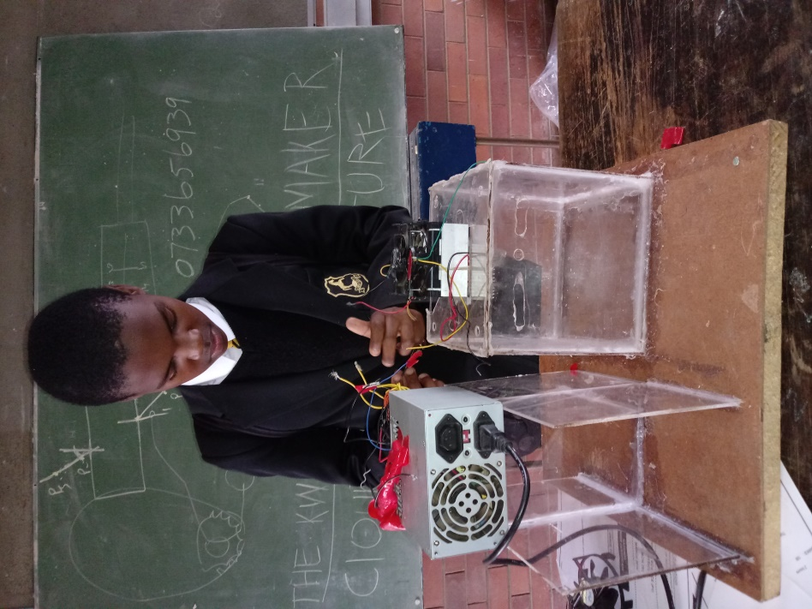

Table of Contents

1. Preliminary matters iii

1.1. Summary of project iii

Purpose of the Project iii

Procedure/method followed iii

Results: iii

Conclusion: iv

1.2 Acknowledgements iv

1.3 Biography iv

1.4 Abbreviations v

1.5 Definitions v

2. Introduction 1

2.1. Introduction 1

2.2. Problem Statement 3

2.3. Aim 3

2.4. Hypothesis 3

2.5. Materials and Methods 3

2.5.1 Materials 3

2.5.2 Methodology 4

3. Cost Benefit Analysis (CBA) 6

4. Results 7

4.1 Water Collection results 7

4.2. Laboratory Results: Graphical representation 9

5. Discussion 12

6. Recommendations 13

7. Conclusion 14

8. References 14

# 1. Preliminary matters

## 1.1. Summary of project

### Purpose of the Project

Water scarcity is becoming a problem in the world we live in, not only did it strike California, but it has reached our country mostly in the Western Cape Province (www.dws.gov.za). New ways of producing, saving and cleaning water are needed. While looking at the outside of a bottle with ice, an idea came which was to create a prototype that will **dehumidify** or cool the air and condense it into water by using a **thermoelectric cooler** (which is the main component of the prototype). The aim of the project is to sustainably produce water using the **Rainmaker.**

### Procedure/method followed

*Building method*

* A Rainmaker system was built using a thermo electric cooler, AC-DC adapter, 12 Volt battery and a closed-glass structure with an outlet pipe.

**Water testing method**

* Samples of water collected inside room conditions and that of outside room conditions were taken to Umgeni Laboratory for water quality analysis.
* The water quality of the samples were tested for the following parameters: Alkalinity, appearance, calcium, chloride, colour, conductivity, E.coli, fluoride, heterotrophic plate counts, iron, magnesium, manganese, nitrate, nitrite, combined nitrate + nitrite ratio*, odour, pH, potassium, sodium, total organic carbon, sulphate, total coliforms, total hardness and turbidity.

### Results:

The results showed that the rainmaker functioned efficiently. It was proven that the Rainmaker is able to produce a considerable amount of water over a period of time and that the water produced can be used for domestic purposes such as lawn watering, crop irrigation etc. The laboratory results further revealed that, the water produced is not suitable for human consumption unless disinfected accordingly or boiled before use.

### Conclusion:

The hypothesis was proven correct. The invention solved the problem and met the design goals, by building and testing a simple and efficient system for households to conserve and reuse water.

## 1.2 Acknowledgements

* Mother: She helped with elastic bands, AC-DC adapter, printing and her continued support and encouragements
* Father: Helped with PSU cable, insulating tape, batteries, posters(financially) and continued support and encouragement.
* Mr Agyemang: Guided me and ordered Peltier Plate for me.
* FutureNet: Supplied PSU, heat sinks and cooling fans.

## 1.3 Biography

Kwazi Zwezwe is a male Grade 09 learner born on (insert date of birth), he is currently 15 years old. The learner resides in rural village called Nokweja under the Emabhaceni valley, under the Msunduzi Local Municipality in the province of KwaZulu Natal. Kwazi currently attends at Ixopo High school, which is a government boarding school which was founded in 1895 as the Ixopo Government School in what was originally called Stuartstown. The first black pupil was admitted for the 1989-1990 school year after the crumbling of Apartheid policies. Over the past five years, the school had been performing excellently in Matric examinations, sports and Eskom science Expo competitions with a lot of trophies, certificates and medals. Currently, the school has a population of 711 learners with 27 teaching staff and 20 non-teaching staff who also assist in the functionality of the school. The school has a well-equipped science and computer Laboratory.

Throughout Kwazi’s schooling career, he has maintained an exemplary academic standard. Kwazi has always expressed an interest in mathematics, science and business, having represented KZN in the Eskom Science Expo and other science related competitions. In addition to this, he is actively involved in numerous cultural and service activities at school.

## 1.4 Abbreviations

TEC - thermoelectric cooler

SLA - Sealed Lead Acid

PSU - Power Supply Unit

AC-DC – Alternating current – Direct current

## 1.5 Definitions

**Dehumidify** – condensing air into the water by cooling it.

**Thermoelectric cooler**–a unit that is a heat pump that gets hot on one side and when heat is dissipated it gets cold when direct current is applied.

**Moist or humid air**–air in the atmosphere that contains water particles.

**Peltier**–a thermoelectric cooler that uses a heat sink to dissipate the heat and gets cold when direct current is applied. One side gets hot and the other gets cold.

**Heat sink**–metallic material that dissipates heat or cools an object.

**A heat sink or thermal compound** – a paste that is used to attach conductive material, they are used to attach a heat sink to thermoelectric coolers or on micro processers, they can conduct very well but it is expensive.

**DC-AC inverter** – a power supply unit that changes the direct current, e.g. battery potential energy, and increases the power to Alternating current or electricity.

**Heat pump**–similar to a thermoelectric cooler, a component that pumps heat away in order to get, cold like the ones in fridges.

**Dissipate**–cooling down the hot side of a thermoelectric cooler or heat pump to make it cold.

# 2. Introduction

## 2.1. Introduction

Water is one of our major needs and it is scarce or very hard to find in some places in the country. This precious resource is vital for human, animal and plant survival. The entire functioning of the world is dependent on water. Only about 1% of the Earth’s 3% of fresh water is available for use. This water is ancient, due to the water cycle - a process whereby the Earth recycles its water. This obviously means that it is difficult to increase the productivity of water (Howard and Bartram, 2003; Sobsey, 2002). Currently, many nations around the world are facing a water crisis. In addition to this, South Africa is a water stressed country, and is struggling to meet the water needs of its growing population (www.dwa.gov.za). This makes it a priority to harvest any suitable (health friendly) form of water as possible.

A water crisis can be defined as water scarcity or the lack of sufficient available resources to meet water needs in a region (Sobsey, 2002). For many years, South Africa, being a water stressed country and the 30th driest country in the world, has faced numerous challenges, in terms of providing the population with a reliable water supply (Baudoin, 2017). In 2014, it was estimated that the country had used 98% of its available water. However last year (2015), the problem reached its “breaking point”. Some of the main contributing factors to this problem are climate change, stolen water, household water wastage and failing infrastructure ([www.dws.gov.za](http://www.dws.gov.za)).

Even with these circumstances, it has been noted that many households do not conserve water. This may be due to the lack environmental education, availability of time and effort, finances required or various other reasons. The water conservation systems that are currently in existence are often expensive, inconvenient and difficult to maintain or operate, discouraging conservation. Instead, there is a great deal of water wastage on a household level.

The negative effects of the lack of water include human suffering, animal and plant suffering, agricultural decline, increased food prices (White and Bradley, 1972). It is imperative that we conserve water, as a way to tackle the looming crisis (Schulz and Okun, 1984; Chasse, 2016).

Water conservation is the act of saving water. This is done in an effort to maintain the resource’s sustainability, protect the water environment and satisfy the human need. Many households do not conserve water, because they lack environmental education, cannot sacrifice time and effort or for the various other reasons. However, it is important that conservation is encouraged (Lyon, 2017). Studies have shown that households can conserve 30% - 40% of their use. There are many everyday ways for households to conserve water, however, long time systems need to be put in place. Conservation is vital to ensure water security (Rinkesh, 2009).

According to Petru and Kyle (2017), South Africa is experiencing a water deficit of 38 billion cubic meters annually and requires an additional R30 billion a year to bridge the gap in water services infrastructure, making this situation a daily nightmare for thousands of people. As a result of this problem, a working model has been developed to solve the water scarcity in the country. This model uses dehumidification process whereby warm moist air or humid air will be cooled on a cold surface. The cold material in the model will approximately sweat in three (3) seconds and then it will produce water droplets continuously. The model works with the principle that, it will not lose its coolness so that it keeps on making water for second, minutes and hours.

This invention will continue to collect the water droplets using a solar powered system, electricity, and other energy alternatives (such as wind power). This provides one of its benefits as it is ideal for energy efficiency and conservation purposes. Once enough water has accumulated, the water can be used for car washing, cleaning, irrigation (lawn, flower gardens) flushing toilets and various other purposes, except for direct human consumption unless water is disinfected using jik or chlorine or HTH or boiled as it may contains contaminants which may result to fatalities if consumed directly.

The concept of producing water from the air is not new however; the existing systems are expensive and cannot be used at a household level. The existing systems cost approximately R39500 to produce 60 litres of water per day (www.waterfromair.co.za). The design and implementation of this project is aimed at ensuring that it is easy and affordable to set up by using readily available material. This project is a step forward in water conservation and ensuring the sustainability of this precious resource and its necessity for life on Earth. The implementation of the project is more suitable for regions that are humid, such as KwaZulu-Natal, Eastern Cape and Mpumalanga provinces. Provinces like Gauteng, which are dry; this model may not be able to collect water effectively.

## 2.2. Problem Statement

Countries around the world, especially South Africa, are currently facing a water crisis (Petru and Kyle, 2017). Added to this, there is a large amount of water wastage and a lack of water conservation on a household level, in both urban and rural areas, due to the inefficiency and the costs of operating and maintaining existing systems. They are expensive, inconvenient, and difficult to operate or maintain (Chasse, 2016).

## 2.3. Aim

The aim of the project is to sustainably produce water using the **Rainmaker** for use for domestic purposes.

## 2.4. Hypothesis

The Rainmaker is able to collect and produce water efficiently for domestic household uses.

## 2.5. Materials and Methods

### 2.5.1 Materials

|  |  |
| --- | --- |
| Peltier Plate (40mm x 40 mm) |  |
| Heat sink with cooling fan |  |
| **SLA** battery |  |
| AC-DC adapter(power source and charger |  |
| **PSU** from CPU |  |
| Aluminium heat sink with strands |  |
| Home-made cubic container with measuring cylinder and gas syringe |  |
| Solar power as an alternative energy source |  |
| Thermal compound or elastic band |  |

### 2.5.2 Methodology

* Step 1: Take the peltier plate and attach the hot side or the unprinted side using thermal compound or an elastic band and attach it to the heat sink. Then attach the cooling fato the top of the heat sink.

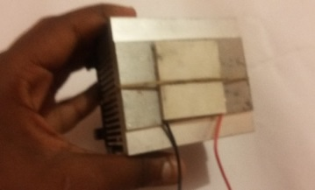

* Step **2**: Attach the aluminium heat sink with strands to the printed side of the peltier.

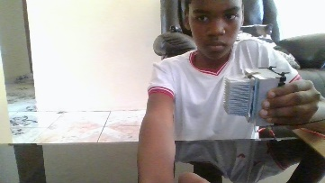

* Step **3**: Initially I made a cubic transparent CD case container which is now being replaced with a plastic transparent container with a space for the heatsink at the top and a stand for the PSU on the side. Make sure you seal gaps at the base of the container.

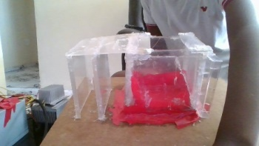

* Step **4**: Take your AC-DC adapter and connect the negative and positive terminals to the cooling fan. Because I am using a TEC1-12709 peltier module connect the red wire of the peltier to the purple wire of the PSU and connect the black of the peltier to any black wire of the PSU, before starting the experiment take the green wire of the PSU and connect it to any black wire so that it will work.

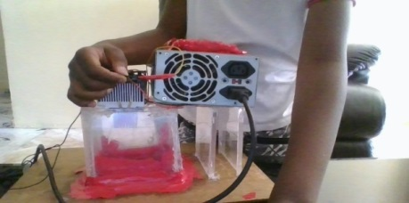

* **Step 5**: Connect the AC-DC adapter and PSU to electricity, or use two 12 volt SLA batteries connected to a power inverter or use solar panels along with a DC-AC power inverter. Test the project, everytime drops of water form vibrate or shake the heatsink so that they will fall. Again the water samples collected were divided into 4 bottles of two 500mls and two 1lt. bottles.
* Step **6**: A test was done for both water collected on outside conditions and room conditions. This bacteria and chemical test of the water was done at Umgeni Water in Pietermaritzburg to assess and evaluate the suitability of the water for drinking and other domestic purposes.

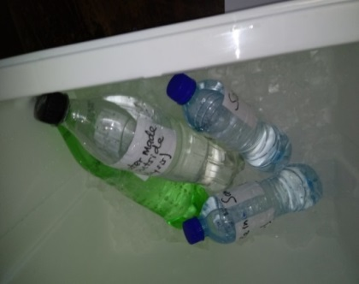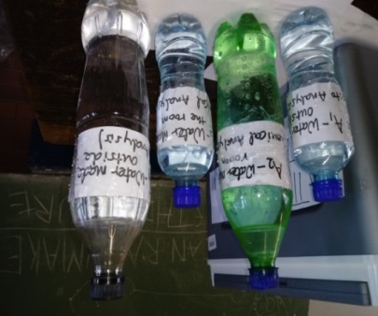

# 3. Cost Benefit Analysis (CBA)

In the table below, attempts have been made to provide both cost of the materials of the model and the estimated cost of materials for a larger (Real) model. It also indicates where these materials can be bought from our local shops which are accessible to the local people.

|  |  |  |  |
| --- | --- | --- | --- |
| **Materials used** | **Cost**  **(Rands)** | **The estimated cost for Real Model(Rands)** | **Shops to buy** |
| Cubic Transparent container | R45 | 10000lts-R9600  5000lts-R6000  (Polytank) | TriCircle/BuildIt |
| Small tap | R15 | R85(metallic tap) | TriCircle/BuildIt |
| Peltium module | R120 | 1745cm2 plate surface AHP-2700CPV 690W- R3500 | Mantech Electronics |
| Electrical energy from Eskom | R200 | R600 | Eskom |
| Solar panel | R75 | R 900 for 3 panels of 300W | Bundu Power |
| PSU from CPU | R350 | R2800 | Bundu Power |
| AC-DC Adapter | R50 | R200 | Flicks,Shoprite,Spar.ETC |
| Aluminium Heat sink | R65 | 200x80x83mm, 0.15K/W- R 2303.20 | RS Company Ltd. |
|  |  | 8900 (*8) 14300 (*3) |  |

A large scale system, implemented in a household, would pay itself off in within three (3) years, depending on the operating costs incurred during use. For a household of eight, to costs of setting up a rainmaker will be R8900 whilst for three families it will cost an estimated R14300. It can therefore be conclude that the **Rainmaker** is a cost effective system and worthwhile investment as compared to the existing systems which costs R39500 to produce 60 litres of water.

# 4. Results

In the process to find out the amount of water that can be produced through condensation within a period of time, measurement was made for 72 hours in my room and outside to be able to assess and compare the amount of water collected. The results can be seen in the Table below.

## 4.1 Water Collection results

Table 1: Amount of water collected over time (in hours) both inside and outside room conditions

|  |  |  |
| --- | --- | --- |
| **Time(Hours)** | **Amount of water collected in my room (ml)** | **Amount of water collected outside (ml)** |
| 7 | 75 | 350 |
| 14 | 150 | 702 |
| 21 | 230 | 1052 |
| 28 | 305 | 1404 |
| 35 | 375 | 1754 |
| 42 | 455 | 2105 |
| 49 | 525 | 2456 |
| 56 | 605 | 2807 |

Table 2: Amount of water collected over time (in days) both inside and outside room conditions

|  |  |  |  |
| --- | --- | --- | --- |
| **Days(Hours)** | **Amount of Water Collected in the room (lts)** | **Amount of water collected outside (lts)** | |
| 1 day(24hrs) | 0.25 | 1.2 | |
| 2days(48hours) | 0.5 | 2.4 | |
| 3 days(72hours) | 0.8 | 3.6 | |
| 7days(168hours) | 2 | 8.4 | |
|  |  |  | |
| **The model(small size)** | **Water Collected (litres)** | **Large or Real Model (litres)** | **Water collected (litres)** |
| 1day (24hrs) | 0.25 | 1day (24hrs) | 20 or 0.02klts |
| 2days(48hrs) | 0.5 | 2days(48hrs) | 45 or 0.045klts |
| 3days(72hrs) | 0.75 | 3days(72hrs) | 66 or 0.066klts |
| 7days(168hrs) | 1.75 | 7days(16hrs) | 87 or 0.087klts |

**Figure 1: Amount of water collected over time (in hours) both inside and outside room conditions**

**Figure 2: Amount of water collected over time (in days) both inside and outside room conditions**

### 4.2. Laboratory Results: Graphical representation

**Figure 3: The *E.coli* content for both inside and outside room conditions**

**Figure 4: The total coliforms for both inside and outside room conditions**

**Figure 5: The pH levels for both inside and outside room condition**

**Figure 6: The electrical conductivity for both inside and outside room conditions**

**Figure 7: Sulphate content for both inside and outside room conditions**

**Figure 8: Nitrate content for both inside and outside room conditions**

**Figure 9: Iron content for both inside and outside room conditions**

**Figure 10: Fluoride content for both inside and outside room conditions**

**Figure 11: Manganese content for both inside and outside room conditions**

**Figure 12: Sodium content for both inside and outside room conditions**

**Figure 13: Chloride content for both inside and outside room conditions**

# 5. Discussion

From the above results, it can be seen that a large amount of water was collected from the outside test than in a room because of the high amount of moist air and with warmth conditions outside, condensation process occurred faster.

From the findings obtained from the bacteria and chemical testing of the collected water, the following conclusions were made:

* Due to the high levels of E. Coli, Coliforms and plate counts, gardening and irrigational purposes of this water can be used for crops that will be cooked before eaten. Thus is not suitable for crops that are eaten raw as vegetables and fruits;
* As a result of the low pH level of the water, care needs to be taken as corrosion can occur on metal surfaces of farm equipment hence regular disinfection is needed to prevent clogging as well as in recreation, contact of water with the body of individuals must be prevented which can cause skin, ear and mucous membrane irritation;
* The water quality results indicate that water collected from inside the room is more polluted that that which is collected outside the room. However, the contaminats detected in the samples could be due to external factors such as the uncleanliness of the prototype and the thermo electric cooler, the possible contamination of the sample bottles. In addition, the high content of sulphate, fluoride, manganese, sodium and chloride could be due to the fact that the surroundings of the school (to which the experiement was conducted) consists of chemical industries and a lot of wood burning. Despite the aforementioned, the chemical analysis shows that the water produced is as good as rainwater and should a second test be ran (with cleaned and sterilised equipment), there is a high possibilty that the bacteria could be low;
* However, the experiment was a success, which proves the hypothesis correct. When the prototype was connected to a power source, the heatsink attached to the cold side started to become white and after a few minutes it was wet. More water was produced and collected as can be seen from the graph that at the end of 24 hours(1 day) is 201ml and 48 hours (2 days) is 514 ml (as per figure 1 and 2). The prototype was tested inside the room and outside the room.

For large scale production of water, a bigger condenser or Peltium module of 1745 cm2 with two square feet plate surface can be used which needs about 690 Watts of the power source of cooling capacity. The estimated amount of 21 litres can be collected in 7 days as compared to two (2) litres collected in seven (7) days by using this small model (as per table below).

The implementation of the project is more suitable for regions that are humid, such as KwaZulu-Natal, Eastern Cape and Mpumalanga provinces. Provinces like Gauteng, which are dry; this model may not be able to collect water effectively.

**6. Recommendations**

* The model is recommended to be adopted by rural households (as it is cost effective) and also urban households; and
* More research is needed on how the model could be improved in order for it to be able to accumulate water faster;
* More water can be collected in high humid areas of the country therefore to adopt it, the real model must be established at the eastern part of the country which has a high humid weather conditions.

1. **Conclusion**

After the research, data collection, building and water testing processes, it can be concluded that the **Rainmaker** was successful in achieving its aim. The problem that was identified was the time it takes for the water to accumulate, it is not as fast as one would want it to be, and however, a great amount of water can be collected over prolonged period of time.

The results from the working of the model and water testing showed that the system achieved its design goals. It was able to collect and that water was proven by laboratory analysis to be suitable for domestic uses, such as car washing, cleaning and flushing toilets, with no direct human consumption unless the water is pre disinfected with Chlorine, Jik or pre boil before human consumption. The system also made use of renewable solar energy as a power source.

The invention proved to be cost effective, allowing a household to harvest water when there is no rain. The system has the potential to bring the world one step closer to tackling the water crisis and protecting the precious and vital resource that is water.

1. **References**

Electron.cc (2017): [How to make Peltier cooler - YouTube](https://www.youtube.com/results?search_query=how+to+make+peltier+cooler). [www.youtube.co.za](http://www.youtube.co.za) [Accessed on 03 November 2018]

Maas, A., Goemans, C., Manning, D., Kroll, S., Arabi, M., and Rodriguez-McGoffin, M., 2017. [Evaluating the effect of conservation motivations on residential water demand](http://www.sciencedirect.com/science/article/pii/S0301479717302062). *Journal of Environmental Management, Volume 196, 1 July 2017,* Pages 394-401.

Lyon, A., Hunter-Jones, P., and Warnaby, G., 2017. [Are we any closer to sustainable development? Listening to active stakeholder discourses of tourism development in the Waterberg Biosphere Reserve, South Africa.](http://www.sciencedirect.com/science/article/pii/S0261517717300109)*Tourism Management*, *Volume 61*, *August 2017*, Pages 234-247.

Glenn, D.T., Endter-Wada, J., Kjelgren, R., and Neale, CMU., 2015, [Tools for evaluating and monitoring effectiveness of urban landscape water conservation interventions and programs](http://www.sciencedirect.com/science/article/pii/S0169204615000547). *Landscape and Urban Planning*, *Volume 139*, *July 2015*, Pages 82-93.

Howard, G., and Burtran, J., 2003. Domestic Water Quanity. World Health Organization, Geneva, Switzerland.

Baudoin, M., Vogel, C., Nortje, K., and Naik., M., 2017. [Living with drought in South Africa: lessons learnt from the recent El Niño drought period](http://www.sciencedirect.com/science/article/pii/S2212420917300985). *International Journal of Disaster Risk Reduction, Volume 23, August 2017,* Pages 128-137.

The Water Project (2007-2018). Safe Water is Scarce. 17 Depot St. 2nd Floor- Concord. NH-03301-USA

Peter Chasse (2016), Water in Crisis – South Africa, [www.thewaterproject.org](http://www.thewaterproject.org) [Accessed 21 April 2018]

Petru, S. and Kyle,C., 2017. The Great Thirst: Water Crisis Paralyses rural towns. Sunday Live, South Africa.

Sobsey, D., 2002. Managing Water in the Home: Accelaraated Health Gains from Improved Water Supply, Geneva, Switzerland.

Techtronics (17 Dec 2017): [How to Turn on PC Power Supply without Motherboard - YouTube](https://www.youtube.com/watch?v=dL4c9ye234Y) [www.youtube.com](http://www.youtube.com) [Accessed 04 November 2017]

Tsoumachidou, S., Velegraki, T., Antoniadis, A., and Poulios, I., 2017. Greywater [as a sustainable water source: A photocatalytic treatment technology under artificial and solar illumination](http://www.sciencedirect.com/science/article/pii/S0301479716305631). *Journal of Environmental Management*, *Volume 195, Part 2*, *15 June 2017*, Pages 232-241.

World Health Organization., 2011. Drinking Water Quality. Fourth Edition. [www.dwa.gov.za](http://www.dwa.gov.za). Media Release by the Minister Nomvula Mokonyane on the state of Dams in South Africa (Accessed on 24 May 2017)

[Water labs (2009): Why do cold drinks get sweaty? - Physics Stack Exchange](https://physics.stackexchange.com/questions/144245/why-do-cold-drinks-get-sweaty)physics.stackexchange.com

Water from the Air [www.waterfromair.co.za](http://www.waterfromair.co.za) [Accessed 27 May 2017].