|  |
| --- |
|  |
| ***"Biological control of they Aedes aegypti"*** |
| The aquatic environments of San Roque provide an ecofriendly answer to health problems in the area. |
|  |
|  |
|  |

**AUTHORS:**

* **Emiliano Fernando Aquino (ID No.: 43533815).**
* **Micaela Itatí Linera (ID No.: 43096552).**

ADVISERS:

Professor Ramon Leonardo Amarilla.

Professor Roque Luis Barrios.

Professor Roque Antonio Arriola.

*(Work team of the Natural Sciences’ Department).*

**Escuela Normal "Juan García de Cossio" (Public School "Juan García de Cossio"). CUE 1800358-00**

**San Martin 715, San Roque, Corrientes, Argentina.**

**CP: 3448. TE: +543777-687469.**

**E-mail: 1800358-00@secundaria.mec.gob.ar**

[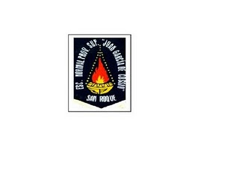](http://4.bp.blogspot.com/_3f9F6S5aVE8/SeSOxVxgPOI/AAAAAAAAACc/VXSJFHrHfY4/s1600-h/Escudo+Escuela.JPG)

**High School Education**

**Ministry of Education of the Province of Corrientes 2018**

**Summary:**

The World Health Organization and the Pan American Health Organization (PAHO / WHO) had expressed the importance of adopting a series of measures to help prevent Aedes aegypti-borne diseases, constituting a public health problem in our country and registering dengue outbreaks in 15 jurisdictions as from August to September 2016, being the worst epidemic in history.

Now, there is generalized consensus among the different social actors around the idea that human health and well-being are closely linked to environmental quality.

The situation demands the urgent need to seek appropriate measures to find new control methods that do not cause environmental problems. Therefore, it was decided to locate biocontrol agents to fight for the important population vector control in their aquatic phase.

The objectives of this study are: 1) To determine the presence / absence of Aedes aegypti in the city of San Roque and prepare a local entomological map (distribution of A. aegypti in the area mentioned). 2) To assess the predatory capacity of the fish Hoplerythrinus unitaeniatus (Aimara) –native species- on mosquito larvae and 3) To continue the search for native biocontrol agents.

The actions were carried out in three stages named below: 1) monitoring Aedes aegypti; 2) testing Hoplerythrinus unitaeniatus (Aimara) in the laboratory and 3),Hoplerythrinus unitaeniatus trials (Aimara) in homes.

Research conducted confirms the importance of water bodies (lakes, esturaies and swamps in this case) found in Mesopotamia, Argentina in the seek of ecological responses to community problems, such as re-emerging diseases that put in risk the public health system of society.

As a result of this research, it has appeared for the first time the presence of Aedes aegypti in the town of San Roque (Corrientes) and, therefore, it has revealed the epidemiological risk for transmission of dengue and other diseases whose vector is the species mentioned, providing valuable tools for decision-making in the field of community health.

In addition, the predatory capacity of Hoplerythrinus unitaeniatus (Aimara) was proved exercising an important control of Aedes aegypti population in the home environment.

**Introduction:**

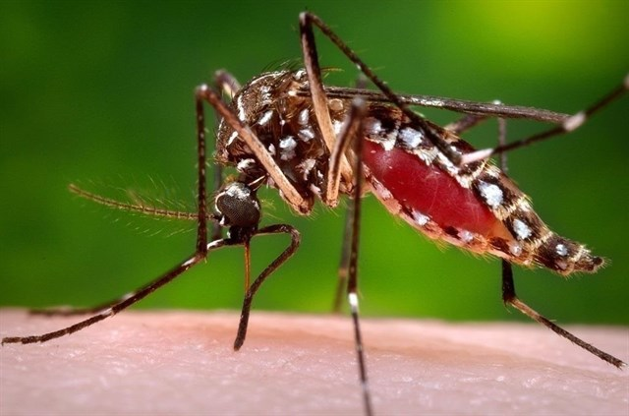The World Health Organization and the Pan American Health Organization (PAHO / WHO) had expressed the importance of adopting a series of measures to help prevent transmitted diseases by mosquito, such as dengue, Zika, yellow fever; which represent a high burden of morbidity and mortality for individuals, their families and communities. They also warned that such phenomena as climate change, migration, increase of air and land traffic, and uncontrolled peri-urban expansion directly affect the reemergence of these diseases.

In recent years, it increased the number of dengue cases in Argentina, as well as an growth in the geographical distribution of its vector (Vezzani & Carbajo, 2008). Aedes aegypti-borne diseases are a public health problem in our country, registering dengue outbreaks in 15 jurisdictions during the months from August to September 2016. During this period, 76,734 suspected dengue cases were reported (including: probable, confirmed, discarded and in study). From those cases, 41,207 were from confirmed or probable native cases; while 2,681 were from confirmed and probable imported cases, distributed in 23 provinces (Integrated Bulletin No. 325. Ministry of National Health). In Argentina, at that time, it ocurred the worst epidemic in history.

Fig. 1: Aedes aegypti adult feeding.

*Aedes aegypti* is an example of adaptation to the human field, with breeding, habitats, power supplies, assets and liabilities related to commuting home environment, which is a challenge to control and surveillance (Marquetti Fernández,Carrazana Trujillo, Silvia Leyva and Bisset Lazcano. 2010).

To take actions on this species of mosquito and its related diseases, and to reduce its existence and its effects, we need to know the situation of each area, through strategies to obtain accurate information on the distribution and population dynamics of the vector mosquito. That is to say, mainly it is necessary to know the population dynamics of Aedes aegypti in a specific location, then take the actions towards alternative control.

Accordingly, it is important to show that Giménez, Almiron and Stein (2015) expressed the importance of taking into account that the oviposition is the final result of feeding, reproduction and research of oviposition sites by the female, thus, by employing ovitraps you can obtain information regarding the activity of adult female in an area or place, at a particular time.

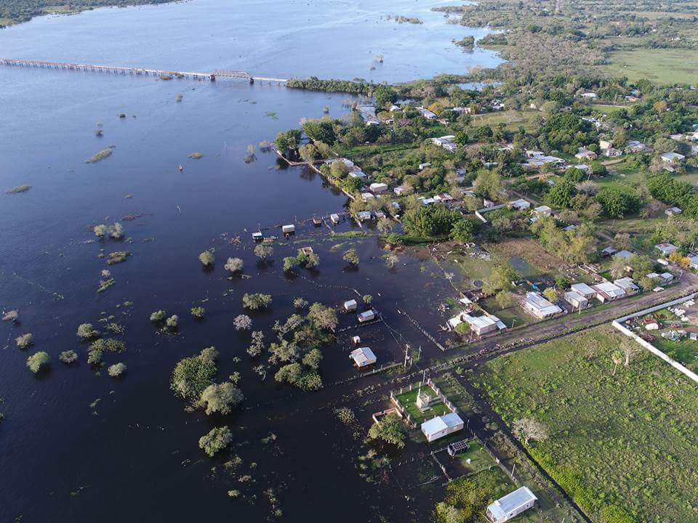At present, there is widespread consensus among the different social actors around the idea that human health and well-being are closely linked to environmental quality. In recent years the issue of climate change as a determinant of environmental factors and therefore the health of populations, has become particularly relevant resulting in numerous health strategies regarding this issue (Impacts of climate change on health. Ministry of Health, Social Services and Equality. Madrid Spain). Active and responsible participation of the community seeking greener alternatives that do not harm the environment and avoid the proliferation of these insects is essential.

Fig. 2: heavy rains increase the number of mosquito breeding sites.

It is also considered important to note that the desperate and intensive use of insecticides has managed to finish it in almost all populations but "pests" have higher biotic potential, they quickly repopulate the environment, requiring new insecticide causing safely a total ecological imbalance. Soil, rivers, lakes, estuaries, glens are contaminated with these components, preventing the development of aquatic faunas of vital importance in nature, besides the risk of toxicity to humans it implies.

Following this line of environmental events, the situation demands the urgent need to seek appropriate measures to find new control methods that do not cause such problems. Therefore it was decided to try to locate biocontrol agents to fight for the important population vector control in their aquatic phase.

*"If there is a fish that shows a suitable feeding behavior of mosquito larvae, it will be prevented in this way to reproduce in greater numbers and help achieve the community for better welfare and reduce environmental pollution." This line of action (biological control of disease vectors, ecological and "cheap" solutions) was proposed by the WHO (World Health Organization).*

Specifically, what it is sought in the present study is to determine the epidemiological scenario in which lies the town of San Roque regarding the presence and distribution of Aedes aegypti, and the possible risk, and to look for ecological solutions that do not harm the environment (native fish that feed on the aquatic stages of mosquito).

The motivation that allowed completion of this work, and following the order to progress in the response to a possible extent on the distribution of Aedes aegypti in the city of San Roque, is the possibility to "improve" the tasks performed on the following background:

* Caceres, A. C. and RM Robledo (2005), who evaluated the feeding behavior of Belostoma elongatum and its importance as predators of vectors,
* Cardozo, SJ, et al (2006) looked for ecological alternatives with fish to control the population of mosquito larvae and flat snails.

Other authors who materialized investigations following this line of action are:

* Borda, CE et al (2009) after 10 years of surveillance (1998-2008) in the city of Corrientes (Argentina), determined that 69% (5,690) of all surveyed households (8,250) were infected by A. aegypti.
* Duarte, F. et al (2009), assessed the efficacy of 3 species of river fish in the control of mosquito larvae in tanks used by the public to store water.
* Nieva, LB et al (2010), provided information on the composition of the diet of fish Gambusia affinis related to mosquito larvae intake of medical importance.

According to history, from collections on field trips and observations of different species of larvivorous fish performed in the laboratory, the Hoplerythrinus unitaeniatus (Aimara) was selected to work with.

**INVESTIGATION QUESTIONS:**

* Is it present the Aedes aegypti mosquito in the city of San Roque? How will it be its distribution?
* Will Hoplerythrinus unitaeniatus (Aimara) have an adequate dietary behavior as a potential controller of the Aedes aegypti population?

**HYPOTHESIS:**

*Hoplerythrinus unitaeniatus* (Aimara) is a biocontrol potential of the Aedes aegypti population, mosquito species that colonized some neighborhoods of the city of San Roque.

**OBJECTIVES:**

* To determine the presence / absence of Aedes aegypti in the city of San Roque and to prepare a local entomological map (distribution of A. aegypti in the community mentioned).
* To evaluate the predatory ability of the fish Hoplerythrinus unitaeniatus (Aimara) – native species- on mosquito larvae.
* To continue the search of native biocontrol agents.

**Materials and methods:**

**Step 1: monitoring Aedes aegypti.**

**Description of the study area:**

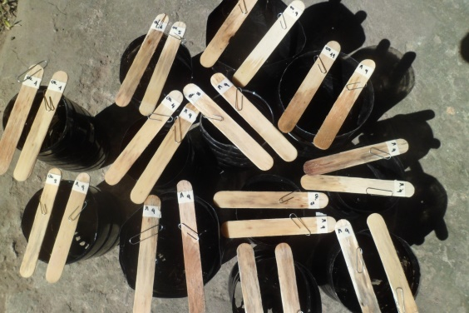The work was developed in the city of San Roque (Corrientes), located 136 km from its capital, to the south ([28 ° 34'27 "S and 58 ° 42'32" O](http://tools.wmflabs.org/geohack/geohack.php?language=es&pagename=San_Roque_(Corrientes)&params=-28.57416667_N_-58.70888889_E_type:city)). It has a population of about 8,500 inhabitants and 2,000 houses distributed in 112 blocks.

**Sampling:**

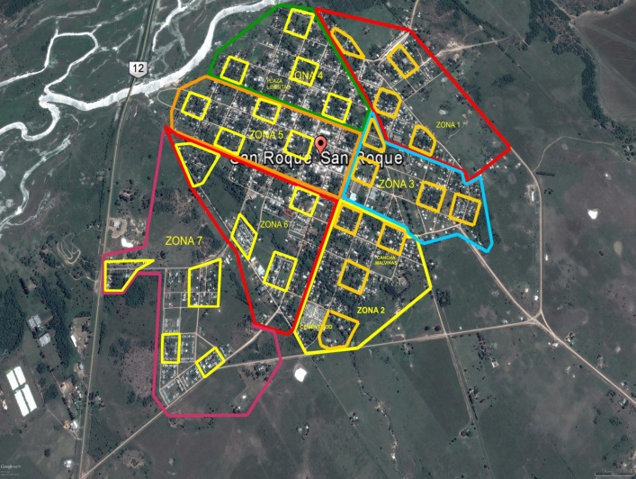Teams were formed by students from 5th year of the Public School "Juan García de Cossio", staff from Hospital San Roque (sanitary workers), the City Town and Volunteer Firefighters. During September-December 2016 an entomological survey was conducted by placing ovitraps in strategic places (houses, clubs and shops) in different areas of the city.

Fig. 3: ovitraps used in

the polls.

A ovitrap is a device easy to manufacture, with a black container (it can be a plastic bottle of water or soda of 15 cm. of base, painted in black), inside two tongue depressors were placed (paddles wood) adjusted for each clip and the corresponding labels.

The city ​​was divided into seven areas, in each of them four blocks and then four houses were selected, there we inserted four ovitraps, 2 in the inside and 2 in the outside (front or backyard). After 5/6 days, they were monitored and relevant data recorded. During Home visits, other stages of the life cycle of the vector (larvae, pupae, adults) were collected, in situations in which homeowners had access to the review of potential breeding sites. The samples were checked in the laboratory of the Public School "Juan García de Cossio" and sent it to the National Center of Parasitology and Tropical Diseases (CENPETROP, Faculty of Medicine, UNNE) to obtain confirmation regarding the specific identification. The cemetery “Maria Auxiliadora” was a specific area of study and the work was held in November 2016.

Fig. 4: selected blocks for

sampling.

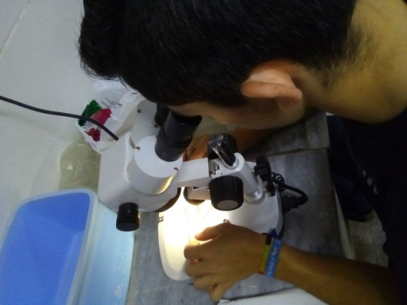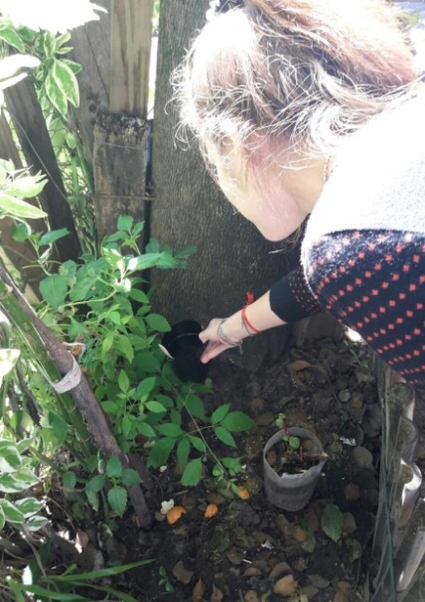In each area, these tasks were implemented after a team of Hospital Health Care Workers, staff of the City Town of San Roque, police and volunteer firefighters were carrying out promotion and prevention tasks. Rainfall data (fallen rain), average of minimum and maximum temperature during the study period (provided by the meteorological station located at the Technical School "Remedios Escalada de San Martin") was also recorded.

Fig. 6: review of the tongue depressor (eggs of Aedes aegypti).

Fig. 5: Location ovitraps in homes.

The obtained data was recorded on appropriate forms.

**Step 2: tests on Hoplerythrinus unitaeniatus (**Aimara**) in the laboratory.**

The study was conducted in the laboratory of the Public School "Juan García de Cossio" (San Roque, Corrientes) during March to June 2017.

* **Field trips and laboratory work - collecting and reconditioning of material:**

Two areas were selected for fish sampling and collecting, prevailing lagoons, wetlands and estuaries: 1) Step Mina (Lujan Spot) (28 ° 34'14.21 "S - 58 ° 35'51.31" O); 2) Step Paloma former National Route 12 (28 ° 37'39.55 "S 58 ° 39'10.64" O) and which they have the appropriate conditions of vegetation and depth for optimal growth and development of fish larvivorous.

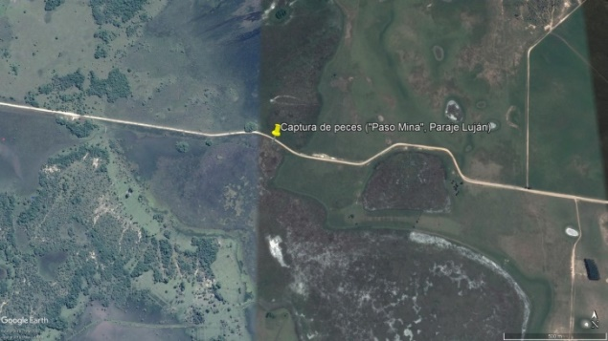In each field trip, temperature measurements of water and air, the sea depth, pH were taken and most abundant vegetation was registered.

Fish net trap was used (50 cm. in diameter) and a similar net used to catch butterflies (50 cm. diameter). In some cases the fishing line was used. They were then taken to school laboratory in a bucket of 20 liters with water of that place, and subsequently transferred to glass fish tanks (length: 60 cm, width: 50 cm, height: 45 cm) containing a mixture of dechlorinated water -water of catch. In each aquarium a temperature controller was placed, a 10 cm PVC tube for fish shelter and approx. 3 cm of sand (bottom). The specimens were identified using the guide "Ibera Fish" (Casciota, et al. 2006).

Fig. 7: zone 1 fish catch (Step Mina streams).

After the capture and once placed in aquariums, 5 days had to go by to achieve adaptation of the fish to the laboratory conditions.

* **Experimental design:**

Tests were performed in six (6) tanks whose measures were detailed above. Aquariums 1 to 5 contained 1 fish (predator) and an increasing number of larvae of mosquito larvae Culex quinquefasciatus species (dams), captured in the gutters and ditches of the city. In the tank 6, there was only mosquito larvae to control natural mortality, ie without the predator placed.

Each experience lasted 3 days, with an initial charge consisting of 100 prey mosquito larvae (day 1), then 200 larvae (day 2) and 300 larvae (day 3).

|  |  |  |  |  |
| --- | --- | --- | --- | --- |
| Aquariums-fish tanks | | | | |
| 1 | 2 | 3 | 4 | 5 |
| Fish  +  Mosquito larvae | Fish  +  Mosquito larvae | Fish  +  Mosquito larvae | Fish  +  Mosquito larvae | Mosquito larvae |
| Amount of preys offered = Day 1 = 100 mosquito larvae (Culex quinquefasciatus) | | | | |
| Amount of preys offered = day 2 = 200 mosquito larvae (Culex quinquefasciatus) | | | | |
| Amount of preys offered = day 3 = 300 mosquito larvae (Culex quinquefasciatus) | | | | |

Table 1: preparation and organization of aquariums (experimental unit).

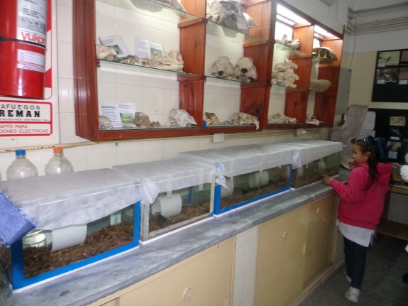After 24 hours, the number of prey consumed in each tank and the related forms were completed and controlled. Four repetitions of the experiences were implemented, renewing the group of fish. Behavior of *Hoplerythrinus unitaeniatus* was also observed at the time mosquito larvae were placed and overnight (8pm/8:30pm).

During the period of study, photoperiod fluctuated naturally and average room temperature was 20.7 ° C and water, 26.5 ° C. For counting mosquito larvae Pasteur pipettes were used.

Fig. 8: experimental unit located in the school laboratory.

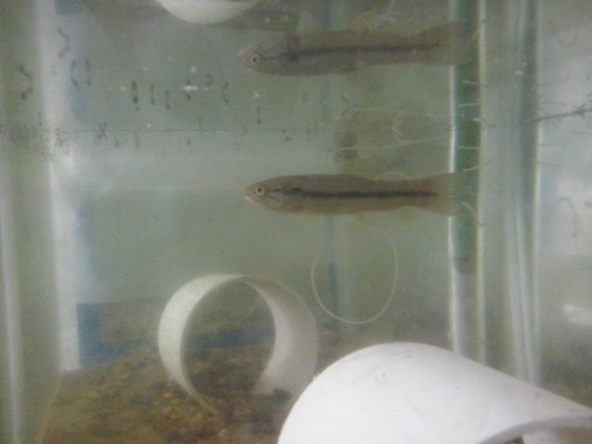**Data processing:** after each experiment and data recording, graphics were prepared, taking into account the number of prey consumed every 24 hours and the density of the dam. The minimum, maximum and average consumed larvae was determined.

**Step 3: tests Hoplerythrinus unitaeniatus (caballita) in homes.**

During September-October 2017, tests were performed within 3 homes located in different parts of the city of San Roque (Home Address 1: Miguel Soto 964, house 2: Beron de Astrada 678, house 3: Desiderio Sosa 855).

Fig. 9: copy of Hoplerytthrinus unitaeniatus in the aquarium.

In these experiences, used tanks had similar characteristics from step 2, placing one tank in each house (kitchen, living and internal gallery), with one fish (predator), 10 cm PVC tube for shelter and a background sand-pebble stone).

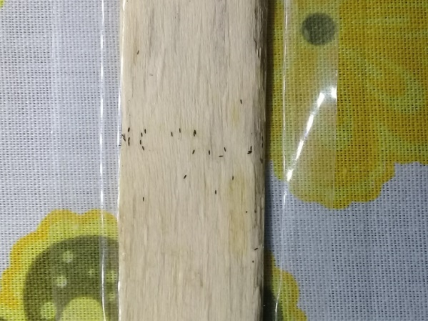**Feeding of *Hoplerythrinus unitaeniatus****:* dams offered were Aedes aegypti larvae, obtained from the use of ovitraps (same method of step 1 of this study). The tongue depressor of positive ovitraps were used, that is to say, 2 tongue depressor were placed on the inner wall of the tanks (fastened with a clip and tape) containing eggs of Aedes aegypti. When larvae hatched it moved in the aquarium and food was available for the fish. The number of eggs and the number of larvae in the aquarium were recorded every 24h for 3 days. This record was started when the larvae hatch was observed. Then the following week, they behaved in the same way without the presence of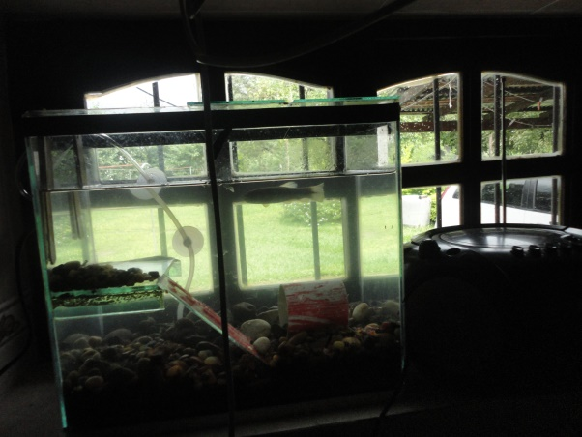 *Hoplerythrinus unitaeniatus* in the aquarium for control of natural mortality of larvae. 3 repetitions of this experience were implemented, renewing the fish. Data wase captured in spreadsheets made for this purpose.

Fig. 10: unitaeniatus copy of Hoplerytthrinus located in the aquarium at home.

During the study period photoperiod it fluctuated naturally and average room temperature was 22.7 ° C and water, 23.9 ° C. For counting the larvae of Aedes aegypti Pasteur pipettes were used.

Fig. 11: eggs (dark spots) Aedes aegypti a tongue depressor (ovitraps).

**Results:**

* **Step 1: monitoring Aedes aegypti.**

The data obtained allowed entomological make a distribution map of Aedes aegypti in the town of San Roque providing relevant vector surveillance data.

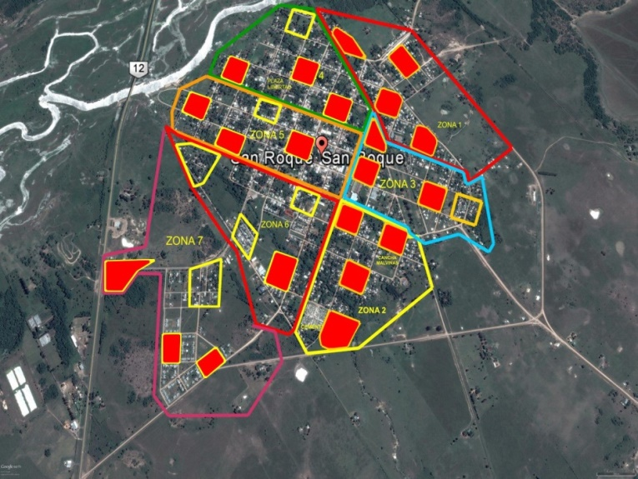Of the 28 blocks surveyed, 21 (75%) were positive in relation to the presence of Aedes aegypti. Regarding the number of households, 50 (44.6%) out of a total of 112 have been positive. 448 ovitraps were placed, of which in 76 (17%) eggs vector were observed.

Fig. 12: positive and negative to the presence of Aedes aegypti apples. Local entomological map. Red colored areas correspond to positive sectors (+) indicating the presence of Aedes aegypti.

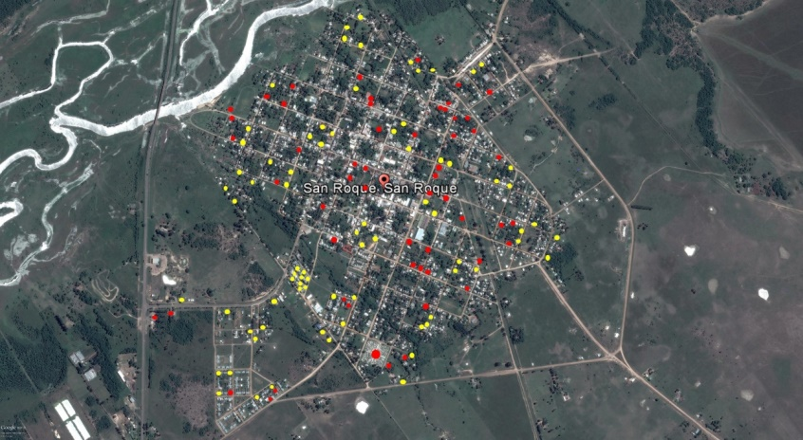

Regarding cemetery "Maria Auxiliadora", the presence of A. aegypti was also found. Eggs, larvae and adult mosquito vector were there.

Fig. 13: positive and negative houses. The red dots correspond to houses where Aedes aegypti eggs were found. Yellow points to homes negative (absence of the vector).

|  |  |
| --- | --- |
| * Revised number of containers: | 390 |
| * Number of positive containers: | **13** |

Table 2: Survey data obtained in the cemetery.

These results demonstrate the strong presence of the vector in most of the sampling area, finding eggs, larvae, pupae and adults of A. aegypti in many homes and businesses surveyed, as well as in the city cemetery. In this situation, we must add the abundance of potential mosquito breeding sites observed in all selected blocks.

During the study period, the data regarding environmental variables were as follows: average temperature: 22.7 ° C, maximum temperature: 37.7 ° C minimum temperature: 7.5 ° C and amount of rainfall (precipitation): 539 mm.

* **Step 2: tests Hoplerythrinus unitaeniatus (Aimara) in the laboratory.**

The following results were obtained:

|  |  |  |  |  |  |  |  |  |  |  |  |
| --- | --- | --- | --- | --- | --- | --- | --- | --- | --- | --- | --- |
| Number of larvae offered | Number of larvae consumed | | | | | | | | | | Average |
| Week 1 | | | | | week 2 | | | | |
| 1 | 2 | 3 | 4 | 5 | 1 | 2 | 3 | 4 | 5 |
| 100 | 94 | 100 | 98 | 100 | 95 | 91 | 77 | 88 | 100 | 98 | **94.1** |
| 200 | 197 | 196 | 171 | 148 | 189 | 200 | 200 | 192 | 200 | 179 | **187.2** |
| 300 | 300 | 300 | 300 | 288 | 2. 3 | 300 | 300 | 300 | 298 | 280 | **268.9** |
| Total | **591** | **596** | **569** | **536** | **307** | **591** | **577** | **500** | **598** | **557** | **542.2** |

Table 3: Data obtained during weeks 1 and 2.

In the first week of testing (first repetition), specimen No 3 of Hoplerythrinus unitaeniatus has consumed a total of 569 mosquito larvae. Therefore, the "comprehension" of the table for the analysis of the predatory ability of the fish is performed.

|  |  |  |  |  |  |  |  |  |  |  |  |
| --- | --- | --- | --- | --- | --- | --- | --- | --- | --- | --- | --- |
| Number of larvae offered | Number of larvae consumed | | | | | | | | | | Average |
| week 3 | | | | | week 4 | | | | |
| 1 | 2 | 3 | 4 | 5 | 1 | 2 | 3 | 4 | 5 |
| 100 | 100 | **56** | 75 | 100 | 98 | 95 | 98 | 100 | 88 | 92 | **90.2** |
| 200 | 200 | 200 | 189 | 200 | 191 | 123 | 200 | 200 | 167 | 183 | **185.3** |
| 300 | 300 | 300 | 200 | 298 | 266 | 286 | 245 | 292 | **300** | 277 | **276.4** |
| Total | **600** | **518** | **364** | **598** | **555** | **504** | **543** | **592** | **555** | **552** | **538.1** |

Table 4: Data obtained during weeks 3 and 4.

|  |  |  |  |
| --- | --- | --- | --- |
| Number of larvae offered | Larvae consumed averages | | **final average (total experience)** |
| Weeks 1 and 2 | 2 and 3 weeks |
| 100 | **94.1** | **90.2** | **92.1** |
| 200 | **187.2** | **185.3** | **186.2** |
| 300 | **268.9** | **276.4** | **272.6** |
| Total | **542.2** | **538.1** | **540.1** |

Table 5: Average number of larvae consumed.

Fig. 14: Number of larvae offered (blue) and average larvae consumed (green) in relation to those offered.

According to these data, it can be argued that increasing the availability of prey is also higher the consumption.

* Minimum larvae consumed: **56.**
* Maximum larvae consumed: **300.**

Aquarium No. 6: control natural mortality of larvae (without the predator):

In a total of 600 larvae have died from natural causes only (on average), 3 mosquito larvae.

|  |  |
| --- | --- |
| Number of larvae (start) | Number of larvae (final) |
| 100 | 98 |
| 200 | 189 + 10 = 199 pupae |
| 300 | 285 + 15 = 300 pupae |
| Total | 597 |

Table 6: control natural mortality of larvae.

**Unitaeniatus Hoplerythrinus behavior in the presence of the preys (direct observation):** when the dams were placed in aquariums, most fish showed no changes in their behavior, only some of them began to feed themselves. Often their movement was "quiet" and to some sensory perception (noise, light), they headed to another direction "as escaping from observation." When they were visualized at a distance, their actions were different, they roamed the fishbowl and sought mosquito larvae. The best time for observation was between 8 pm and 8:30 pm.

**Step 3: testing Hoplerythrinus unitaeniatus (caballita) in homes.**

The results obtained in each house are as follows:

|  |  |  |  |  |
| --- | --- | --- | --- | --- |
| Aquarium fish without the presence of (witness) | | | | |
|  | Number of eggs in each tongue depressors (average) | Number of larvae in the tank (average) | | |
| 24h | 48h | 72h |
| 1 | **2. 3** | **2** | **17** | **28** |
| 2 | **31** |
| total | **54** |

* House 1: address, Miguel Soto 964.

|  |  |  |  |  |
| --- | --- | --- | --- | --- |
| Aquarium fish presence | | | | |
|  | Number of eggs in each tongue depressors (average) | Number of larvae in the tank (average) | | |
| 24h | 48h | 72h |
| 1 | **3. 4** | **0** | **0** | **0** |
| 2 | **Four. Five** |
| total | **79** |

Table 8: Number of larvae in the control aquarium.

Table 7: larvae consumed in the home 1.

* House 2: address, Beron de Astrada 678.

|  |  |  |  |  |
| --- | --- | --- | --- | --- |
| Aquarium fish presence | | | | |
|  | Number of eggs in each tongue depressors (average) | Number of larvae in the tank (average) | | |
| 24h | 48h | 72h |
| 1 | **28** | **0** | **0** | **3** |
| 2 | **12** |
| total | **30** |

|  |  |  |  |  |
| --- | --- | --- | --- | --- |
| Aquarium fish without the presence of (witness) | | | | |
|  | Number of eggs in each tongue depressors (average) | Number of larvae in the tank (average) | | |
| 24h | 48h | 72h |
| 1 | **fifteen** | **4** | **8** | **16** |
| 2 | **13** |
| total | **28** |

Table 10: Number of larvae in the control aquarium.

Table 9: larvae consumed in the 2nd house.

* House 3: address, Desiderio Sosa 855.

|  |  |  |  |  |
| --- | --- | --- | --- | --- |
| Aquarium fish presence | | | | |
|  | Number of eggs in each tongue depressors (average) | Number of larvae in the tank (average) | | |
| 24h | 48h | 72h |
| 1 | **16** | **1** | **3** | **0** |
| 2 | **22** |
| total | **38** |

|  |  |  |  |  |
| --- | --- | --- | --- | --- |
| Aquarium fish without the presence of (witness) | | | | |
|  | Number of eggs in each tongue depressors (average) | Number of larvae in the tank (average) | | |
| 24h | 48h | 72h |
| 1 | **22** | **6** | **twenty** | **37** |
| 2 | **42** |
| total | **64** |

Table 12: Number of larvae in the control aquarium.

Table 11: larvae consumed in the 3rd House.

The recorded data demonstrate a direct effect of Hoplerythrinus unitaeniatus in the population of Aedes aegpti.

**Discussion:**

Given the results obtained, the town of San Roque epidemiologically can be classified in Tier I (NI), ie, that there are mosquito breedings, but no cases of Dengue (Technical standards. Ministerio da Saude. Fundação Nacional da Saúde, Brasilia, Brazil- “Health Department. National Health Foundation”). This situation demands the urgent need to increase activities, which goals surveillance and control of mosquito A. aegypti throughout the territory of the Department of San Roque, providing meaningful data for prevention activities carried out in the province of Corrientes, therefore preventing outbreaks or epidemics of diseases transmitted.

It should also be noted that positive ovitraps mean risk of transmission of the disease by the presence of female mosquitoes feeding themselves, accentuating the importance of the realization of ecological studies Aedes aegypti, determining their variation according to season and the correlation of its abundance with environmental factors to meet their reproductive behavior associated with external factors.

It is the first time the presence of the mosquito vector documented in the city of San Roque.

After detecting Aedes aegypti in specific parts of the city of San Roque, it should be guided the search for focus, elimination of breedings and education of the community in different neighborhoods (Borda and Mosqueda, 2000).

This situation increases the importance of the role that could have Hoplerythrinus unitaeniatus (caballita) in controlling the population of Aedes aegypti that develops in homes. However, it should be noted that the elimination of breeding sites or potential mosquito breeding a line of action is as essential as the search for biocontrol. The action exerted by the mentioned fish should be added to tasks of promotion and prevention organized between local institutions with similar functions. Local society must notice the actions held by the coordinated staff of the institutions that have an impact on social work community work.

Regarding the feeding behavior of Hoplerythrinus unitaeniatus, it is shown that the increase in prey density leads to an increase in successful search predator or a decrease in handling time. According to the results achieved in this work, the tendency is towards the first, since it was observed no significant differences in relation to the amount of prey available during the handling time.

It is considered important to clarify that the species that have this kind of response have the potential to more efficiently control of the population of dams, the success on search search increases as the amount of available prey increases.

All the above above is even more significant if one takes into account the work done by Calderon and Troyos (2007) and Suarez Delgado, et al (2005) in which investigated and expressed that *Culex* *quinquefasciatus* and *Aedes aegypti* often coexist in containers of household use in urban areas. That is to say, these two mosquito species can efficiently share the habitat. Also, it was warned that when removing any of them, the other performs an effective occupation of the abandoned habitat.

Also, the location of aquariums in homes provides an approach to the predatory role of this species of fish in the control of Aedes aegypti, being necessary deeper studies on ecological aspects of both: *Hoplerythrinus unitaeniatus* and *Aedes aegypti,* and that they play an important role in the dynamics of the ecosystems in which they interact.

**Conclusions:**

Research conducted confirms the importance of the water bodies not very deep (lakes, marshes and swamps in this case) found in Mesopotamia Argentina in search of ecological responses to community problems, such as re-emerging diseases. They jeopardize the public health system in which people live. This situation requires more attention as Step 1 of this study was finished, the report that shows for the first time the presence of *Aedes aegypti* in the town of San Roque (Corrientes) and, therefore, it revealed the epidemiological risk the transmission of dengue and other diseases which vector is the mentioned species, providing valuable tools for decision-making in the field of community health,

In addition, the predatory capacity of Hoplerythrinus unitaeniatus (Aimara) exerting an important control of Aedes aegypti population in the home environment was checked.

It is considered significant to remember that using these natural enemies of mosquito larvae, implies working in accordance with the environmental proposals from the World Health Organization.

* All work done allows us to plan an investigation by proposing an increase in fish tanks placed in homes during the period of greatest activity of Aedes aegypti, conducting an appropriate follow-up.

During this work, the backbone of the held actions has been the Public School "Juan García de Cossio," advised by the technical and scientist staff of CENPETROP (Center for Parasitology and Tropical Diseases of the Northeast. Faculty of Medicine. UNNE, Corrientes) and by the Institute of Regional Medicine (Campus de Resistencia, Chaco. UNNE).

**References:**

1. Integrated Surveillance Bulletin No. 325, SE 35, 2016. Secretary of Promotion and Health Programs. Ministry of Health of the Nation, Argentina.
2. **Borda C, M Rea, L. Mosqueda 2000**. Observations on the presence of Aedes aegypti Linnaeus, 1762 in the city of Corrientes, Argentina. Regional conference on mosquitoes Paraguay-Uruguay-Argentina. Buenos Aires, Argentina,. p. 23-24.
3. **Borda, CE; MJF Rea; Benitez L. O. Mosqueda. 2009**. Aedes aegypti: Biology and epidemiological surveillance in the city of Corrientes. Communications Science and Technology. Northeastern University.
4. **Caceres, A. C. and RM Robledo. 2005**. *Belostoma elongatum* feeding behavior and health importance. Sanitary and Environmental Engineering AIDIS Argentina. No. 80. Buenos Aires, Argentina, pp 44-50.
5. **Calderon, A. and A. Troyos. 2007**. Evaluation of the ecological niche of larval forms of Aedes aegypti and Culex quinquefasciatus in an urban community of San José, Costa Rica. Rev. Parasitol. Latinoam. 62: 142-147.
6. **Cardozo, SJ; FJ Lezcano; LJ Leiva and Legal SD. 2006**. biocontroladores fish. An alternative for the control of disease vectors. 2006. Sanitary and Environmental Engineering AIDIS Argentina. No. 86. Buenos Aires, Argentina, pp 53-61.
7. **Casciotta, J .; A. Almirón and Bechara J. (2006)**. Fish from Laguna Ibera. Ecology and fish fauna. Description of species. Ed. Univ. Of La Plata.
8. Vector Control da febre amarela and dengue. Instrucçôes for pessoal of Operações. Technical standards. Ministerio da Saude. Fundação Nacional da Saúde, Brasilia, Brazil. Gráfica e Editora Brasil Ltda. 95 pp., 1994

Available in:

1. **Duarte, RF; Castle JC Basin; Cepero O. Rodriguez; E. Corona Santander and R. González González. 2010**. Effective control of mosquito larvae (Diptera: Culicidae) with larvivorous fish in Placetas, Villa Clara province, Cuba.REDVET. Electronic Journal of Veterinary Science. Volume 11, Number 03B.
2. **Gimenez, JO; Almirón, WR and Stein, M. 2015**. Spatio-temporal distribution of Stegomyia (Stegomyia) Aegypti Linnaeus (Diptera: Culicidae) in Resistencia (Chaco). XXI Meeting of Scientific and Technological Communications, UNNE.

http://scielo.sld.cu/scielo.php?script=sci_arttext&pid=S0375-07602010000200005&lng=es.

1. Impacts of climate change on health. Executive Summary. Ministry of Health, Social Services and Equality. Madrid Spain.
2. **Marquetti Fernandez Maria del Carmen, Carrazana Trujillo Midiala, Leyva Maureen Silva, Juan Lazcano Bisset**. Factors related to the presence of Aedes aegypti (Diptera: Culicidae) in two regions of Cuba. Cubana Med Trop Rev [Internet]. 2010 Aug [2017 cited Sep 17]; 62 (2): 112-118.
3. Nieva, LB; C. L. Flores and Lopez Herrera. 2010. Diet composition introduced fish Gambusia affinis (Baird & Girard, 1853) in permanent water bodies linked to the river Oath Department. Metan, Salta, Argentina.CIUNSa. Faculty of Natural Sciences. Salta, Argentina.
4. **Suarez Delgado, S .; J. Rodriguez; Z. Menendez Diaz; D. Mounted Dorta; I. Ávila García Fernández and M. Marquetti. 2005.***Macrocyclops albidus* (Copepoda: Cyclopidae): a new alternative for the control of mosquito larvae in Cuba. Rev. Cubana Med. Trop. 57 (3).
5. **Vezzani Darío, Aníbal E. Carbajo 2008.**Aedes aegypti, Aedes albopictus, and dengue in Argentina: current knowledge and future directions. Mem. Inst. Oswaldo Cruz [Internet]. 2008 Feb [cited 2017 Sep 18]; 103 (1): 66-74.

* Project description:

The World Health Organization and the Pan American Health Organization (PAHO / WHO) have shown the importance of adopting a series of measures to help prevent Aedes aegypti-borne diseases, constituting a public health problem in our country and registering dengue outbreaks in 15 jurisdictions during the months from August to September 2016, happening the worst epidemic in history.

At present, there is widespread consensus among the different social actors around the idea that human health and well-being are closely linked to environmental quality.

The situation demands the urgent need to seek appropriate measures to find new control methods that do not cause environmental problems. Therefore it was decided to locate biocontrol agents to fight in the population vector control in their aquatic phase.

Research conducted confirms the importance of water bodies (lakes, esturaies and swamps in this case) found in Mesopotamia, Argentina in the seek of ecological responses to community problems.

As a result of this research, it has appeared for the first time the presence of Aedes aegypti in the town of San Roque (Corrientes) and, therefore, it has revealed the epidemiological risk for transmission of dengue and other diseases whose vector is the species mentioned, providing valuable tools for decision-making in the field of community health.

In addition, the predatory capacity of Hoplerythrinus unitaeniatus (Aimara) was proved exercising an important control of Aedes aegypti population in the home environment

* Importance of parental, researchers and peers involvement:

This search for ecological responses to environmental and health problems of the community is a theme that worked at the school for several years. It is a great opportunity to learn about the tasks performed by researchers because we contact these people working in the institutes that train and help us improve our ideas. Through school teachers, researchers contact with them and organize actions to guide and conduct the investigation itself. Our parents and guardians help in a very important way regardless of their professions and daily chores, because most of them always require “actual” information, they ask what we're doing, why we are going into extra time to lab school, "Take care of yourself in field trips" "Where did you get?", among other questions. Their support is essential and its insistence to finish the job is necessary. Specifically, in this paper we contacted Dr. Edgardo Borda National Center for Parasitology and Disease of Northeast (Faculty of Medicine, Corrientes. Northeastern University - UNNE) and Dra. Marina Stein and hes team at the Regional Medicina Institute (Campus de Resistencia, Chaco. UNNE) who guided us and taught to learn even more about mosquitoes and ecological alternatives that we can work. it is important to finish emphasizing that without the help of our colleagues, the fulfillment of this work would be more in a future time, and maybe we would be graduates of school. Thanks to them and to the teachers who organize field trips and lab work, today we can show this school investigation.